When Lehi listened to the Lord
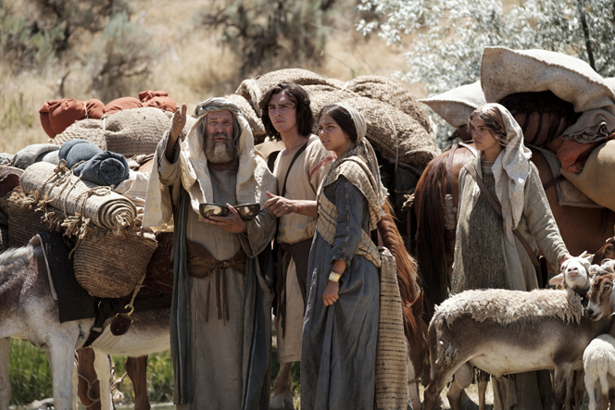
And his family left their home and riches
His sons returned back home again
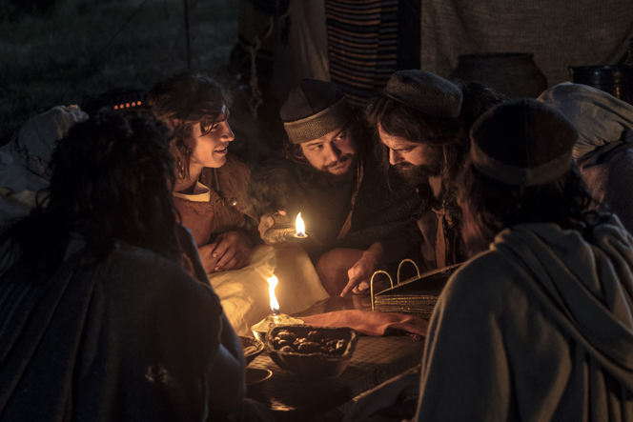
So they could get the scriptures
So Lehi’s people knew the Lord
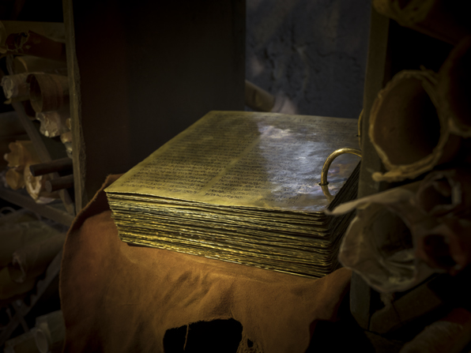
As the plates of brass helped them remember
When they obeyed the prophet’s voice
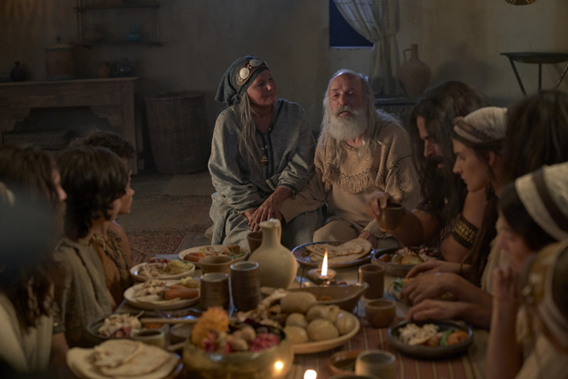
They prospered all together
The Savior visited their land
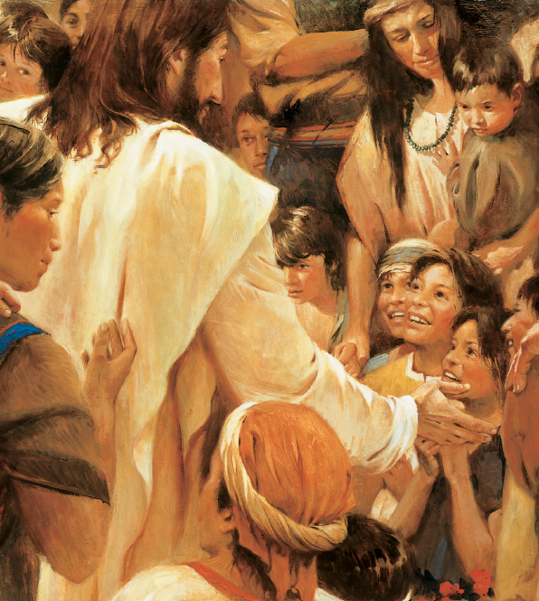
After He had risen in His glory
He blessed the children just like me
I love to read their story
The Book of Mormon tells of Christ
And helps me feel the Holy Spirit
Heavenly Father’s voice is calling me
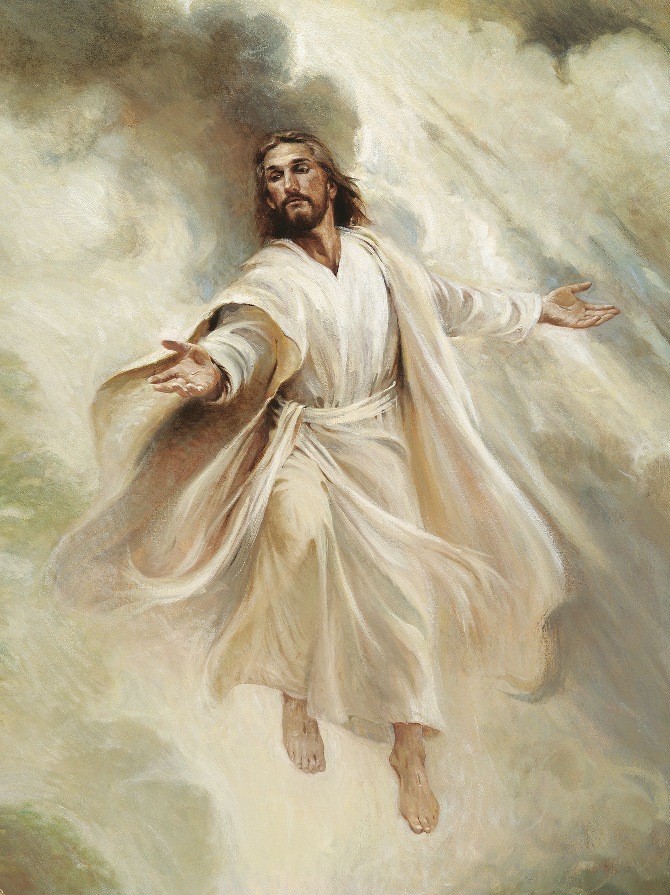
And the scriptures help me hear it

