The witness of the Holy Ghost
As borne by those who know
Has lifted me again to thee
O Father of my soul
I know that thou art in the heav’n
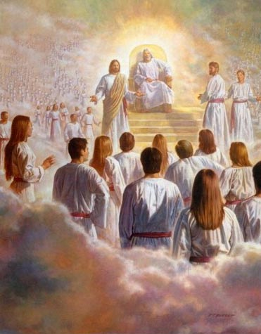
I know the Savior reigns
I know a prophet speaks to us
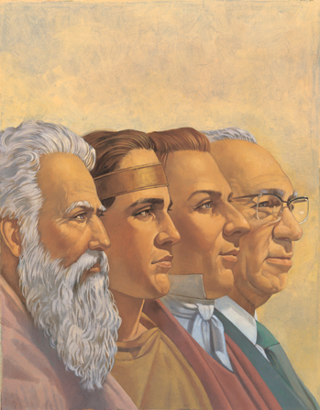
For our eternal gain
My eyes are wet
My heart is full
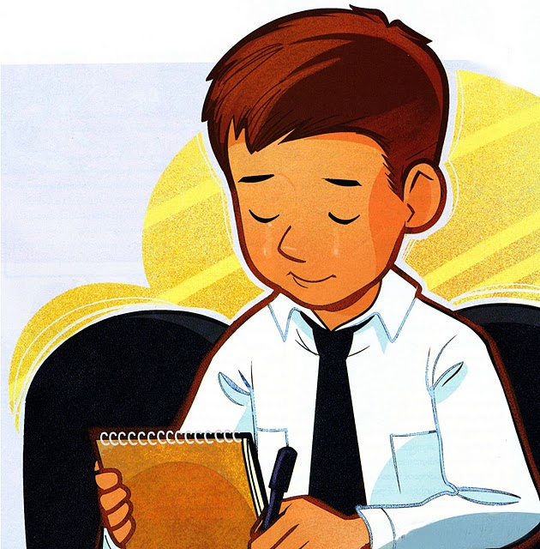
The Spirit speaks today
O Lord, wilt thou my life renew
And in my bosom stay
As testimony fills my heart
It dulls the pain of days
For one brief moment heaven’s view
Appears before my gaze

