Tell me the stories of Jesus
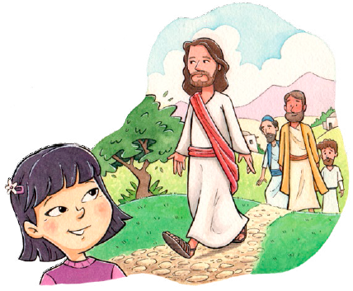

I love to hear
Things I would ask him to tell me
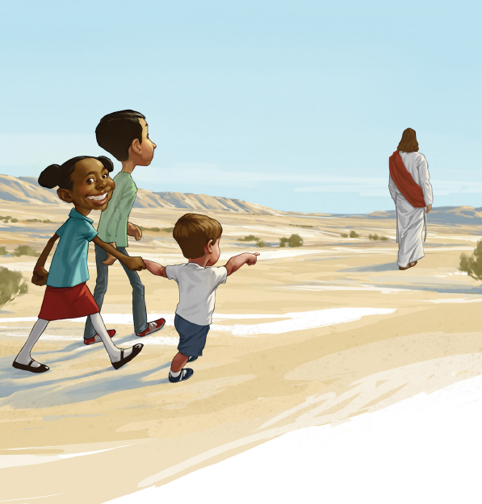

If he were here
Scenes by the wayside
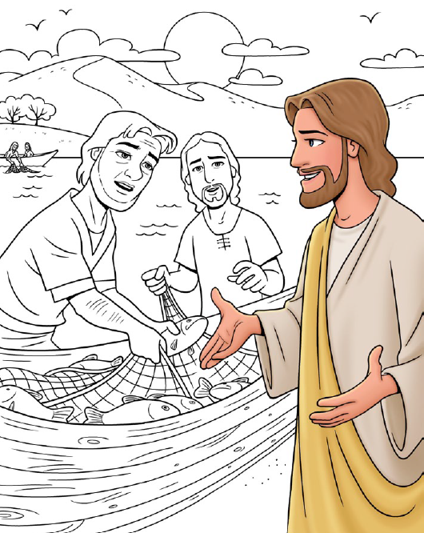

Tales of the sea
Stories of Jesus
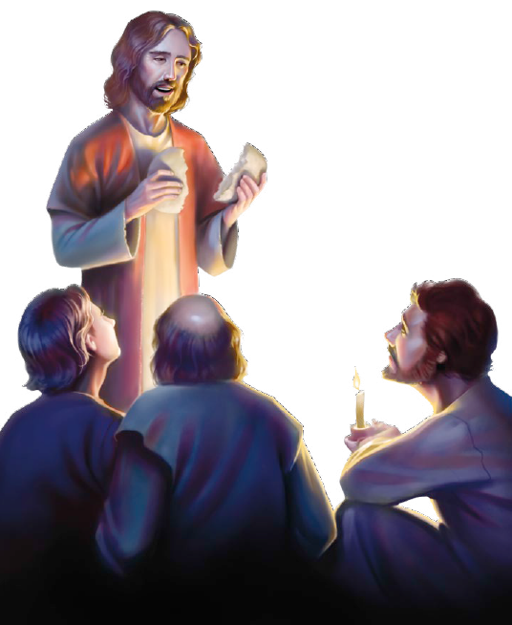

Tell them to me
Oh, let me hear how the children
Stood round his knee
I shall imagine his blessings
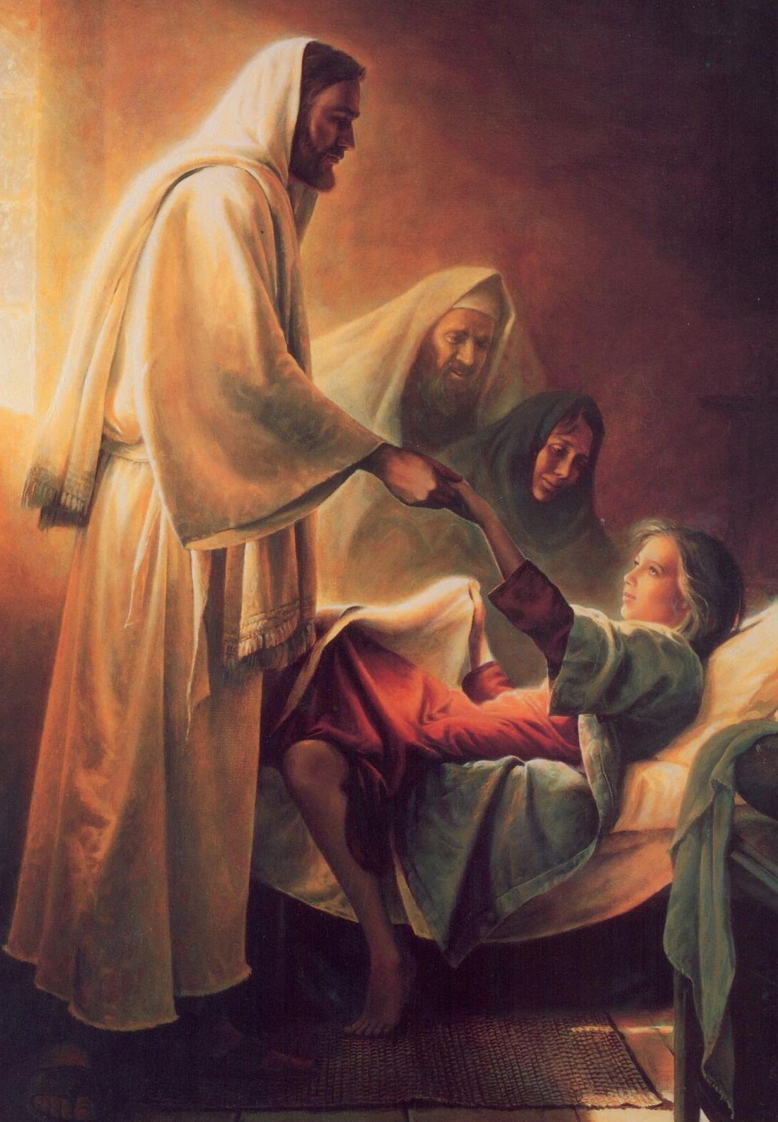

Resting on me
Words full of kindness
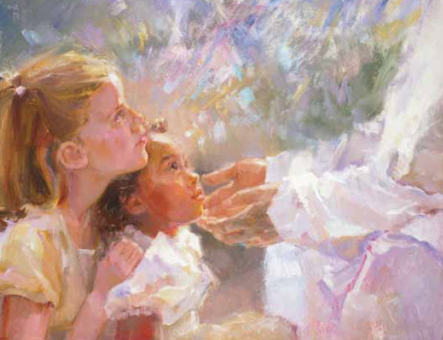
Deeds full of grace
All in the love-light of Jesus' face
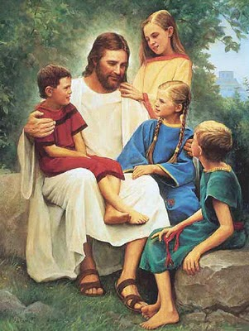
Tell me, in accents of wonder

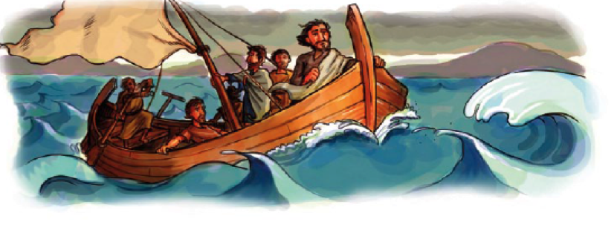

How rolled the sea
Tossing the boat in a tempest
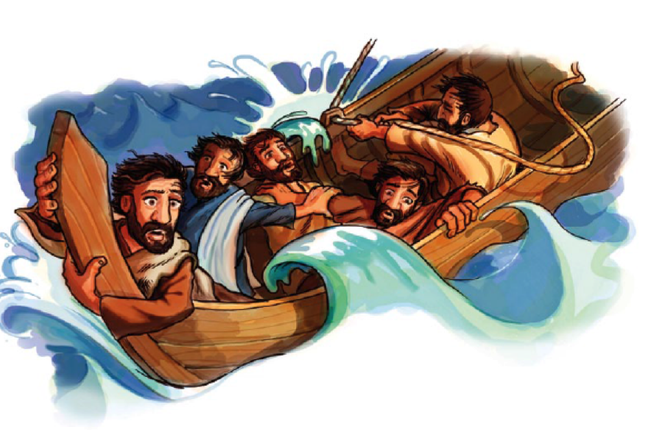

On Galilee!
And how the Master,

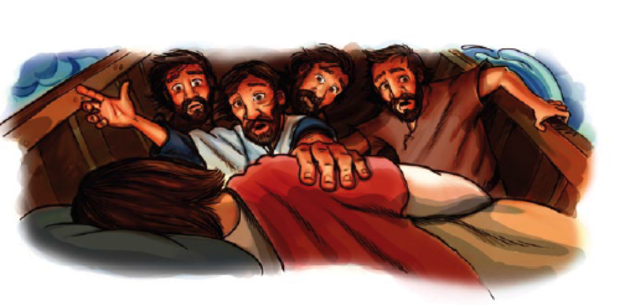

Ready and kind
Chided the billows
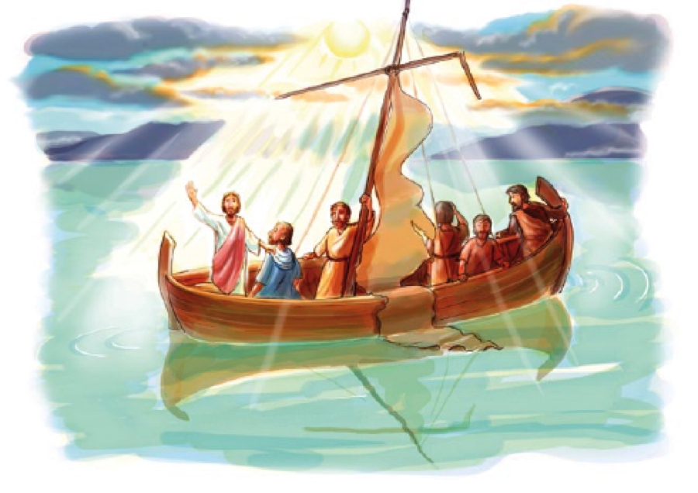
And hushed the wind

