Tell me, dear Lord,

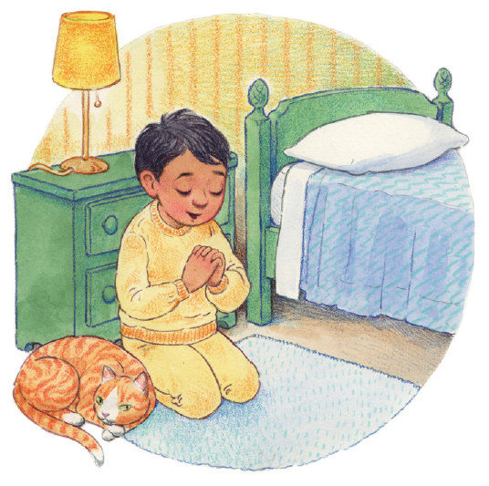

In thine own way I pray

What thou would'st have me say



And do today

 Teach me to know

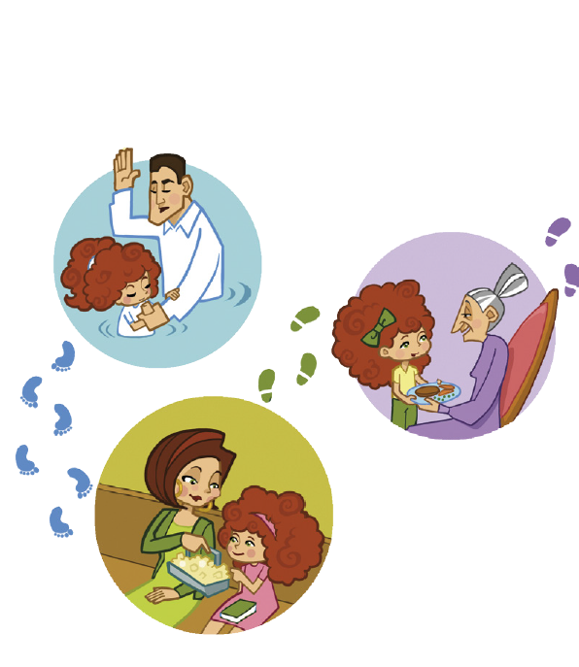

And love thy will

O Lord help me to understand



Thy loving word

I would be guided



By thy loving hand

Would hear thy voice



Obey thy blest command

Each moment just to know



That thou art near

Will strength impart



And banish ev'ry fear