Teach me to walk in the light of his love

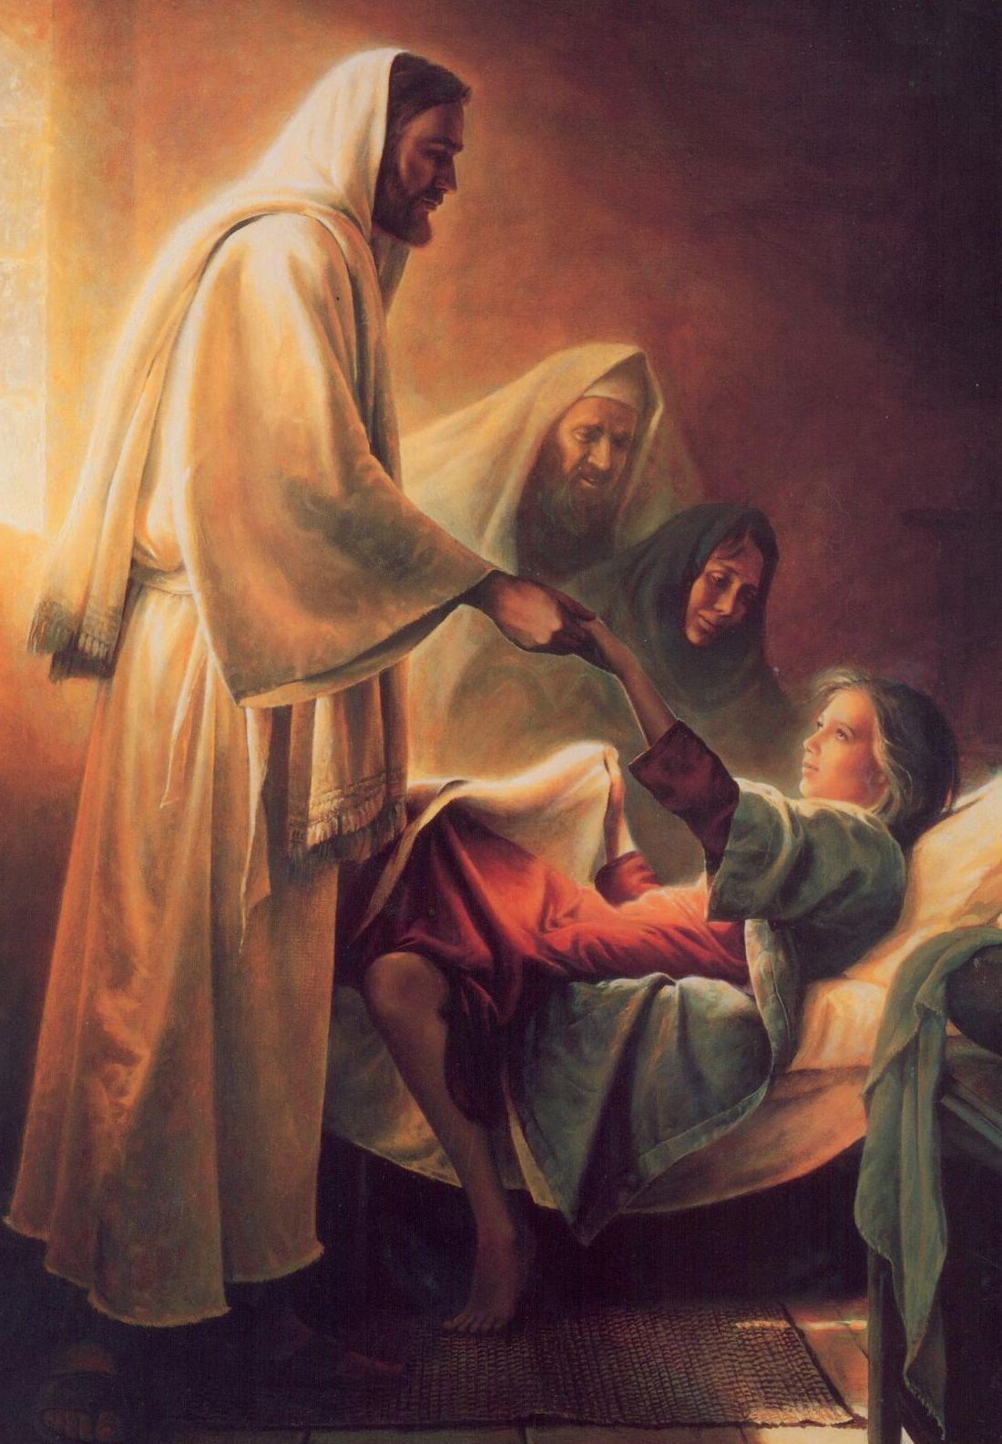

Teach me to pray to my Father above

****

Teach me to know of the things that are right



Teach me, teach me to walk in the light

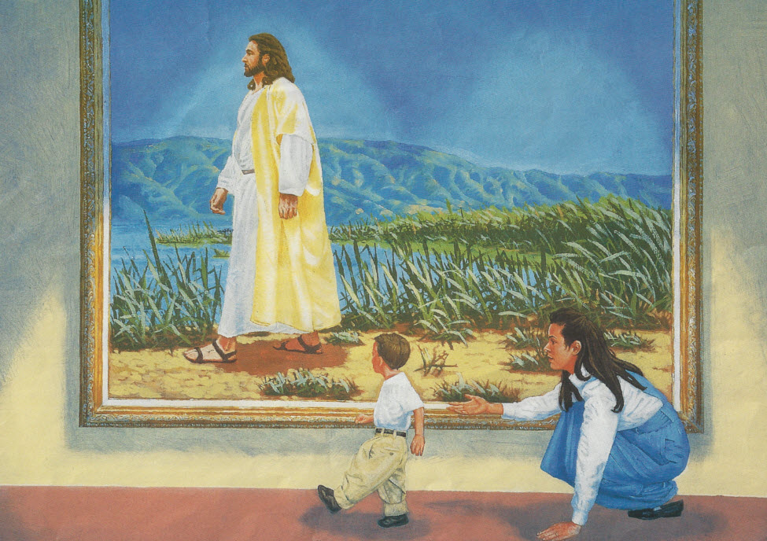

Come little child and together we’ll learn

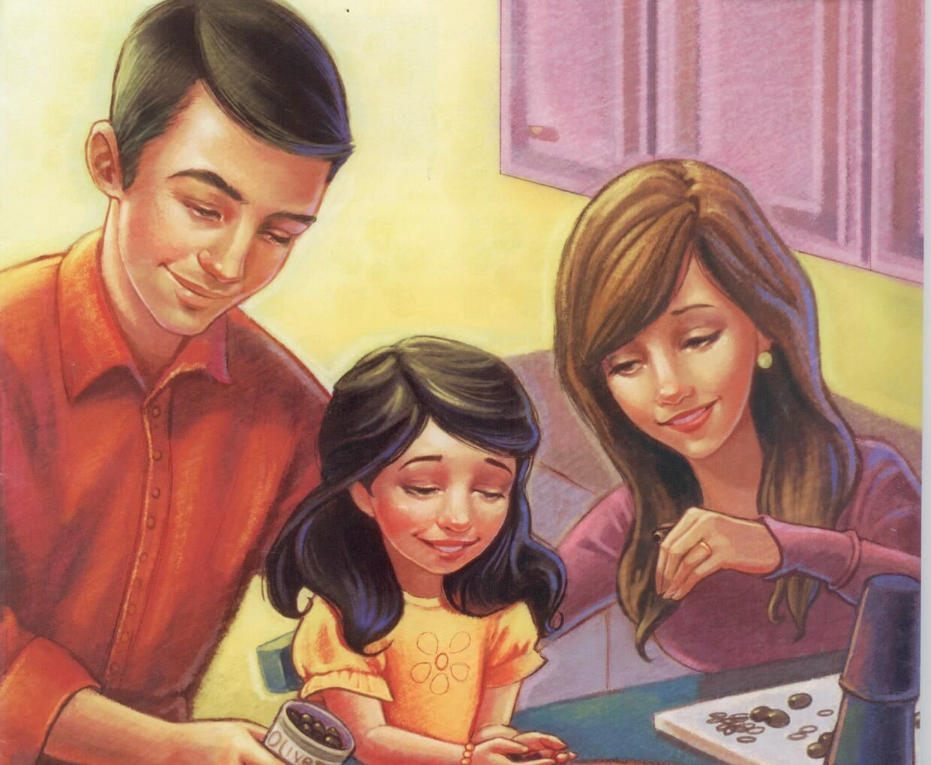

Of his commandments that we may return

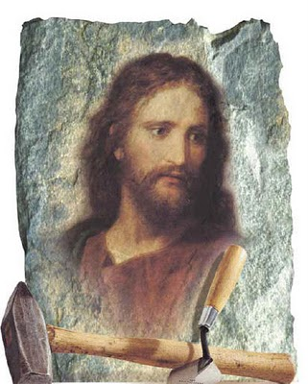

Home to his presence, to live in his sight

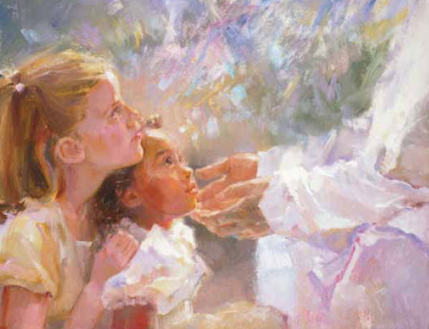

Always, always to walk in the light



Father in Heaven we thank thee this day



For loving guidance to show us the way



Grateful, we praise thee



with songs of delight!

Gladly, gladly we’ll walk in the light

