I see the light of the temple at night
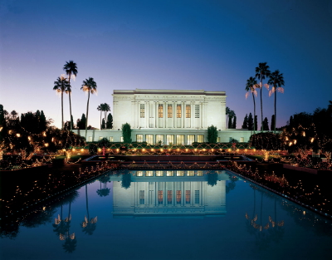
As it shines it reminds me
I must prepare so that I can go there
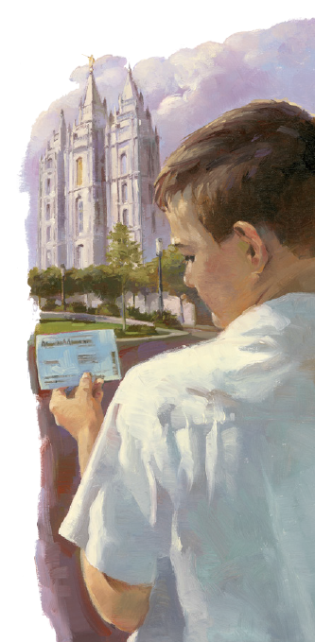
And I need someone to guide me
I see the light of the temple at night
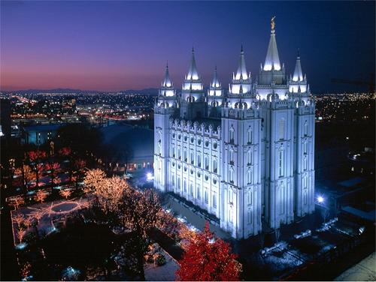
And its glow is a symbol
Helping me think of the safety and peace
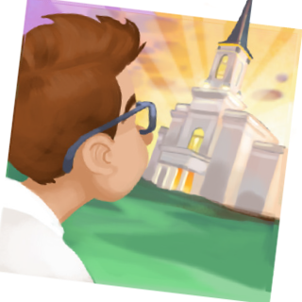
That come from the holy temple
Please teach me about the temple
Please show me how to prepare
Then all of my life I will try
To be worthy to enter there
Please teach me about the temple
I want to know so that someday I may go

