Still, Still, Still

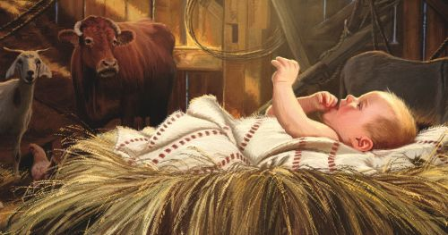
Jesus sleeps and
all is still

His mother Mary gently holds Him
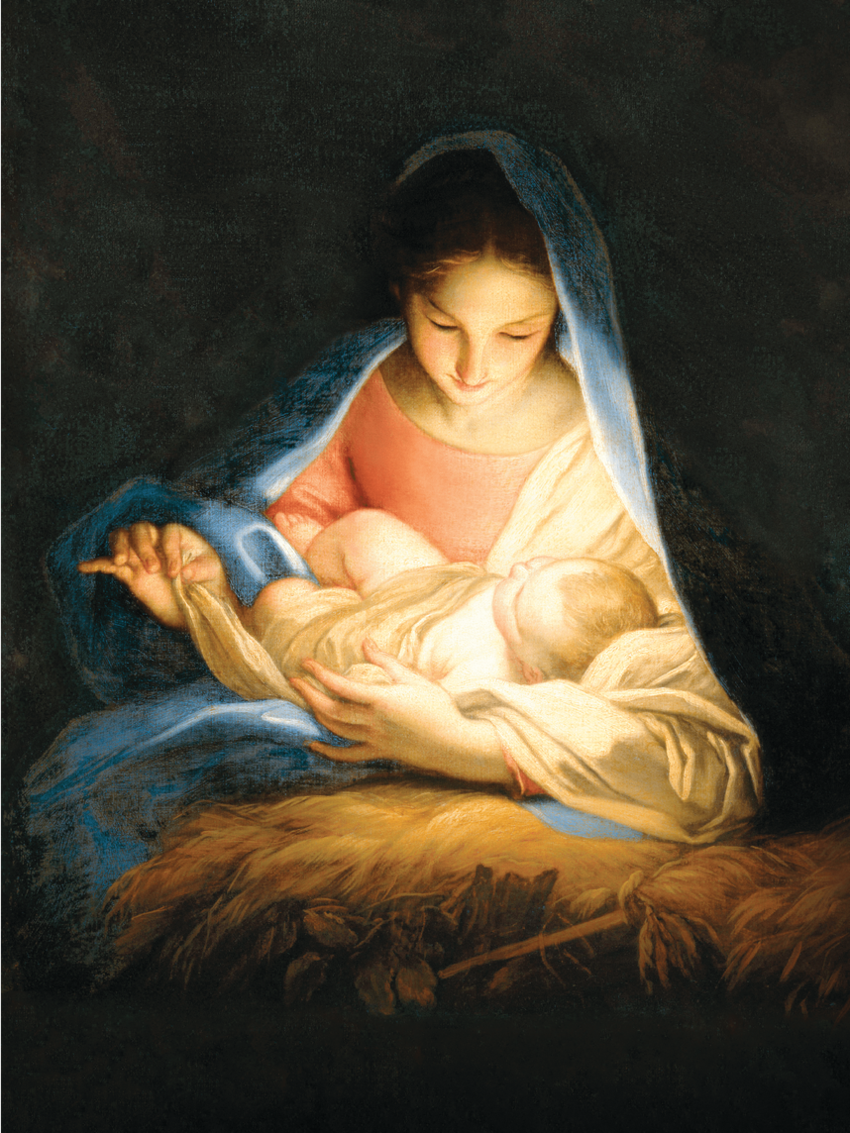
Softly in her arms enfolds Him
Still, Still, Still

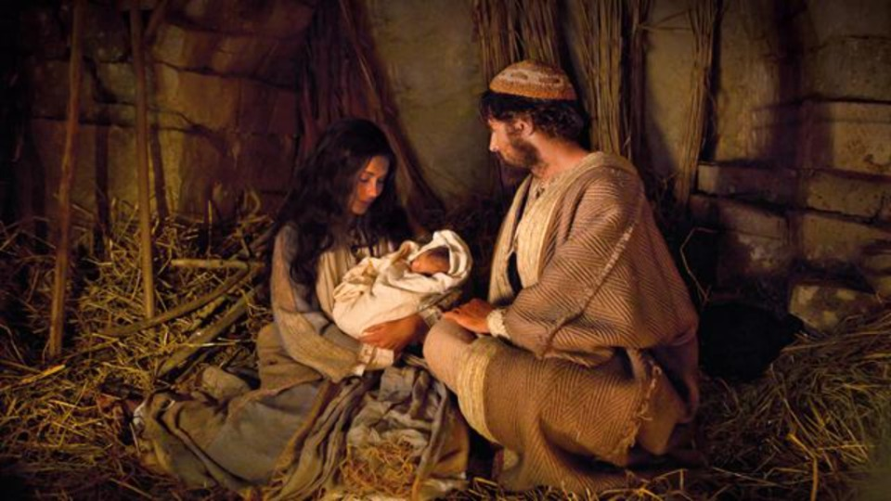

Jesus sleeps and
all is still

Sleep, Sleep, Sleep

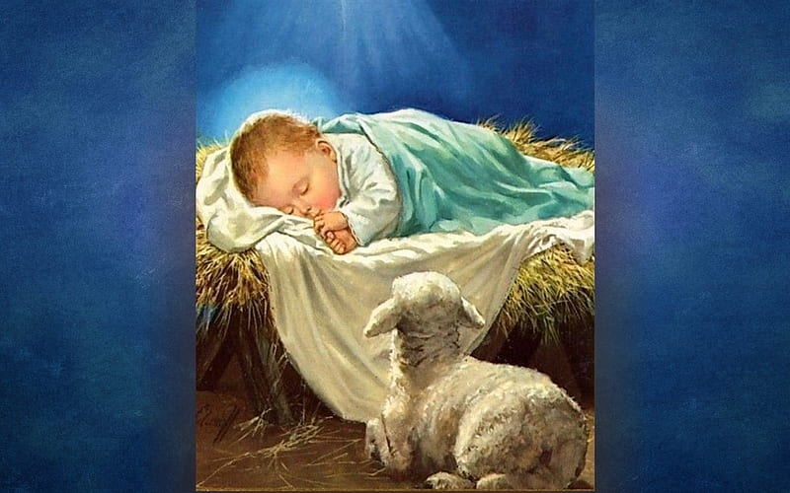

See the blessed baby sleep
While heavenly choirs in jubilation
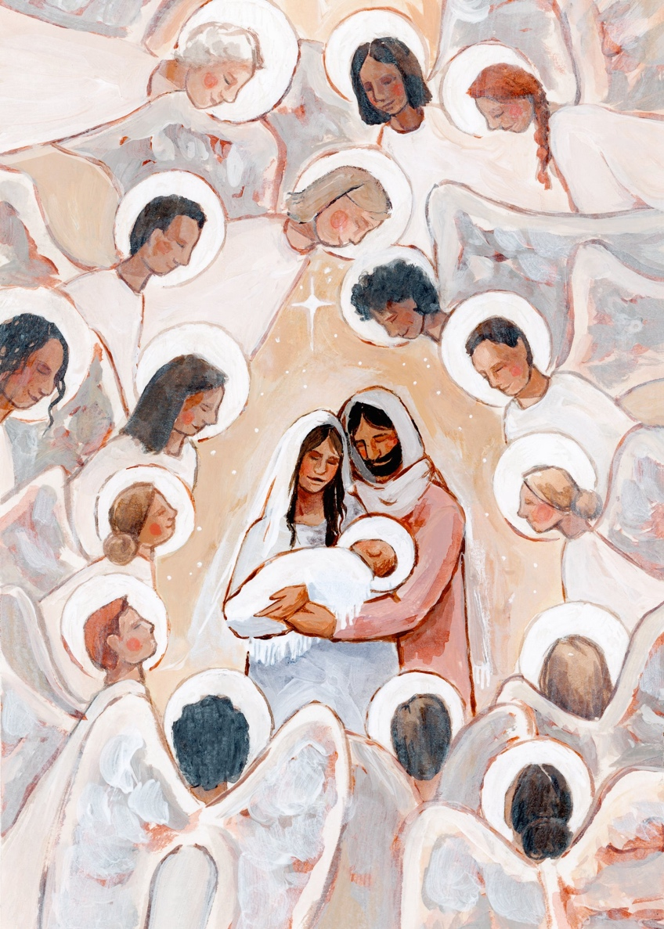
Sing God’s praise through all creation
Sleep, Sleep, Sleep

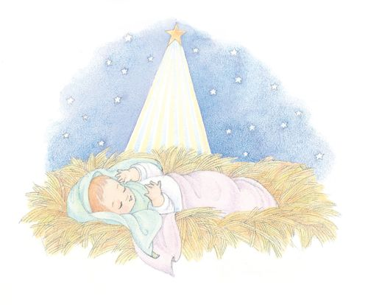

See the blessed baby sleep

Love, Love, Love

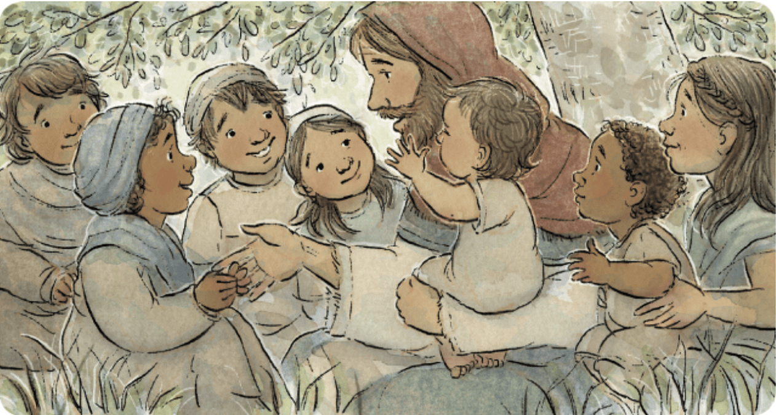

Oh, how great the Father’s love
He sent His Son, so meek and lowly
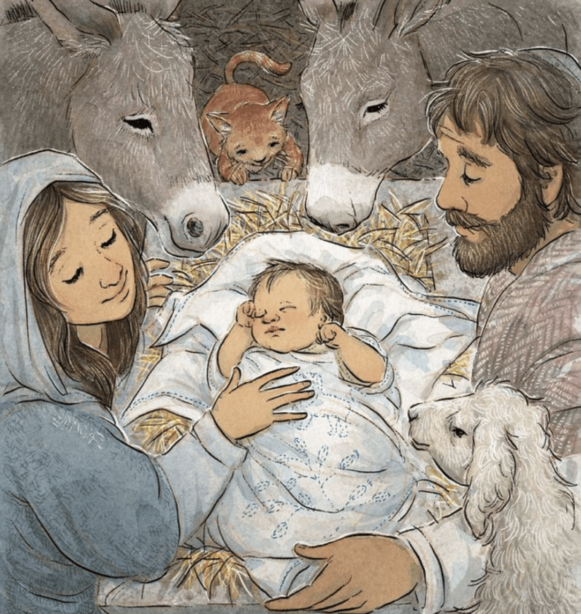
That through Him we may be holy
Love, Love, Love

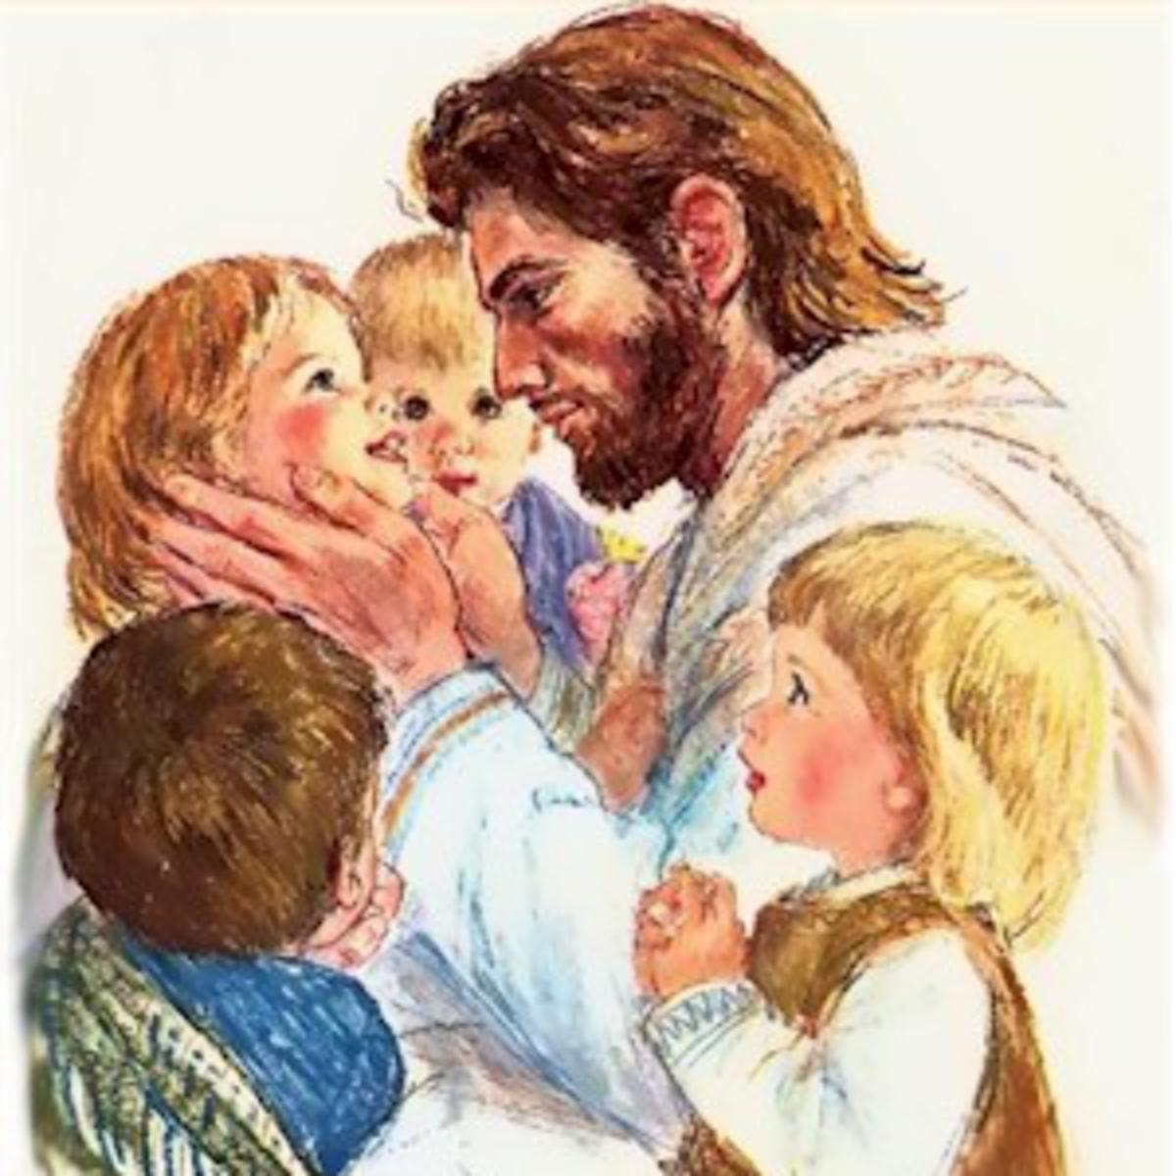

Oh how great the Father’s love

