Starlight

Music by Monica Scott
Lyrics by
Kyle and Monica Scott

If I was a shepherd
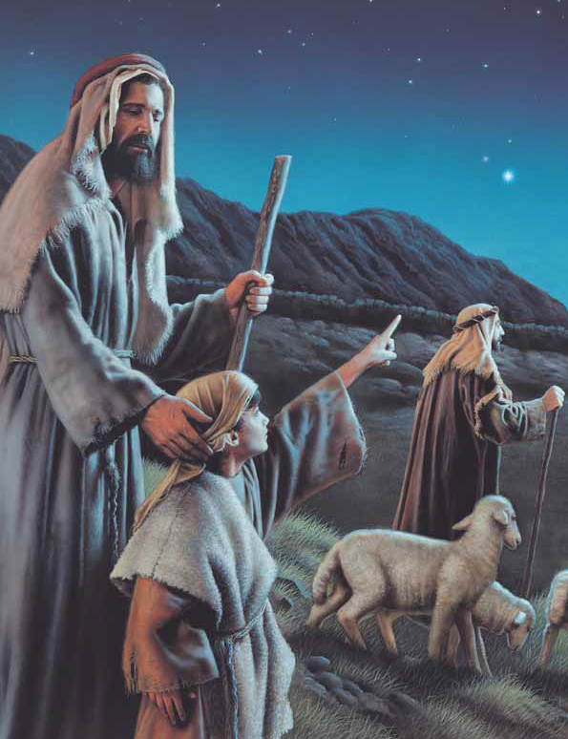
On that night long ago
When the new star appeared
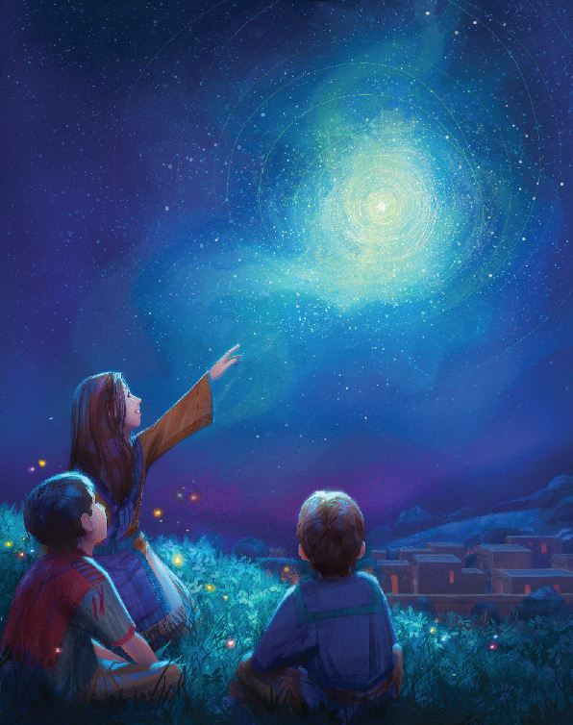
And started to glow
I would follow that star
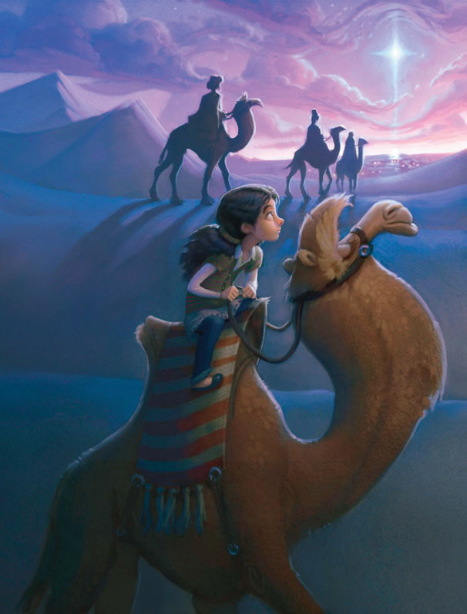
That would never grow dim
I would follow that star
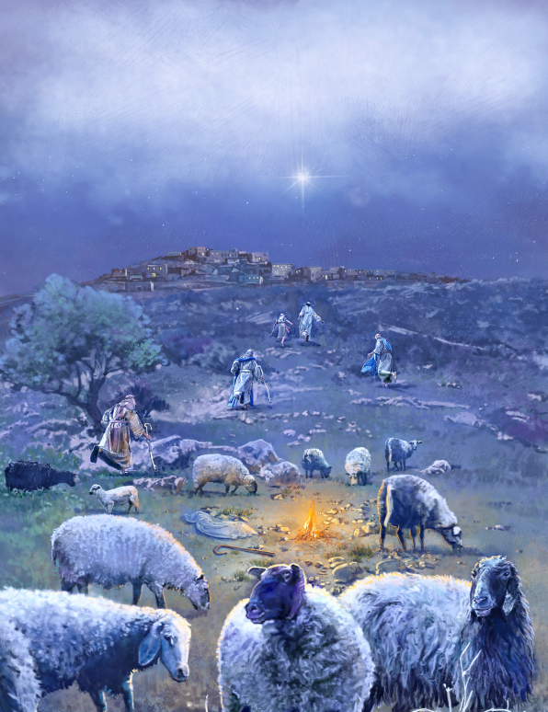
It would lead me to Him
Starlight shining bright
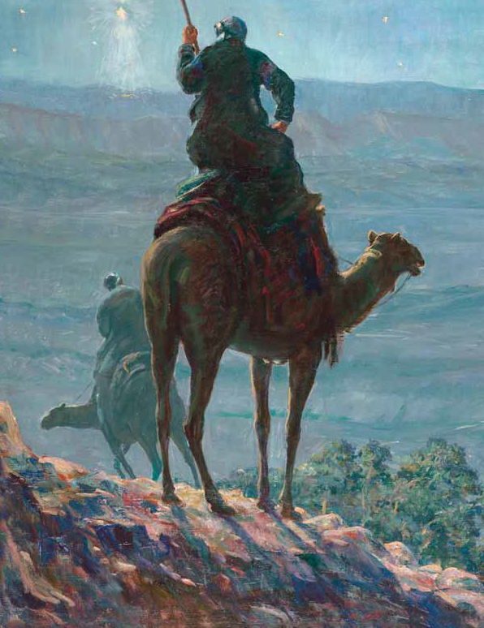
Lighting my way
His light shining bright
Forever will stay
I’ll be like that shepherd
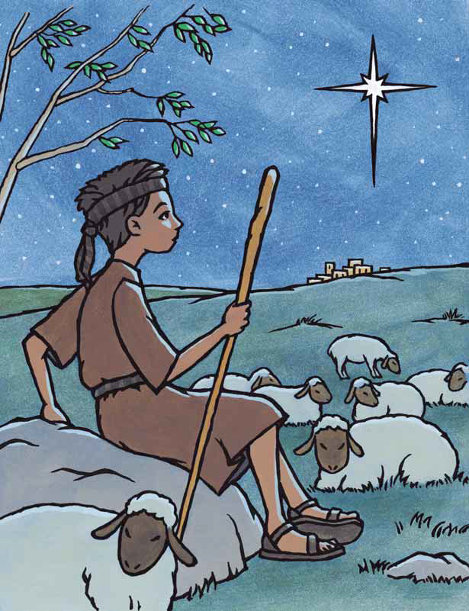
On that night long ago
Who trusted the light
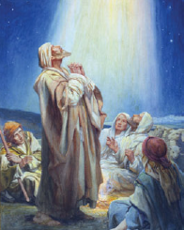
And decided to go
I will follow His light
that will never grow dim
I will follow His light
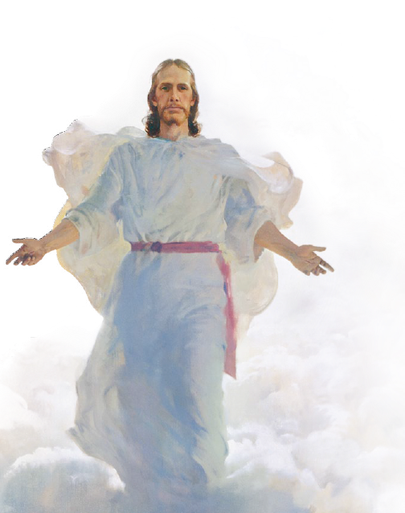
That will lead me to Him
Starlight shining bright
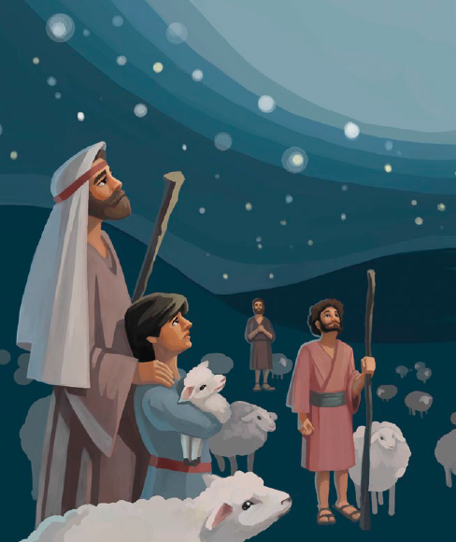
Lighting my way
His light shining bright
Forever will stay
Starlight shining bright
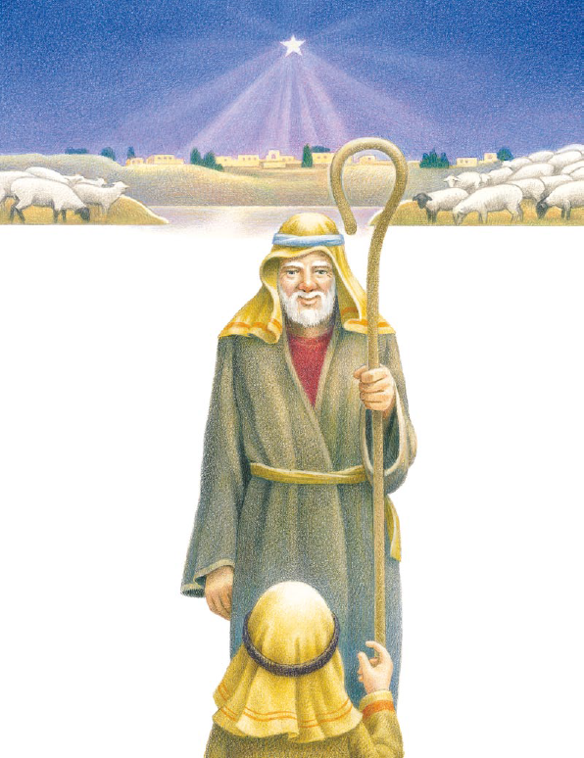
Lighting my way
His light shining bright
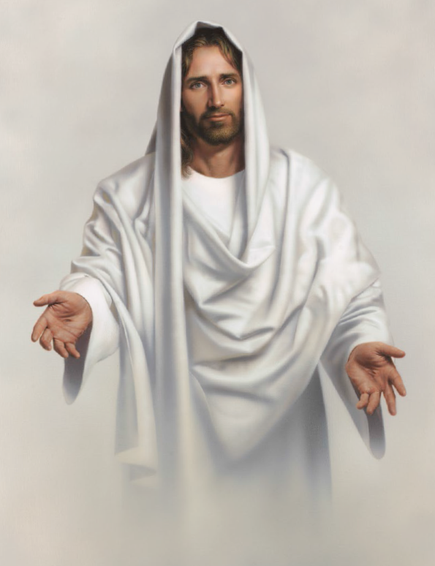
Forever will stay

