The heavens with light o’erflowing
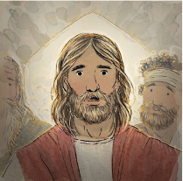
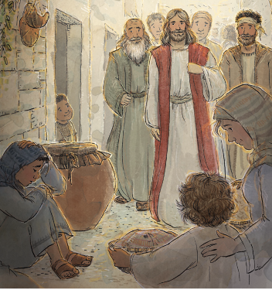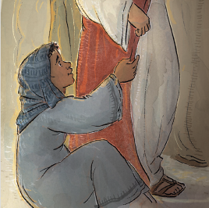
A story of love will tell
A new star will shine in glory
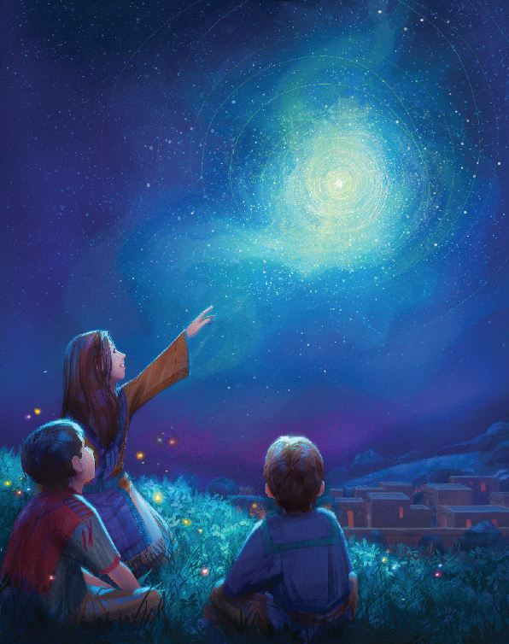
When Jesus comes on earth to dwell
O star bright, the world is pining
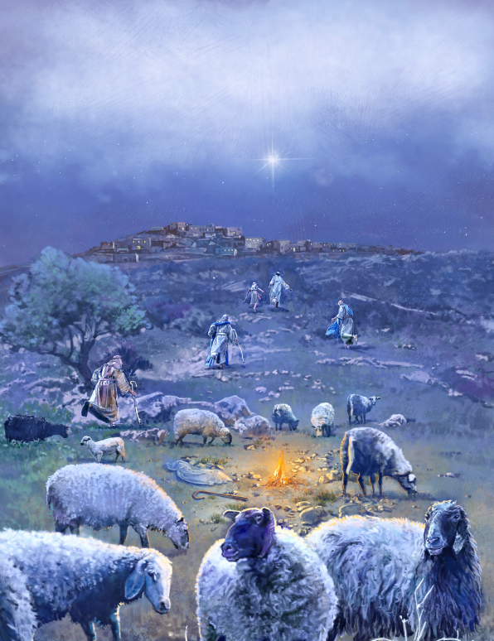
For you to turn night into the day
O star bright in heaven shining
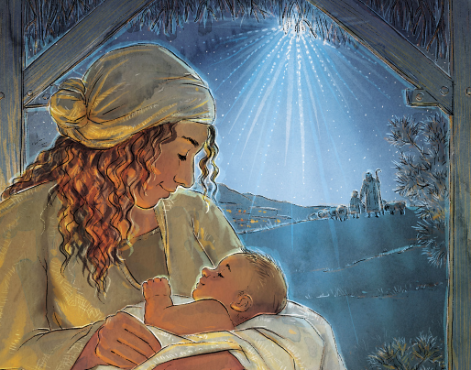
Come, glow within me on Christmas Day
Be joyful with eyes upturning
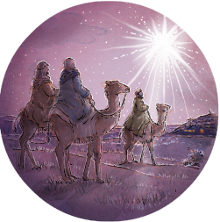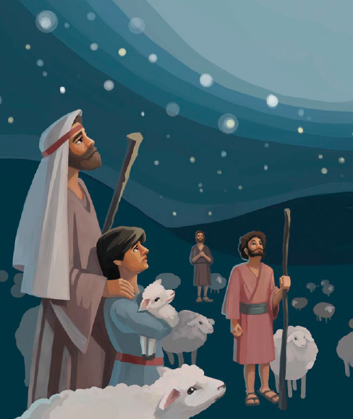
Beholding the time at hand
The night sign will soon be burning
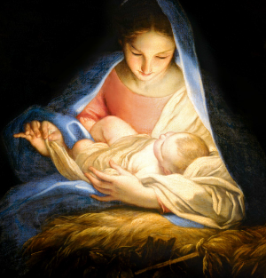
He’s coming to our promised land
O star bright, the world is pining
For you to turn night into the day
O star bright in heaven shining
Come, glow within me on Christmas Day
Our Father with love is sending
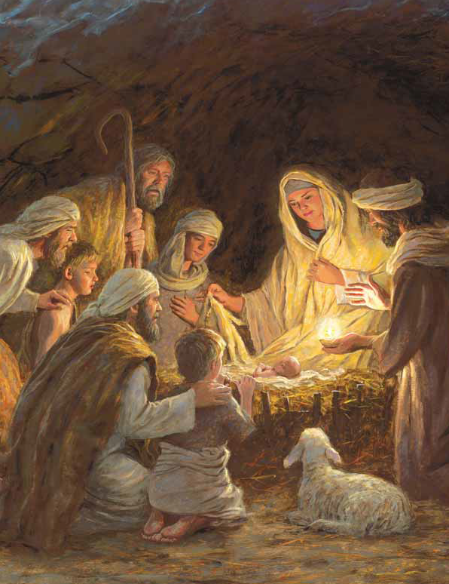
The Christ child to conquer strife
His mercy to all extending
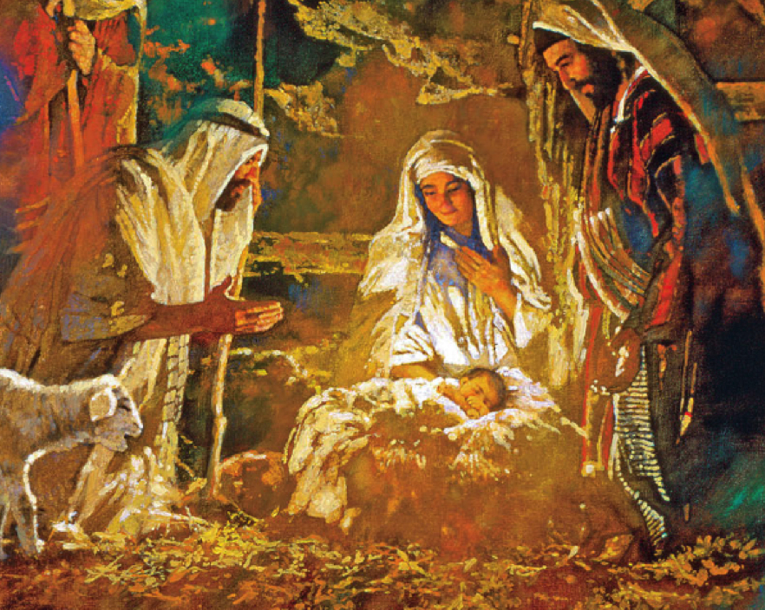
He’s bringing everlasting life
O star bright, the world is pining
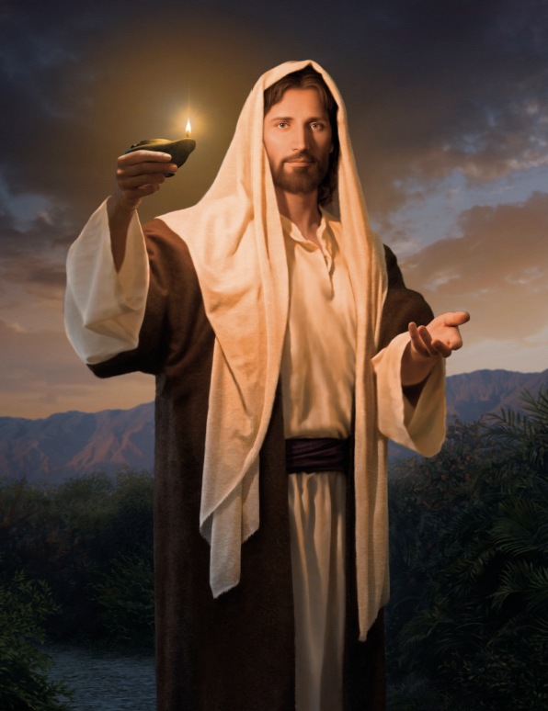
For you to turn night into the day
O star bright in heaven shining
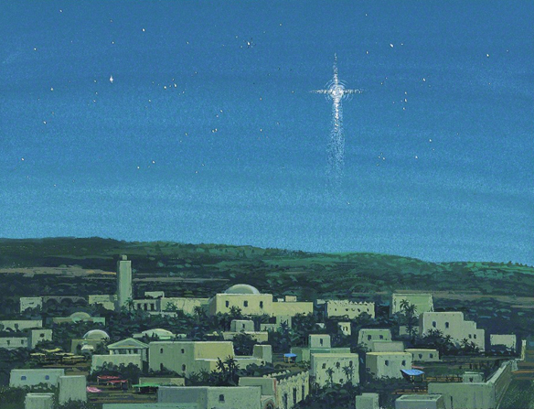
Come, glow within me on Christmas Day

