Our prophet has some words for you

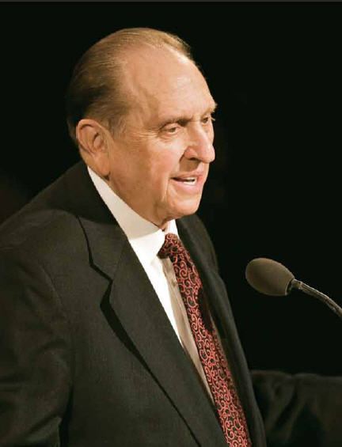

And these are the words:

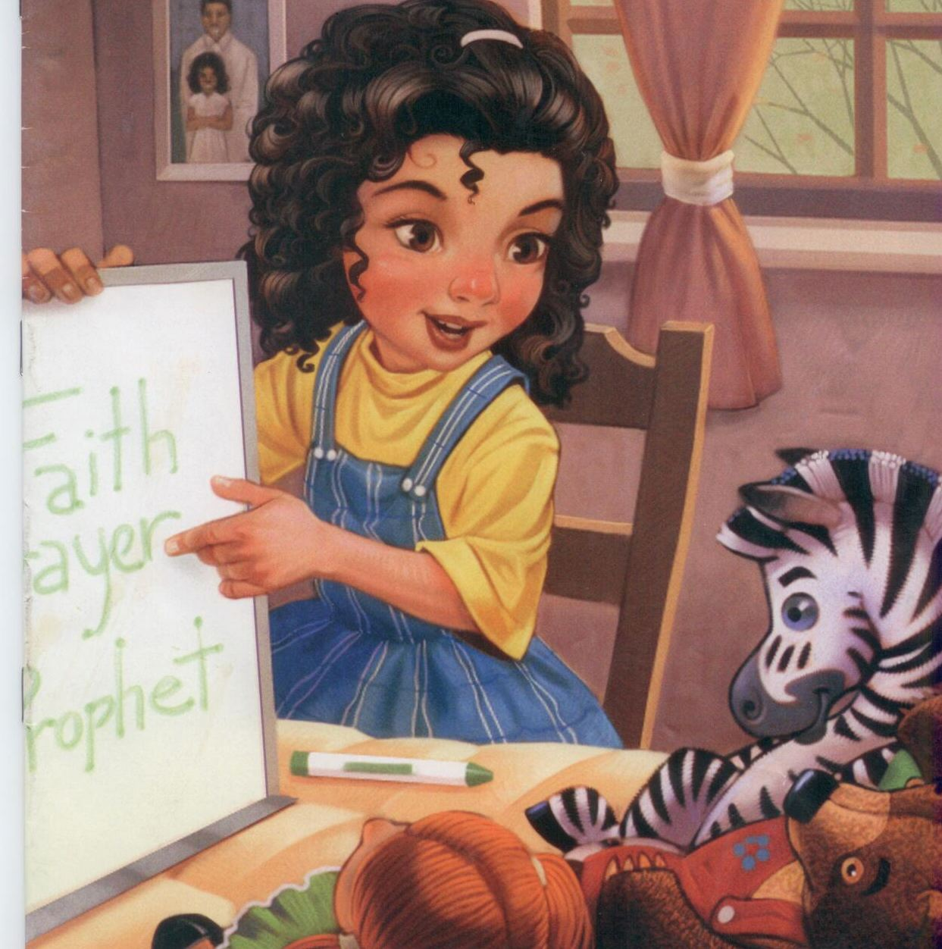

“Be True, be true.”

At work or at play



In darkness or light

Be true, be true,



And stand for the right

The Lord needs valiant servants



To do His work in the latter day

 Who follow the teachings of Jesus



And serve His people in a loving way

 I will be His servant



And keep my cov'nants valiantly

I'll stand for truth



I'll stand for right

The Lord can depend on me

