Sleep the Holy child
Thy manger bed
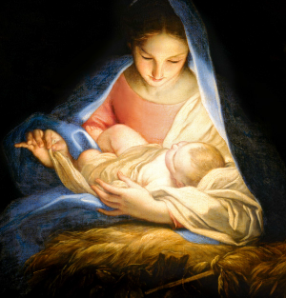
Holds Heaven’s King
Sleep the Holy child awaiting
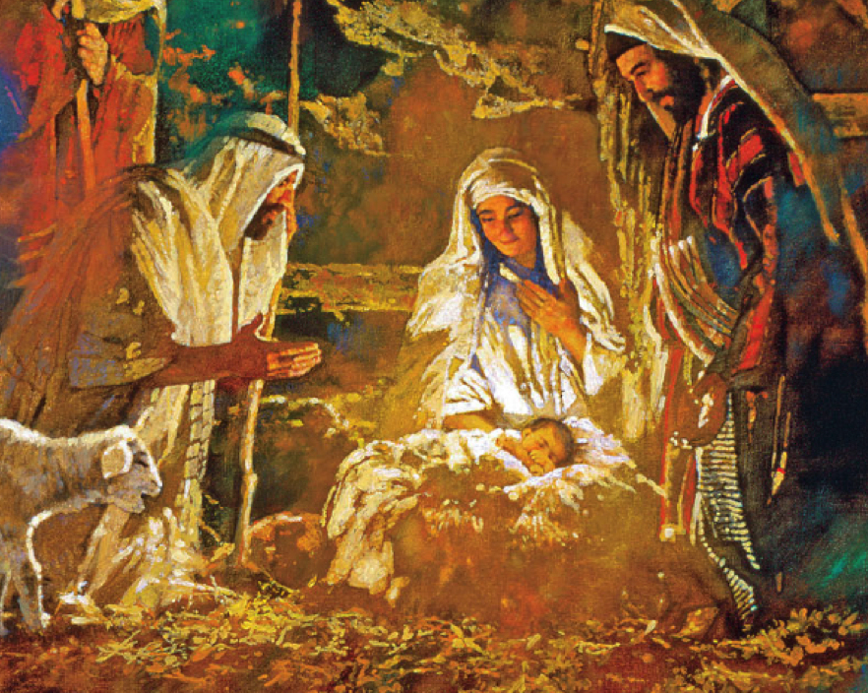
Thy peace to bring
We saw His star
Shining o’er the plains
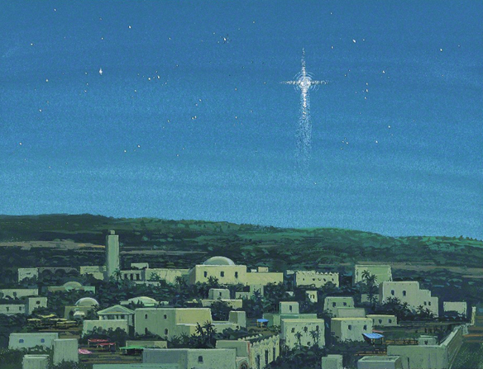
Trav’ling far to give these gifts
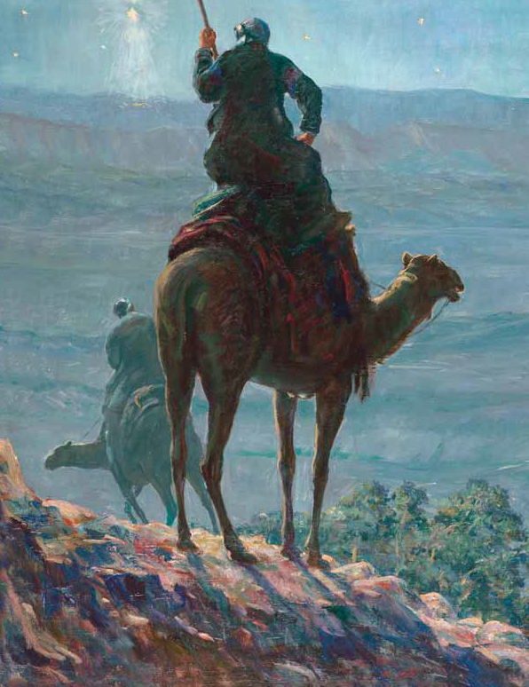
In our hearts He reigns
So spake the wise men three
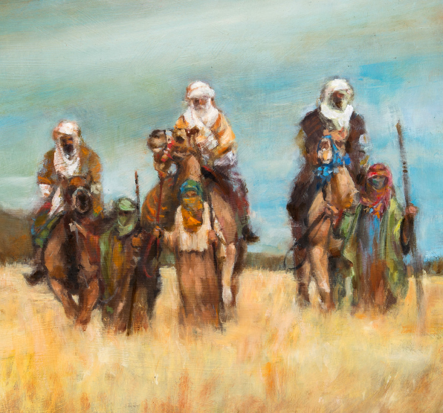
A gift of gold to see
Frankincense and Myrrh
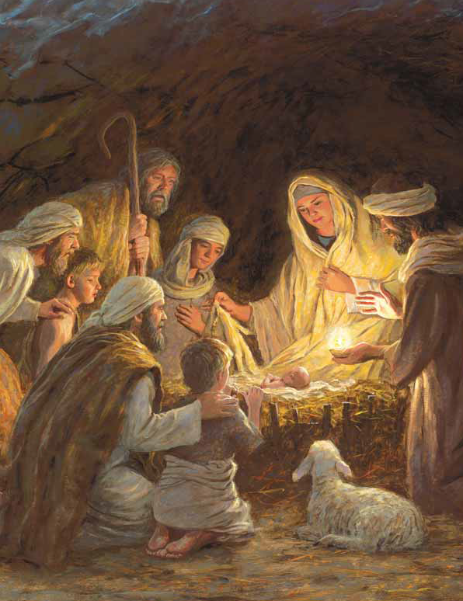
All priceless gifts for Him
Sleep the Prince of Peace
