Shine
By Angie Killian

Sheet Music
Available at
https://www.angiekillian.com

When staring at the starry sky
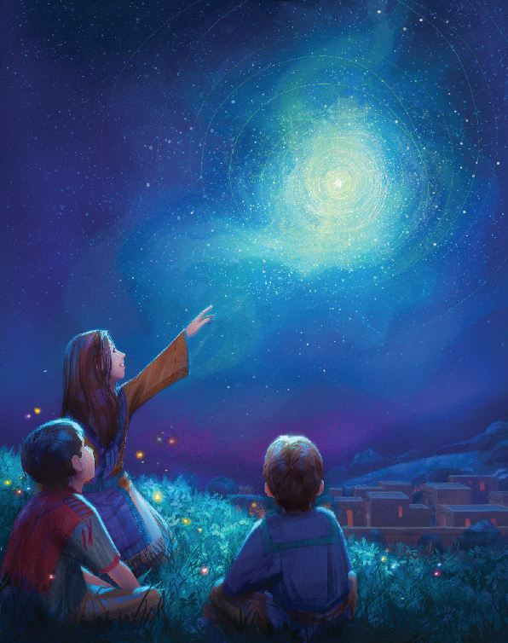
That winks and blinks within the night
I wonder if I see the light
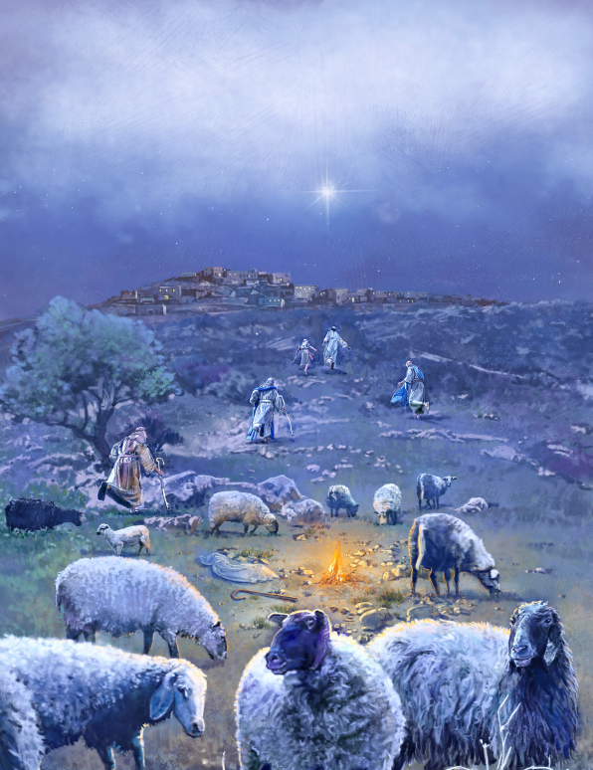
That marked the Savior’s birth
That light once led the wisest men
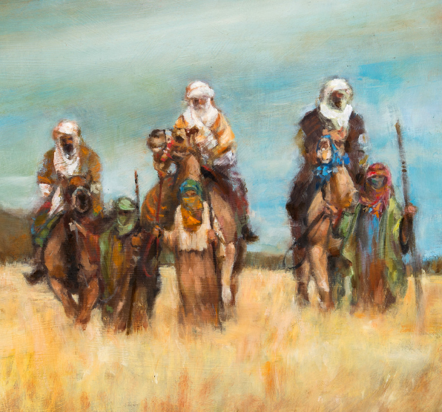
To find the Babe of Bethlehem
Does it still shine as it did then
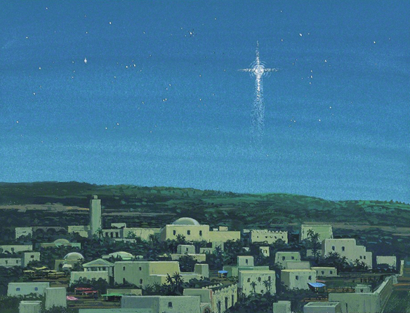
An emblem to the earth?
Alleluia! Alleluia! Alleluia!
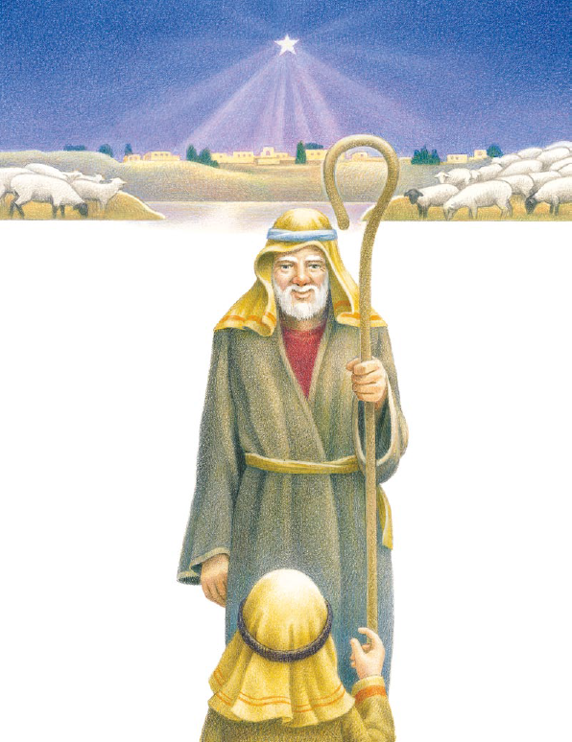
Shine for all the world!
The Baby born so long ago
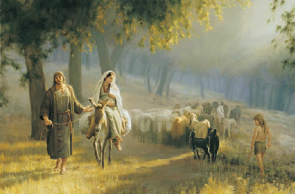
Who dreamed beneath that brilliant glow
Was sent to earth so all could know
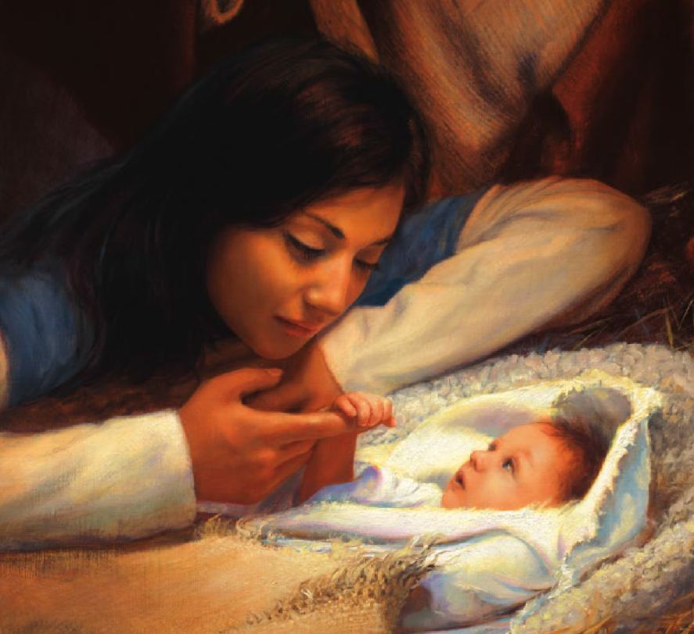
The source of love and hope
Yes, Jesus is the guiding light
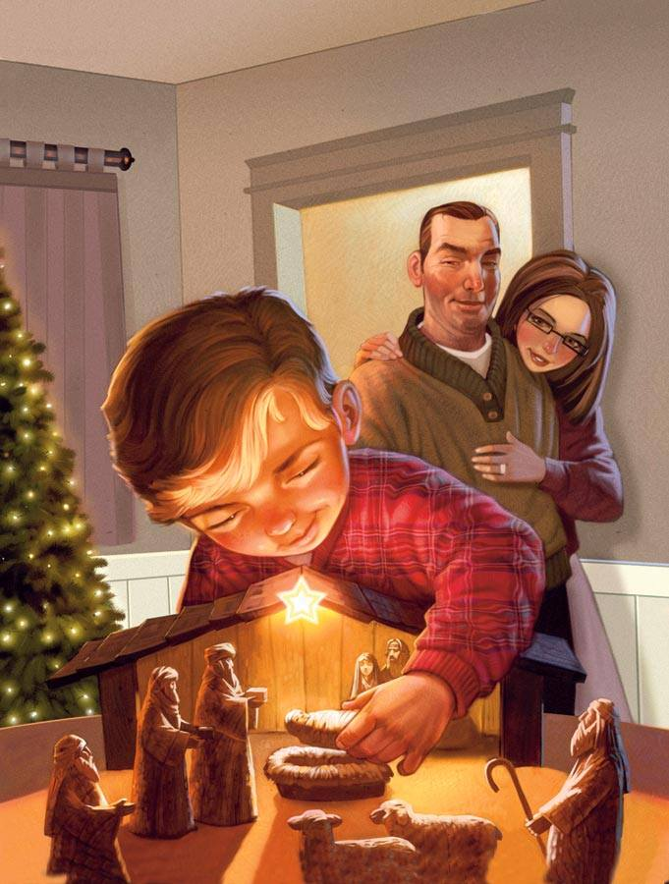
The star that leads through darkest night
He shines for us, so pure and bright,
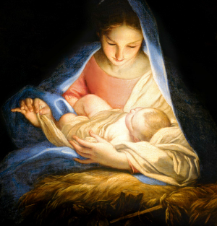
To bring us safely home
Alleluia! Alleluia! Alleluia!
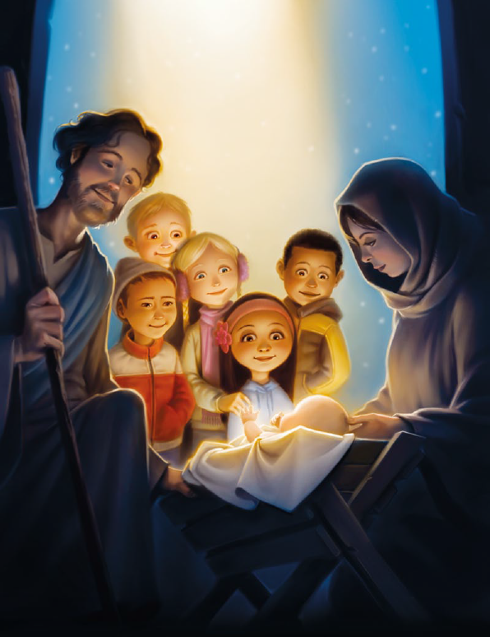
Shine for all the world!
I’ll shine His light,
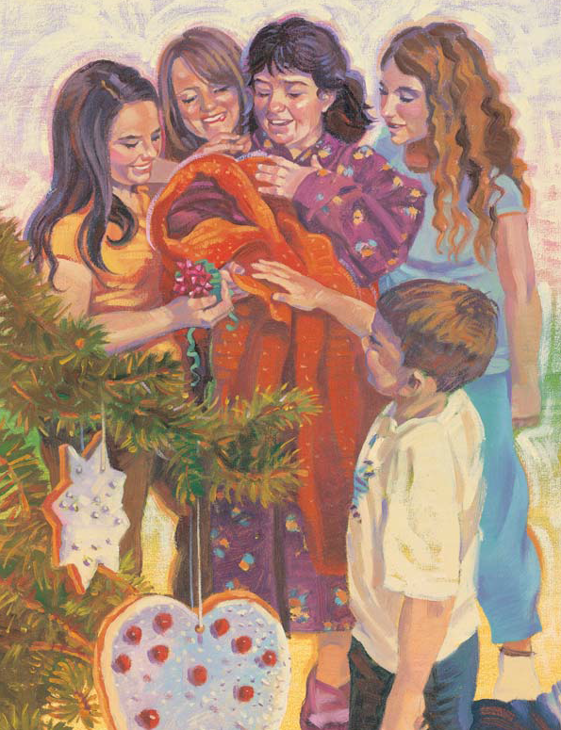
His light that shines in me
(It shines in me)
I’ll shine so bright,
so all the world can see
(I’ll shine so all can see)

I’ll shine His light,
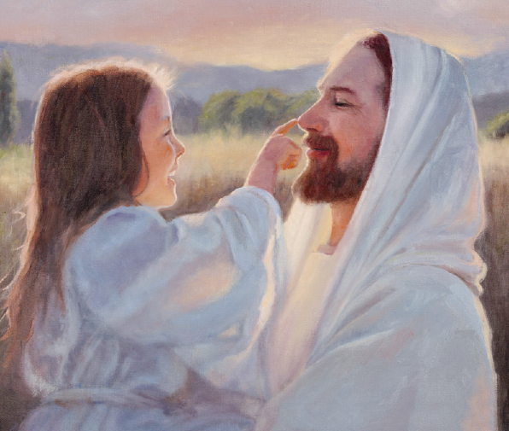
His light that shines in me
(I’ll shine His light; it shines in me)
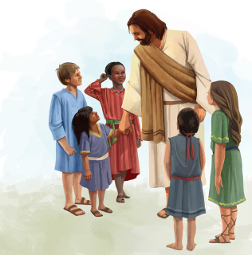

I’ll shine so bright,
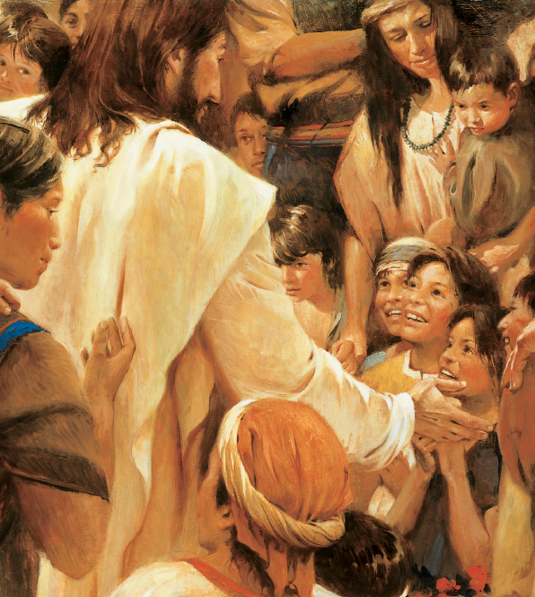
so all the world can see Him
(I’ll shine so all can see Him)
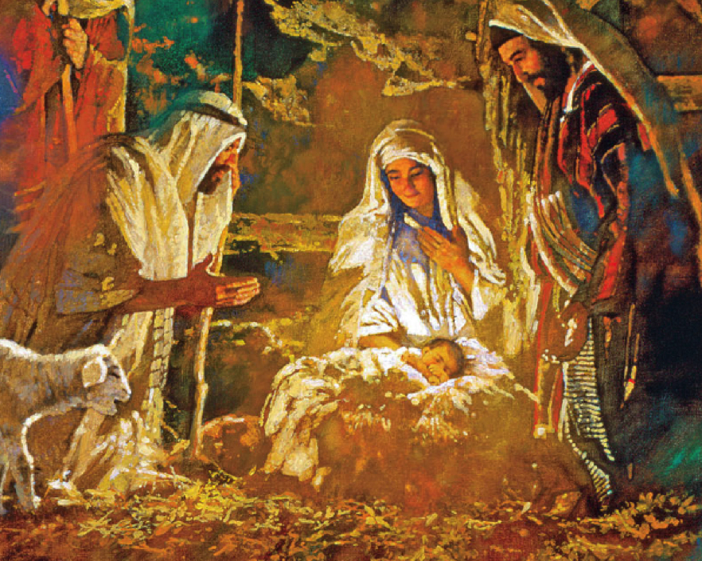

Alleluia! Alleluia! Alleluia!
Shine for all!
Alleluia! Alleluia! Alleluia!
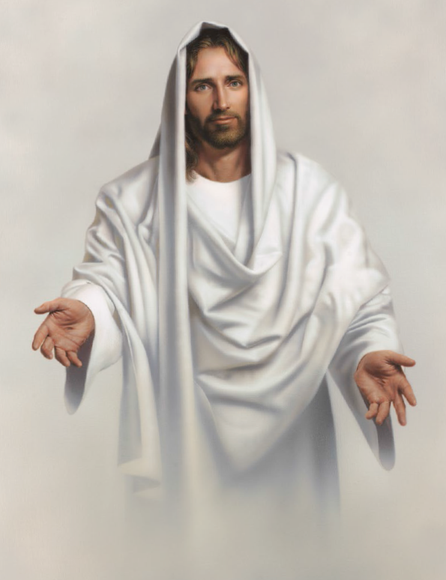
Shine for all the world!
Shine

