She Put the Music in Me
By
Calee Reed

Purchase Sheet Music at DeseretBook.com

It started with rock-a-bye
Comforting when I'd cry
All in her own style
Then popcorn before my eyes
Turning frowns upside down
Into smiles
With songs of the birds up high
Looking at the blue blue skies
The wind as it rushes by
Then leading me, guiding me,
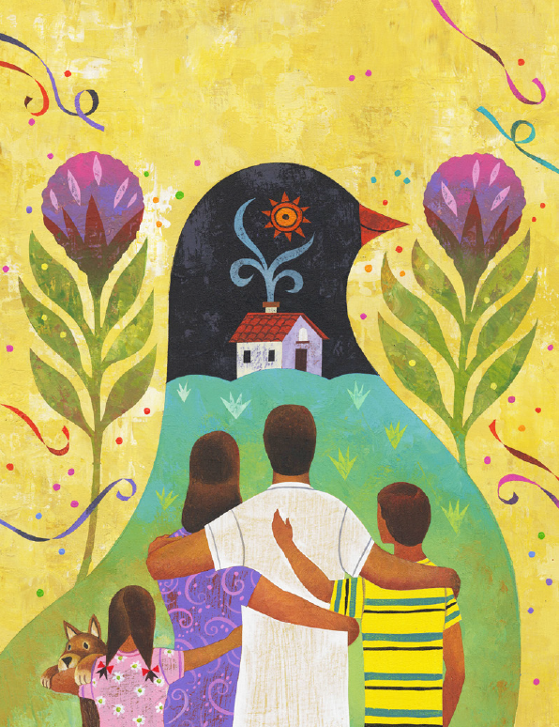
Walking beside me

She helped me
To walk in the light
And she built my house on a rock
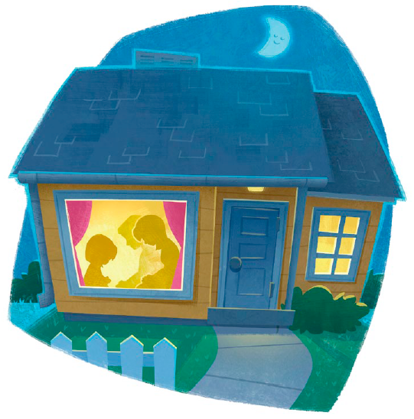
And she lives all that she taught
And she is all that a woman should be
She put the music in me
I knew He was really there
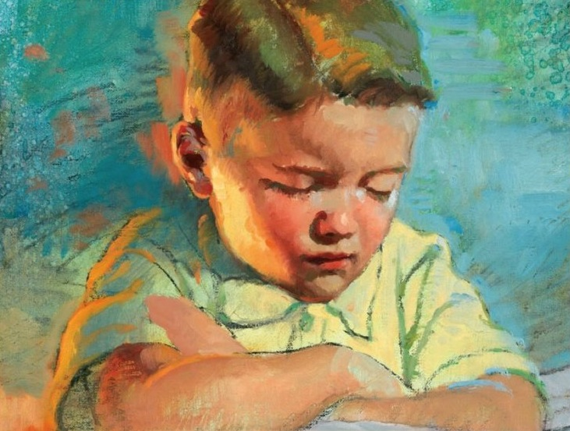
He heard my child's prayer
Answering from up above
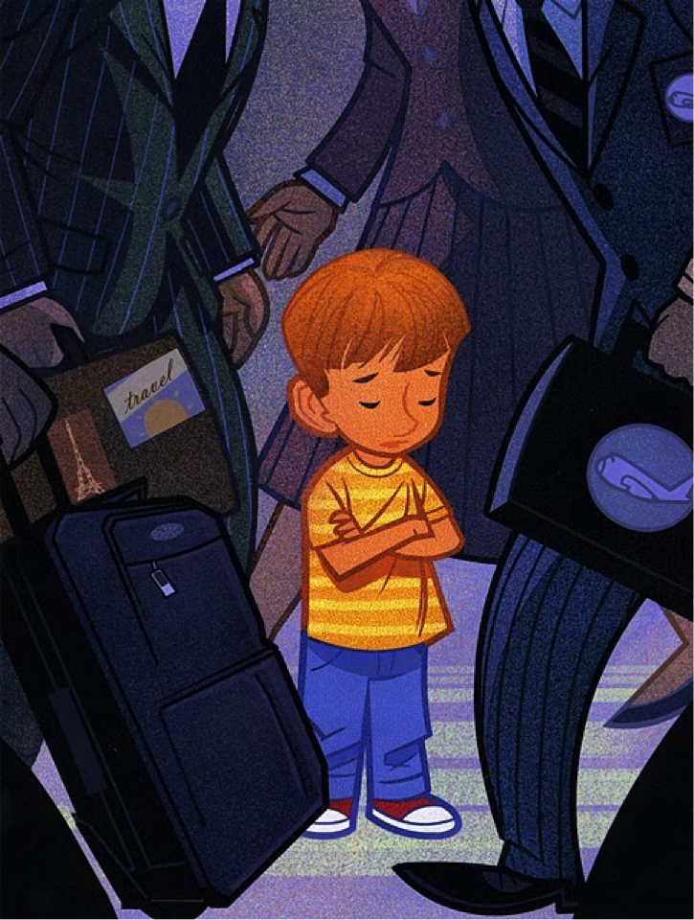
She gave like a little stream
I was her sunbeam
And I felt my Savior's love

I saw her kneel and pray with our fam'ly ev'ry day
List'ning to each whispered word
Gentle in deed and thought
All the things Jesus taught
Following promptings she heard
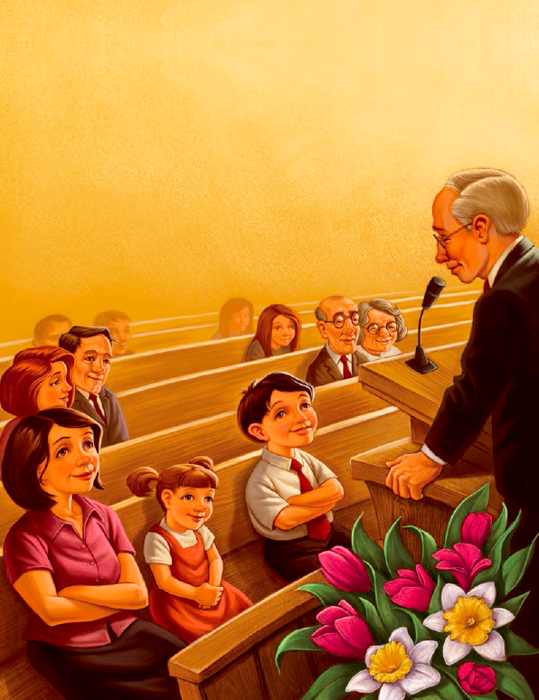
And she lives to search, ponder, pray
And she gives everyday
So her thanks will always be
Thanks indeed
She put the music in
She made the tiny wings
Of each little bird that sings
In the leafy treetops up high
And all creatures great and small
I know God made them all
Because of her sweet lullaby
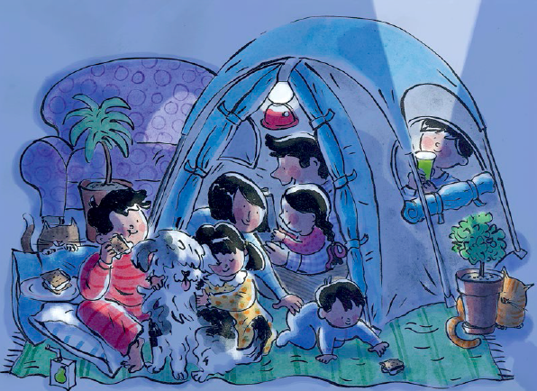
She's like a star shining bright
And helps me to choose the right
And she gives me the hope of a life
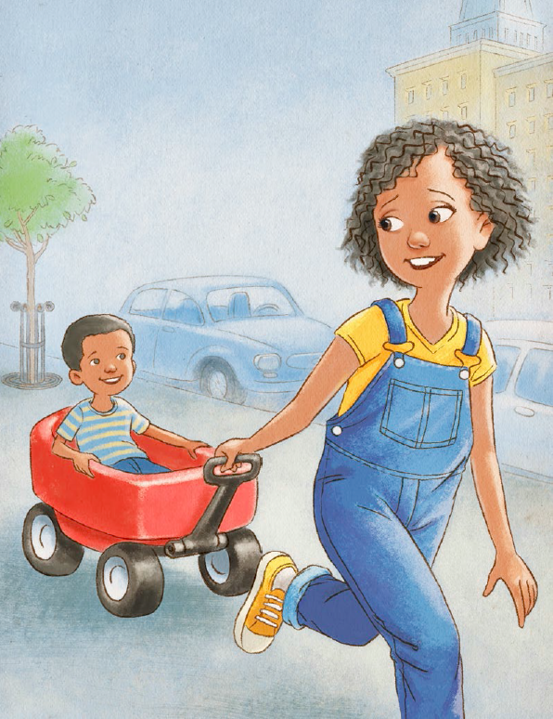
Yet to be
She put the music in

She is so good to me
Heav'nly Father sent her to me
And she taught me to lift up my voice
And sing
She put the music in me

