I will be honest, true, chaste
And benevolent
I will do good to all men
I will serve family, friends
And God’s children
And live with my Savior again
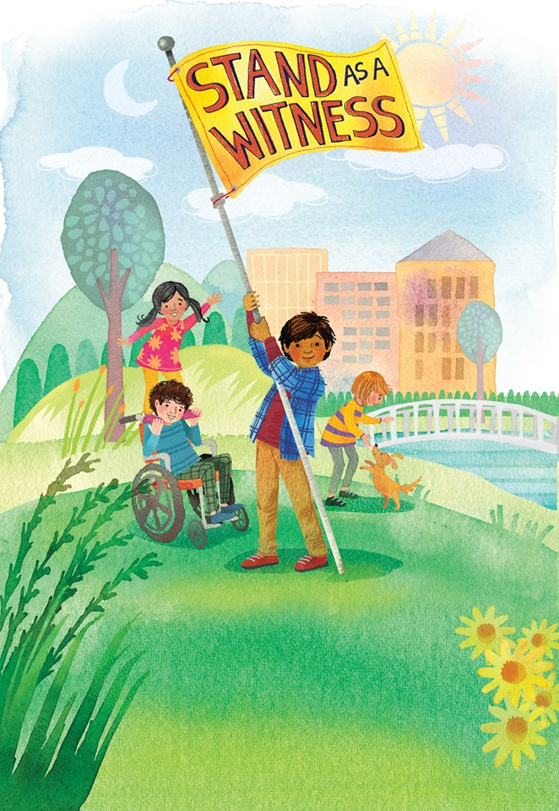
Keeping my covenants
True to my faith
I feel all of the joy
That righteousness brings

If there is anything virtuous, lovely
Of good report and worthy of praise
I will seek after the beauty, the radiant
I will seek after these things!

