SAVIOR

By Melanie & Roger Hoffman

Sheet Music Available
at
www.HoffmanHouse.com

In my wilderness
I’m not comfortless
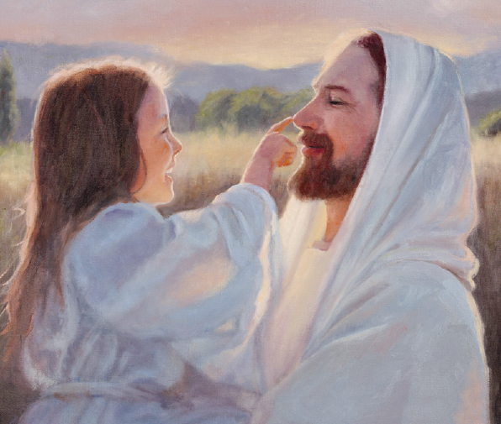
He is there
Savior
Holy Counselor
Friend and Rescuer
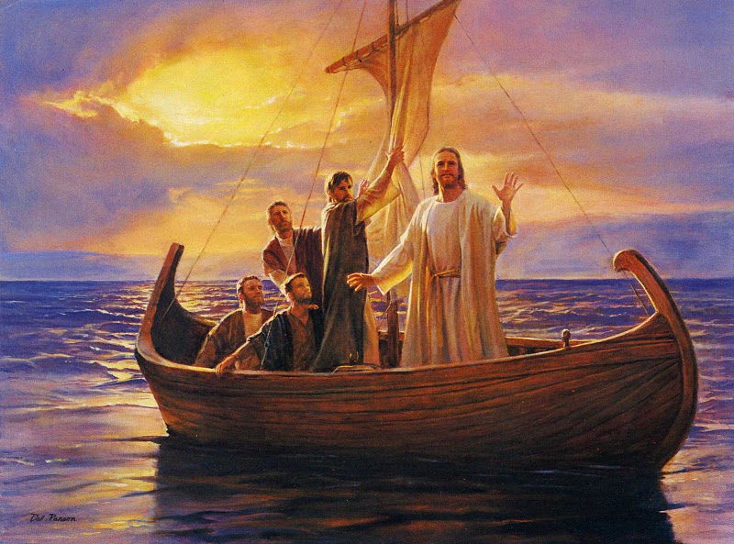
He is Hope
Savior. Savior.
In forgiveness
He is wond’rous
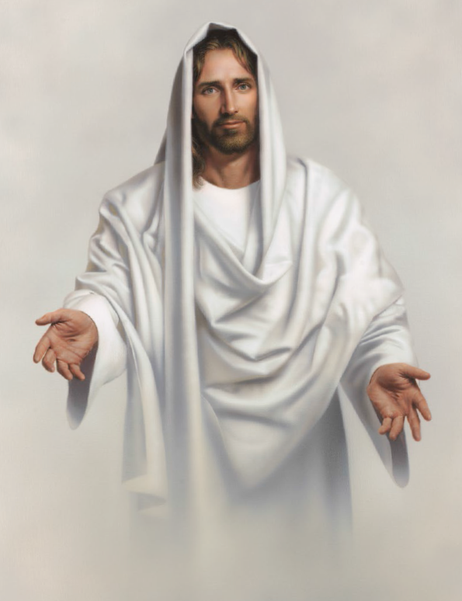
He is love
Savior
He will hear me,
Comfort, cheer me
Loves me dearly
Savior. Savior.
And I’ll praise Him evermore
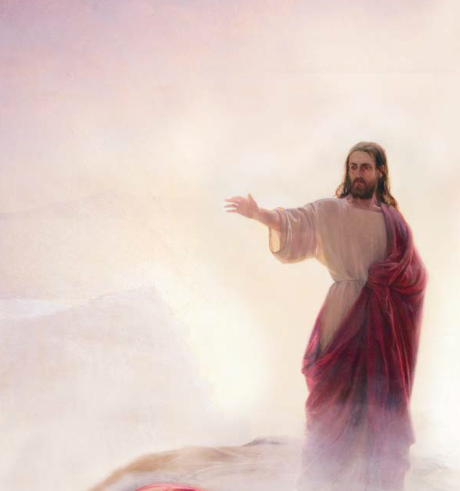
He opened Heaven’s door
Give my heart to Him
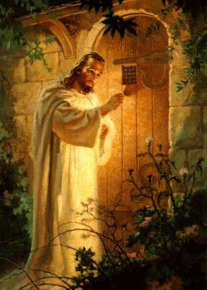
He let me in
In His kindness
He is gladness
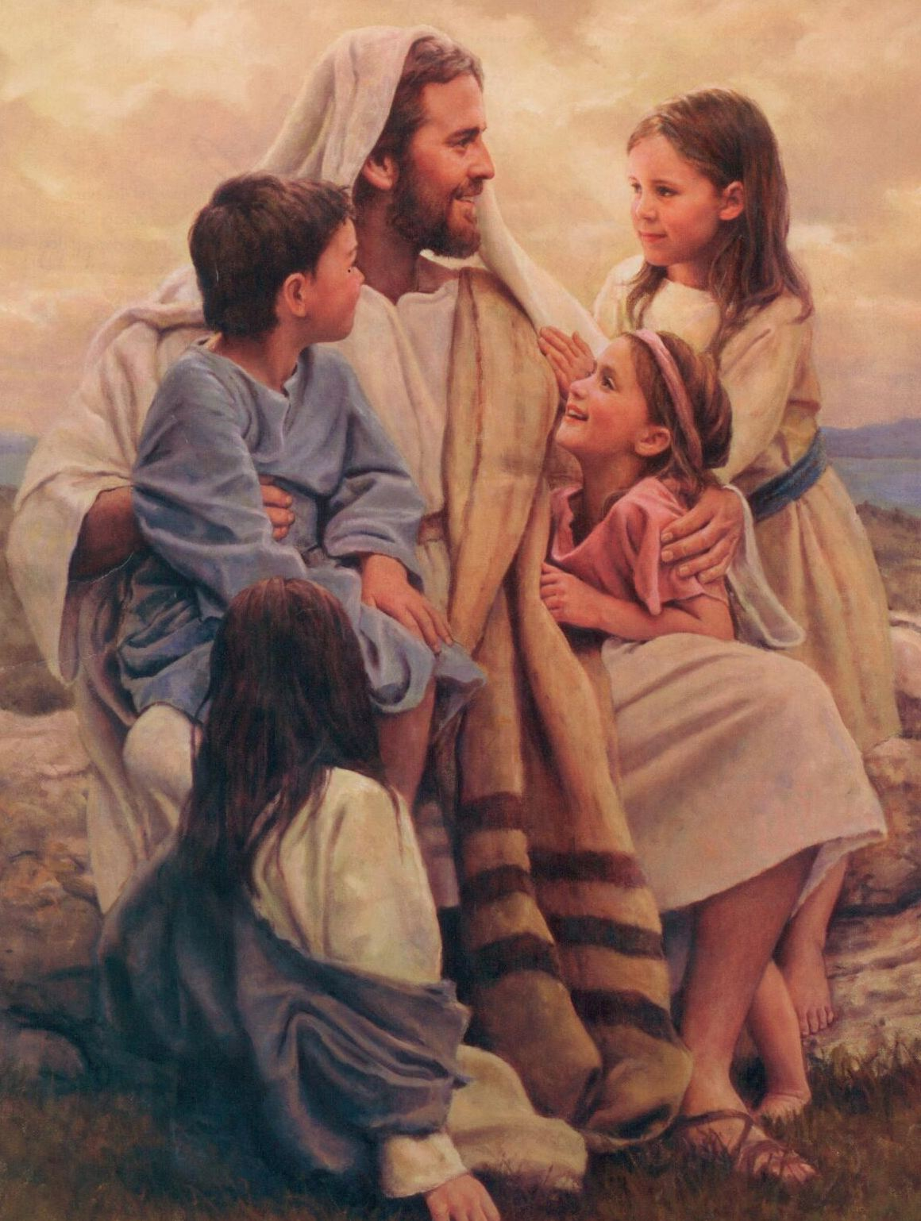
He is joy
Savior
Gave His life for me
Paid the price for me
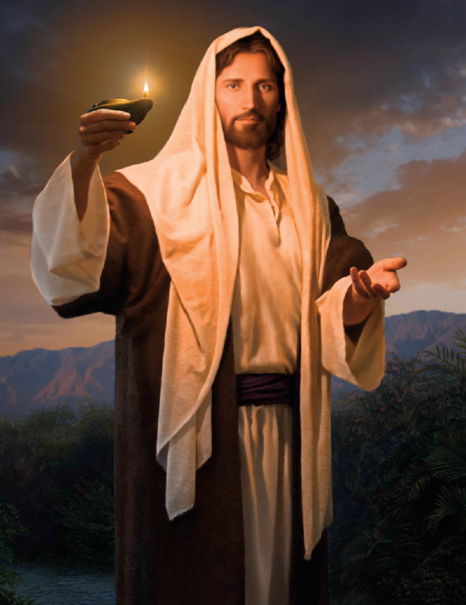
He is my
Savior. Savior
Ooohhhh
Ooohhhh
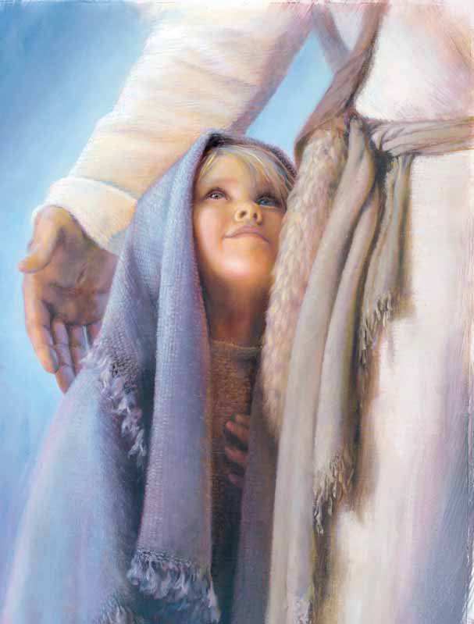
He is my Savior Savior

