Sariah’s Faith

By Monica Scott

www.monicascottmusic.com

Sariah sought the promise
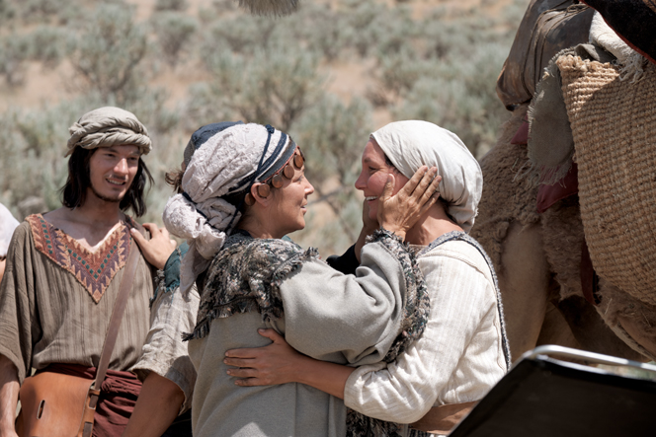
Of an unknown sacred land
Filled with faith and courage
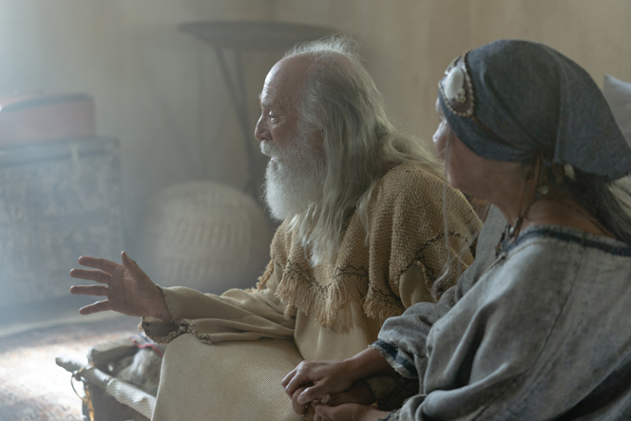
She trusted in God’s plan
Though she did not know
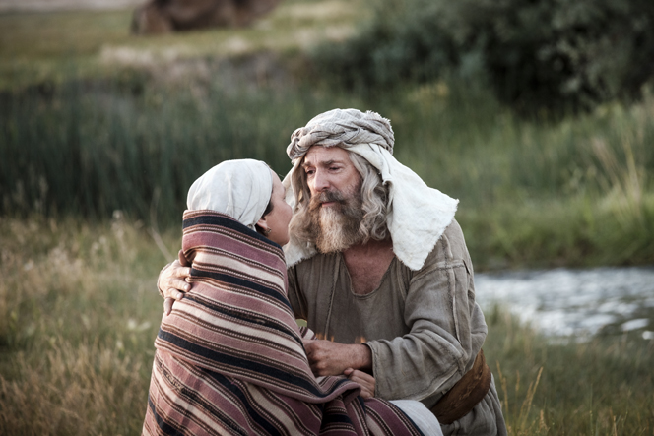
But willing to go

She understood
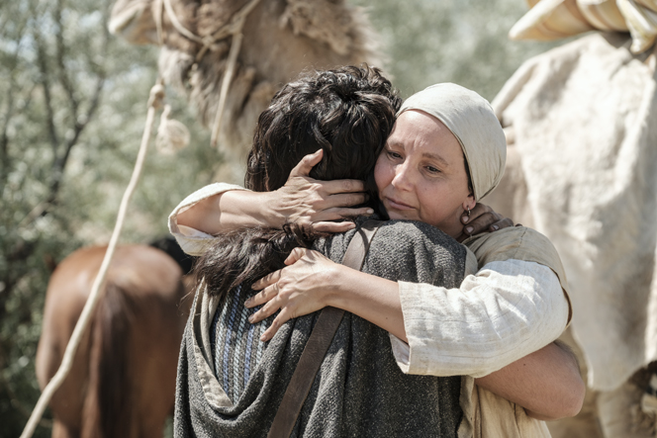
God’s plan for her
With faith in God
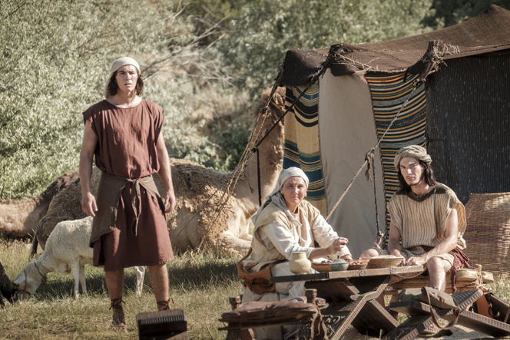
She left her land

With only hope and a plan
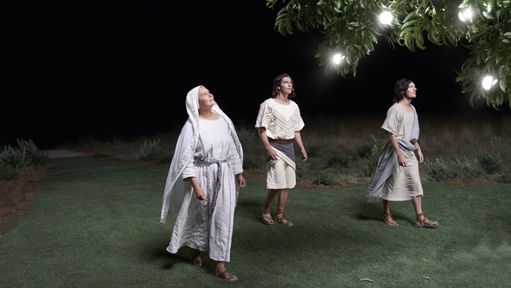

Because she knew
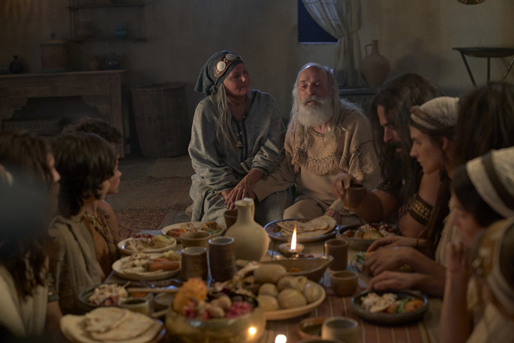
When the Lord Commands
And through her faith
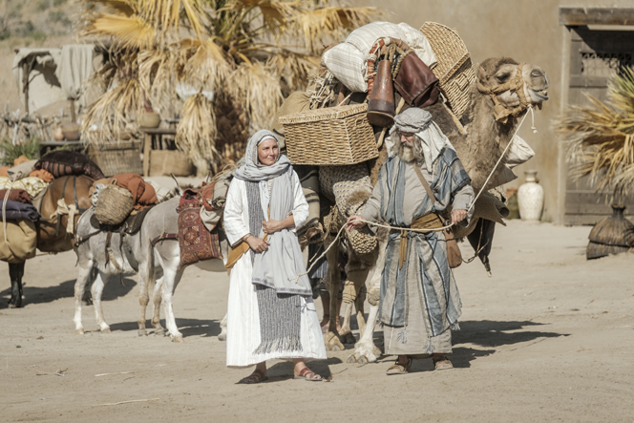
She took a stand
Sariah blessed her children
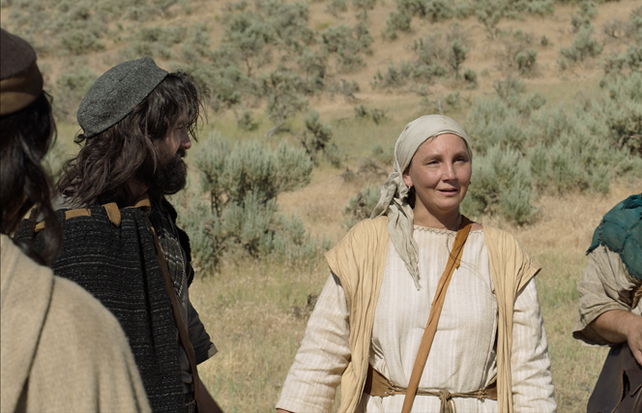
Through water, rain and wild
With a mother’s love
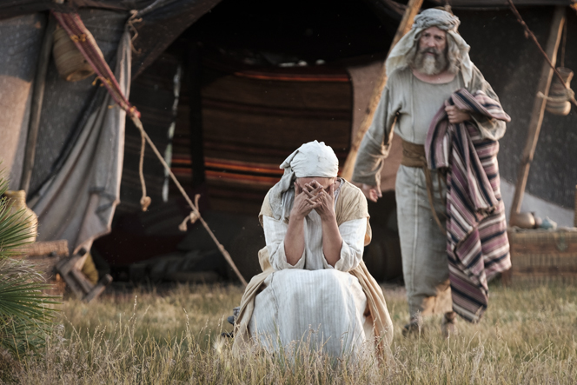
She endured her trial
Though she did not know
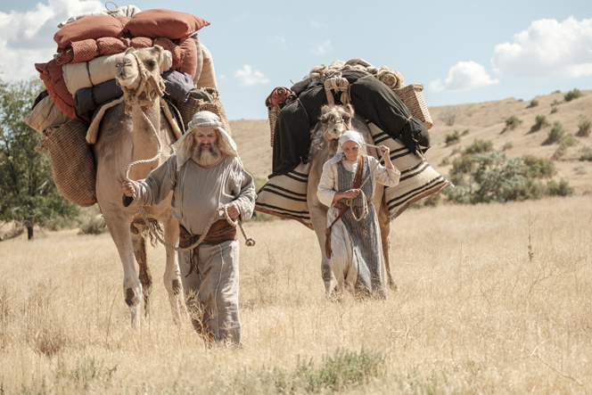
But willing to go
She understood God’s plan for us
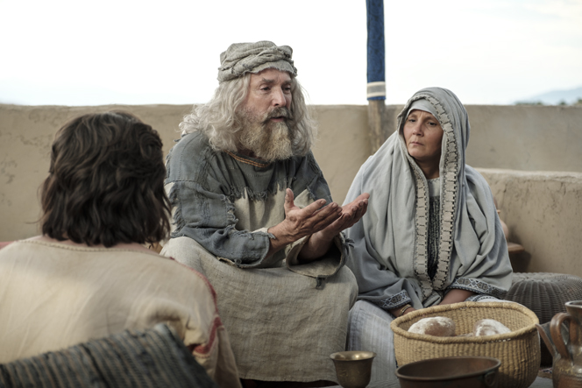

Because I know when the Lord
Commands and through my faith
I’ll take a stand

