Said Samuel within five years
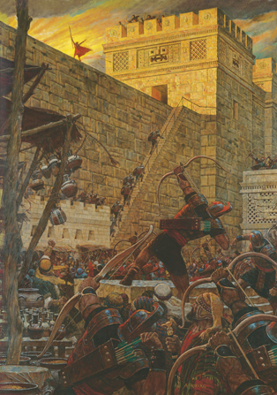
A night will be as day
And Baby Jesus will be born
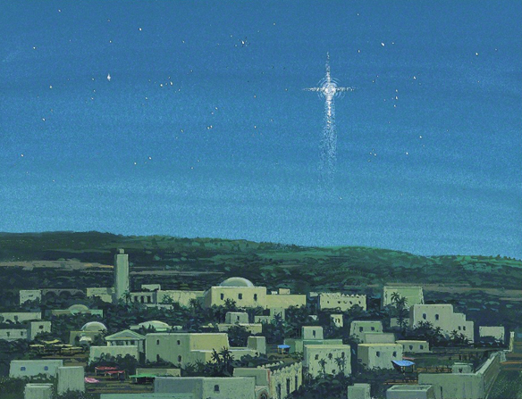
In a land far, far away
Hosanna! Hosanna!
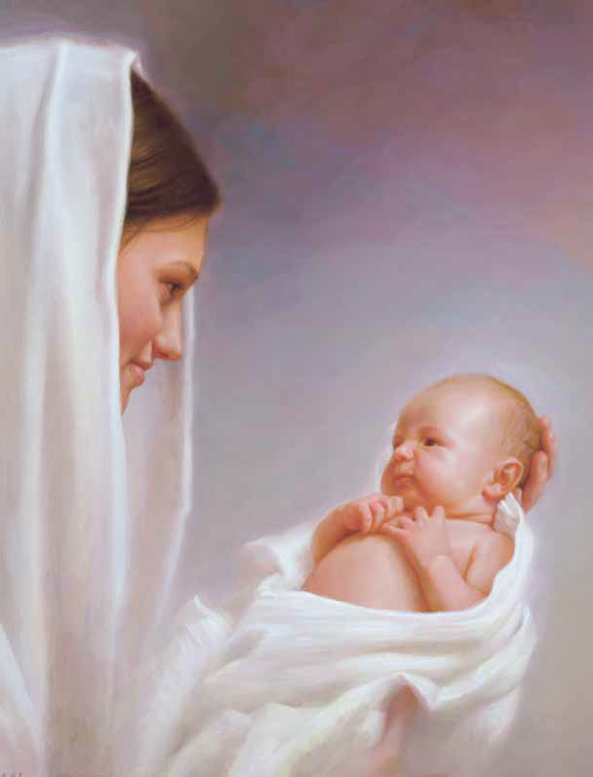
Oh, let us gladly sing
How blessed that our Lord was born
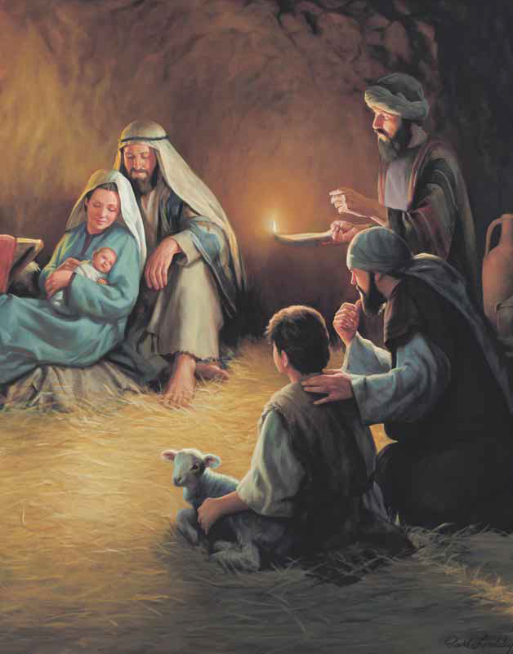
Let earth receive her King!
Across the sea in Bethlehem
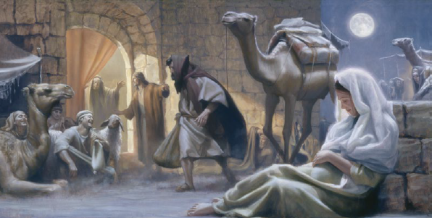
Lord Jesus came to earth
As Samuel had prophesied
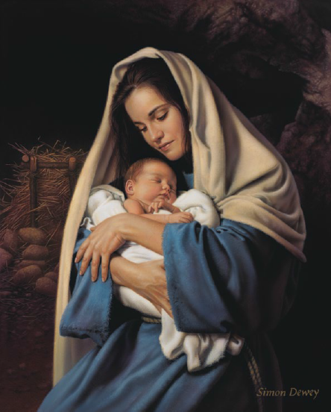
And angels sang His birth

