Prince of Peace-
by
Monica Scott
(Buy the music at monicascottmusic.com)
Peace be still, still still
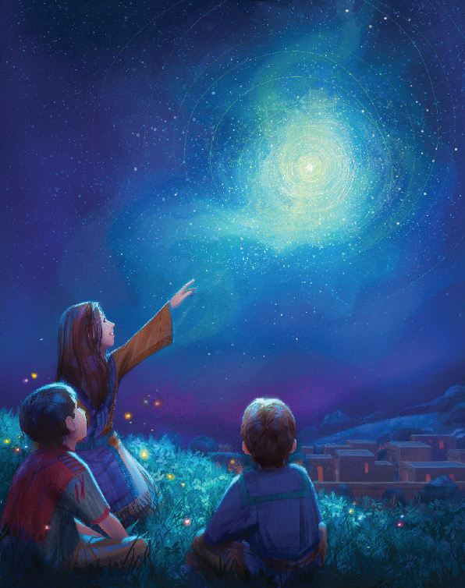
On this night heaven’s light
Allelujah, Allelujah, Allelujah
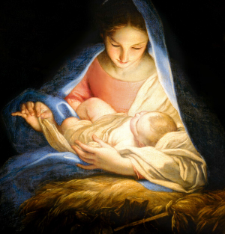

Peace, Peace, Prince of Peace
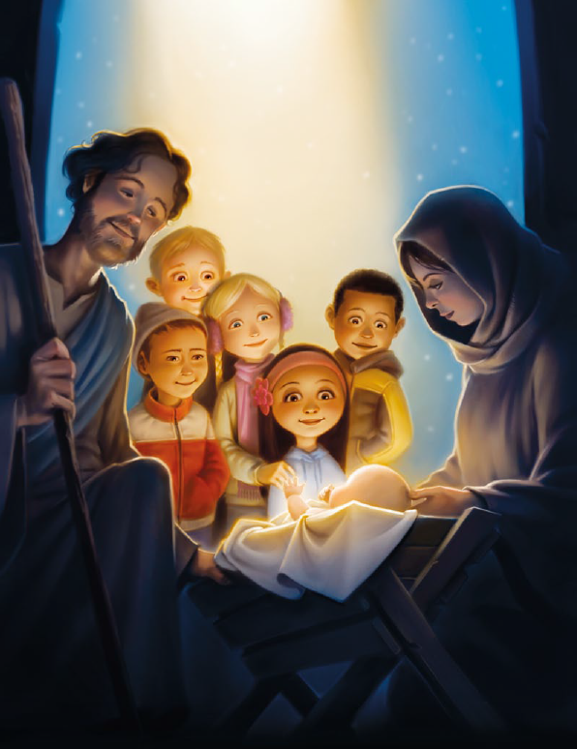
Healer of men
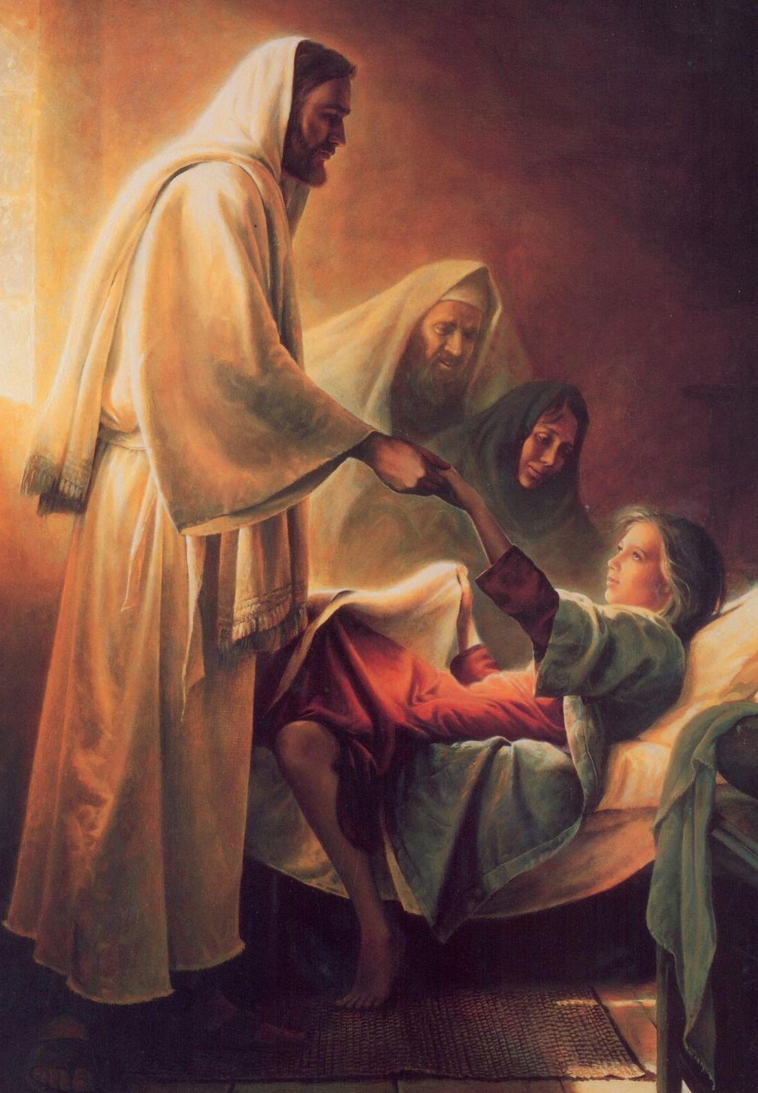
Peace again, Peace
Peace is here, angels near
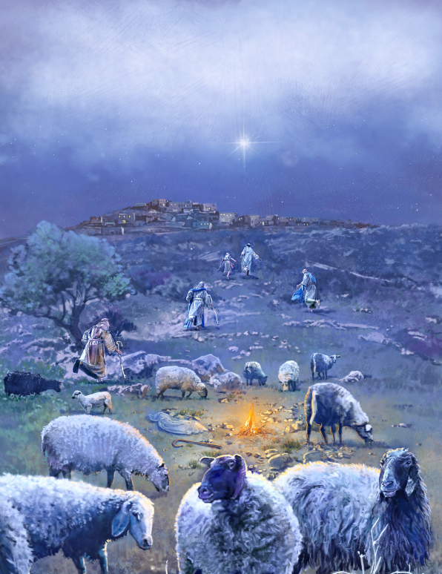
Shepherds meek
wise men seek
Allelujah, Allelujah, Allelujah
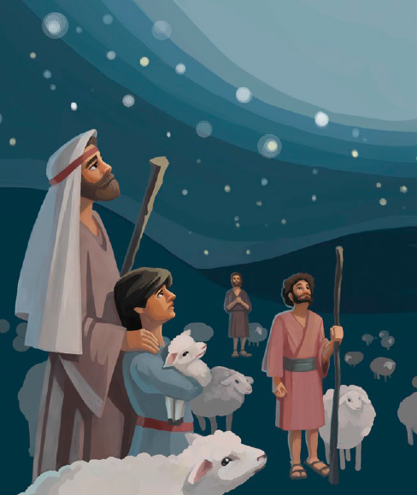
Peace, Peace, Prince of Peace
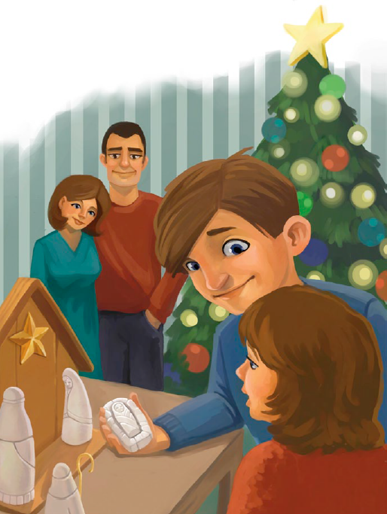
Healer of men
Peace again, Peace
Peace on Earth Savior’s birth
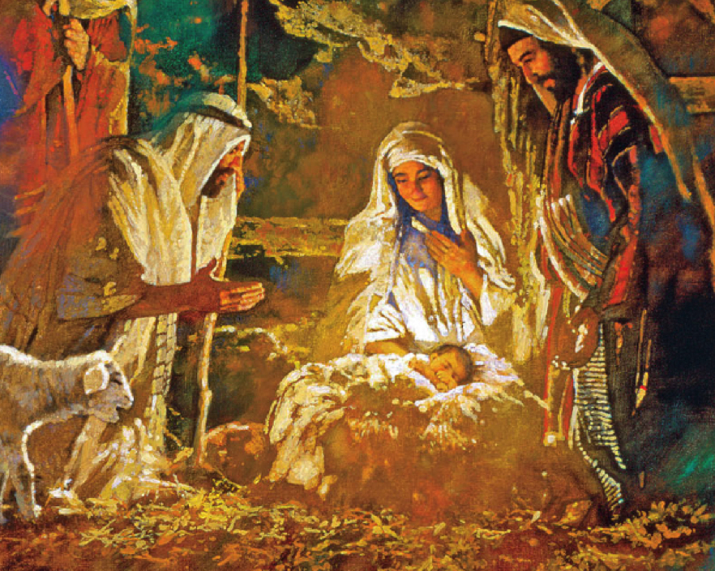Heav’n-ly peace we will keep
Allelujah, Allelujah, Allelujah

Peace, Peace, Prince of Peace

Healer of men
Peace again peace
Prince of Peace
