There is peace in Christ
When we learn of Him
Feel the love He felt for us
When He bore our sins
Listen to His words
Let them come alive
If we know Him as He is
There is peace in Christ
He gives us hope
When hope is gone
He gives us strength
When we can’t go on
He gives us shelter
In the storms of life

When there’s no peace on earth
There is peace in Christ
There is peace in Christ
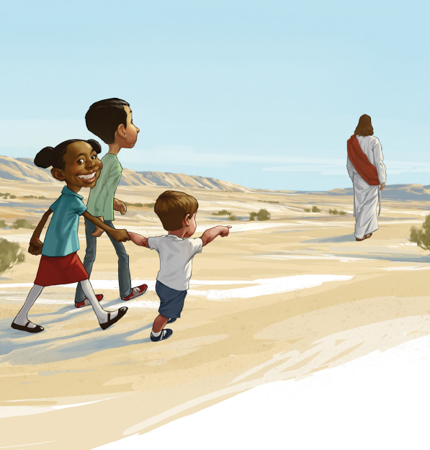
When we walk with Him
Through the streets of Galilee
To Jerusalem
Mend the broken hearts
Dry the tear-filled eyes
When we live the way He lived
There is peace in Christ
He gives us hope
When hope is gone
He gives us strength
When we can’t go on
He gives us shelter
In the storms of life
When there’s no peace on earth
There is peace in Christ
He gives us hope

When hope is gone

He gives us strength
When we can’t go on
He gives us shelter
In the storms of life
When there’s no peace on earth
There is peace in Christ
When there’s no peace on earth
There is peace in Christ

