It’s time to peek inside our box
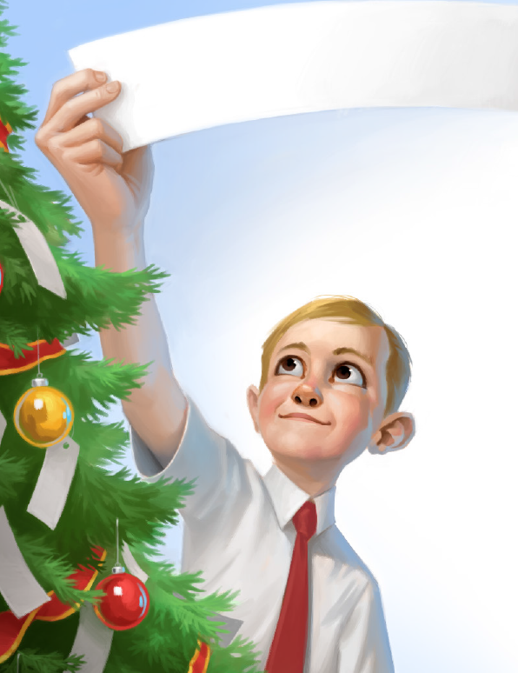
Of ornaments to see
Which ones we’ll choose to decorate
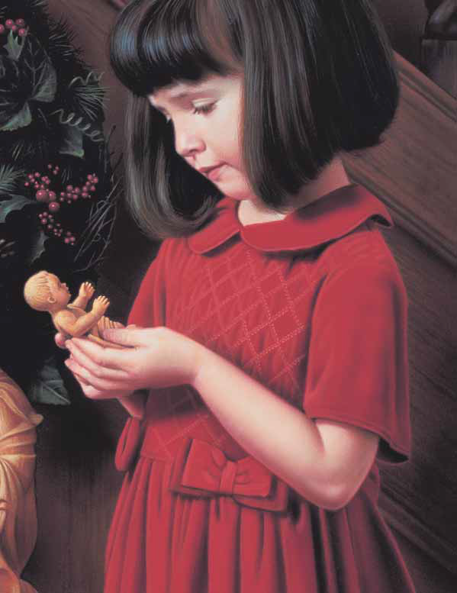
Our Christmas story tree
Let’s hang a cane of peppermint
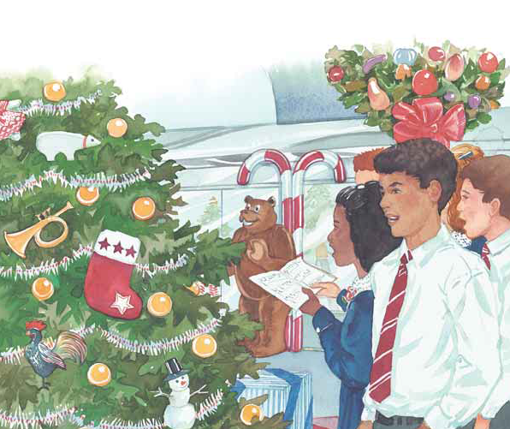
Upon the nearest bough
To tell of shepherds watching lambs
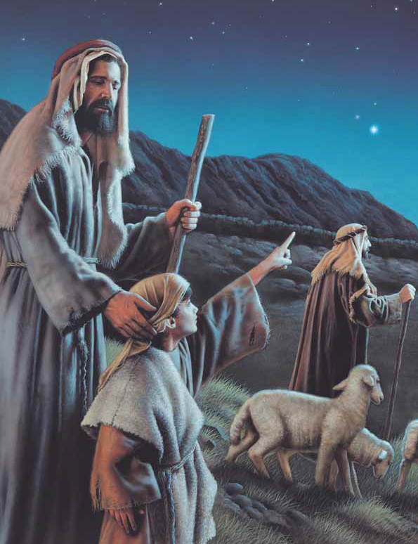
As Jesus watches now
The angel on the highest branch
Still sings the joyful song
Of peace on earth, goodwill to men
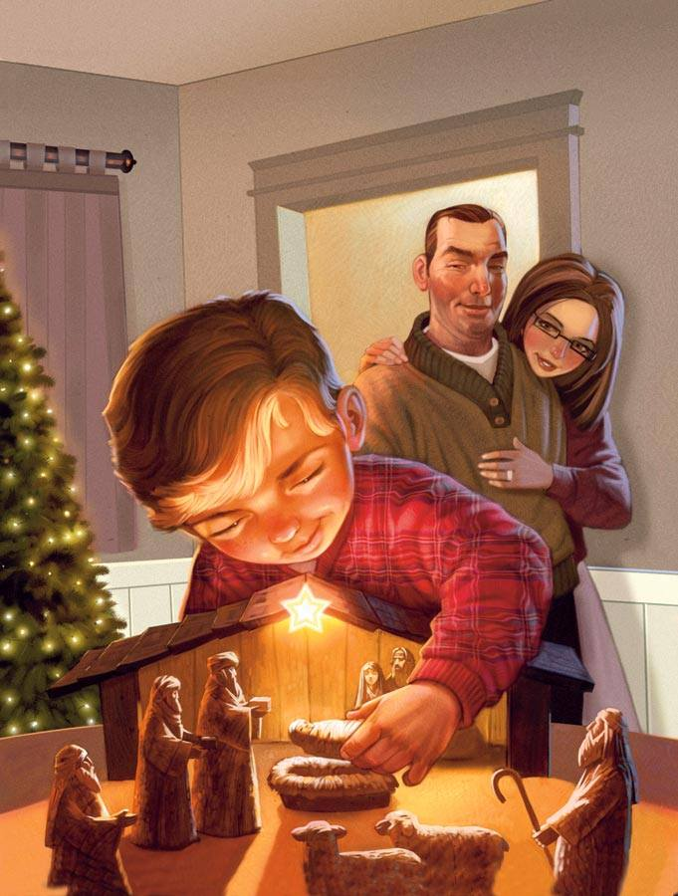
Of pardon for our wrongs
We’ll set a star of silver here
Among the twinkling lights
Like one that shone on Bethlehem
That sacred, starry night
And there beneath the tree we’ll place
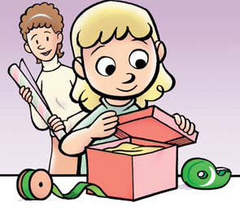
A package wrapped in red
Reminding of our Lord’s great gifts
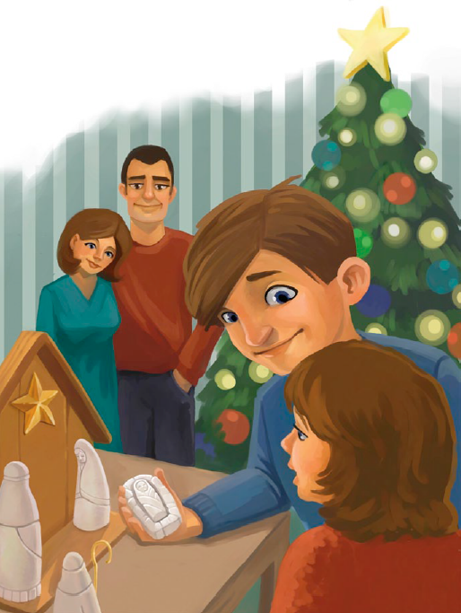
His love, the blood He shed
Our Christmas tree is ever green
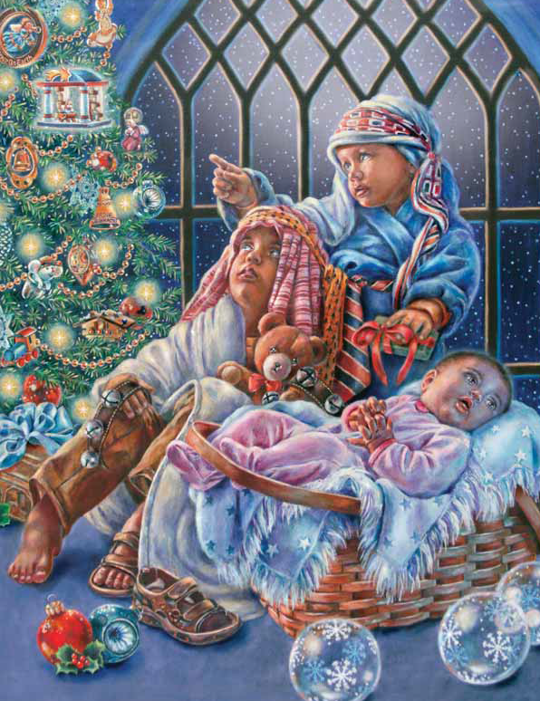
Its needles never fall
Our Savior dear was born to bring
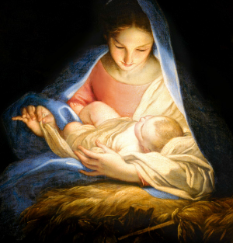
Eternal life to all
Our Savior dear was born to bring
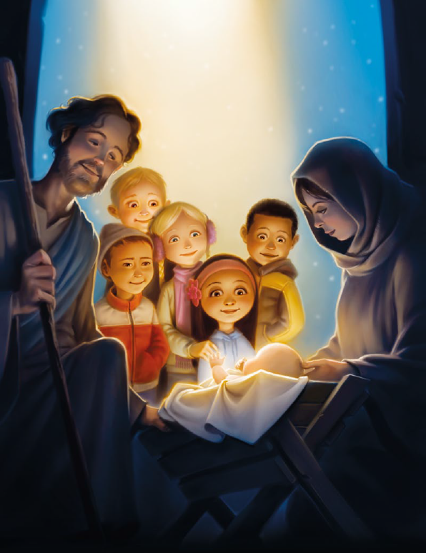
Eternal life to all

