One By One

Words by
Elder David Bednar
&
Music by
Paul Cardall
New Era July 2016
One by one
One by one
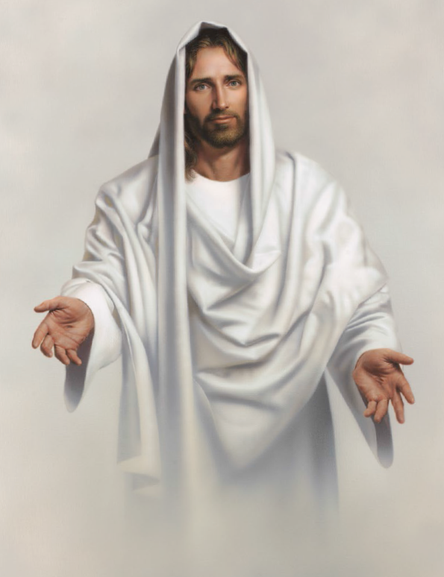
Jesus, the Father’s Beloved Son
One by one
One by one
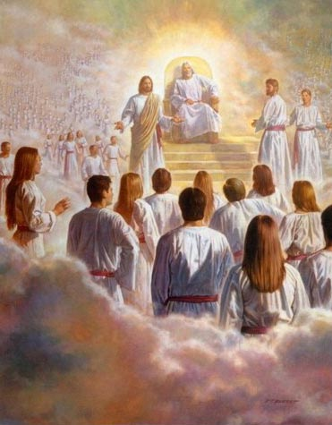
From the beginning said, “Thy will be done”
Jesus Christ came to earth
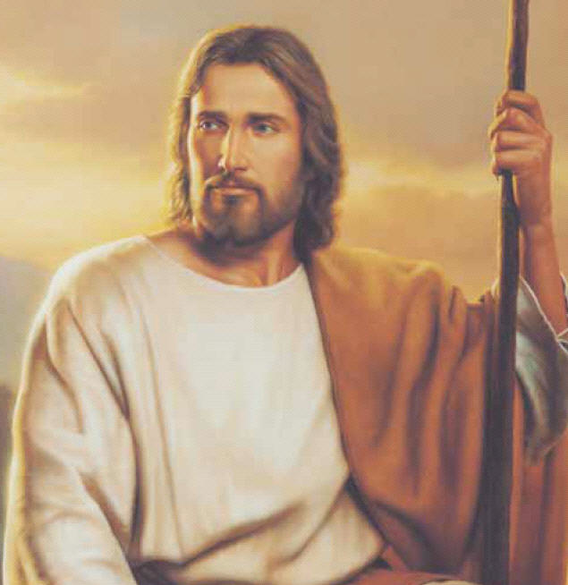
To fulfill God’s plan
For He alone could atone
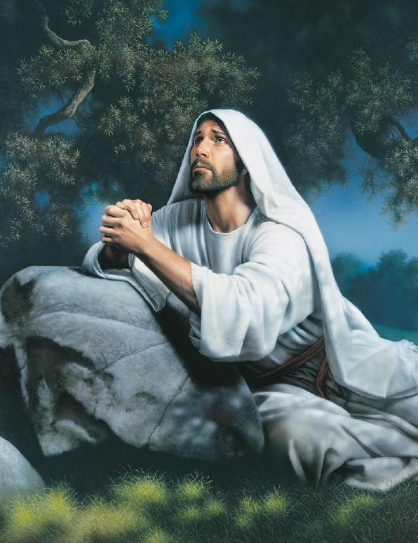
As Savior of man
The Lord blessed and beckoned them
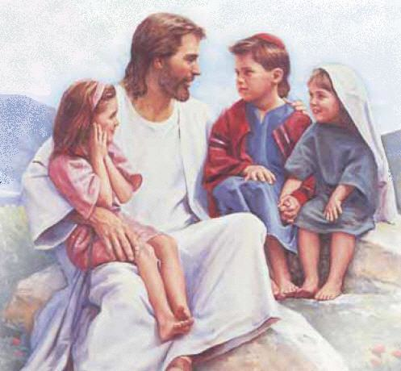
“Come unto me”
And willingly sacrificed
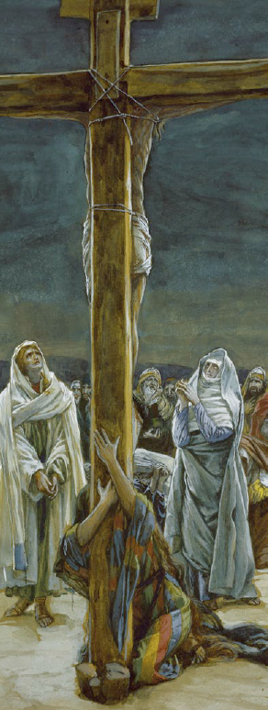
To set us free
One by one
One by one
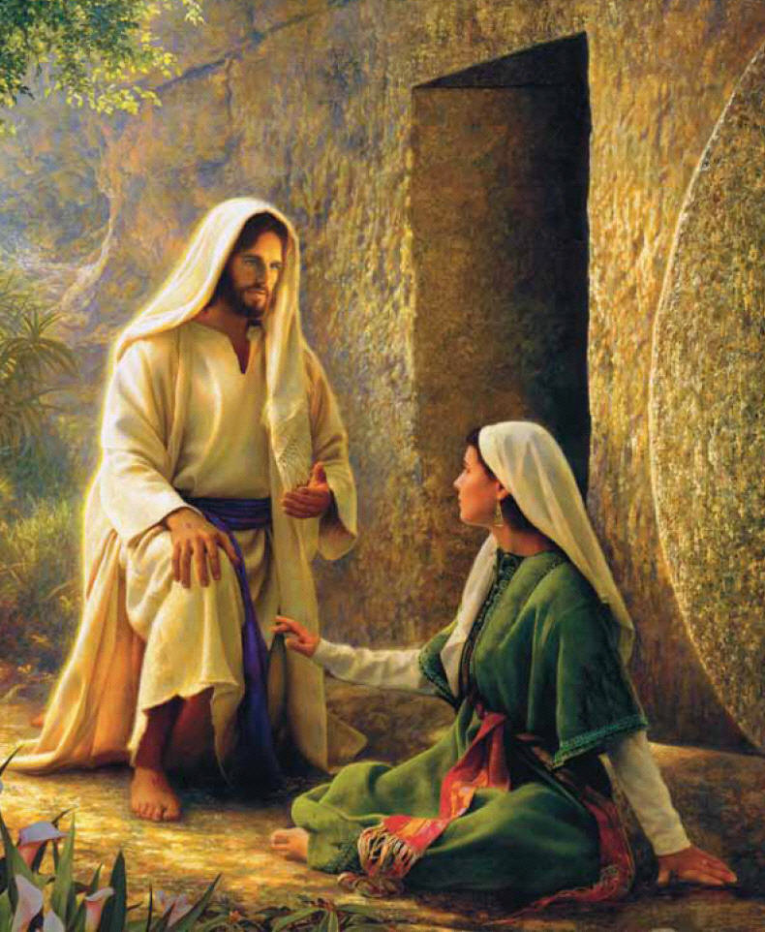
He suffered for us and victory won
One by one
One by one
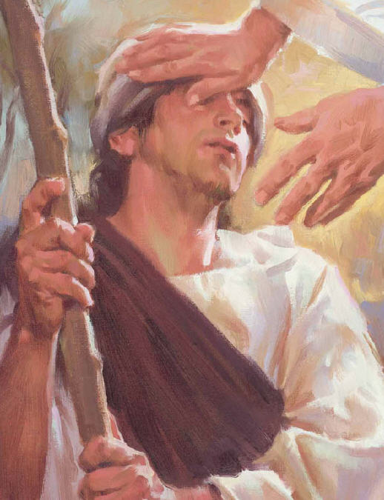
We marvel at all His love has done
One by one
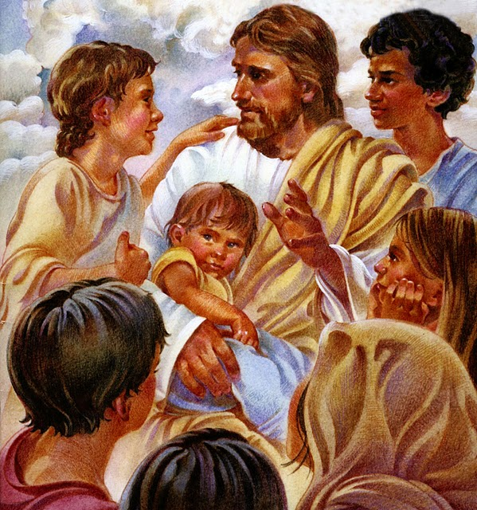
One by one
One by one
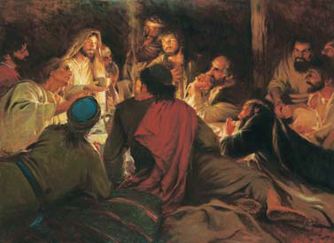
Multitudes gathered and saw Him come
One by one
One by one
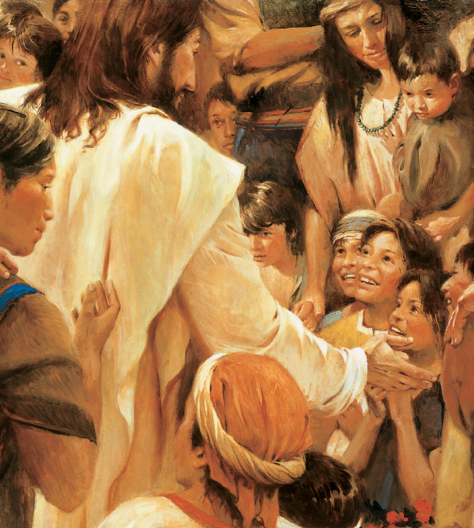
Each heard a voice declare, “Behold My Son”
Jesus Christ came
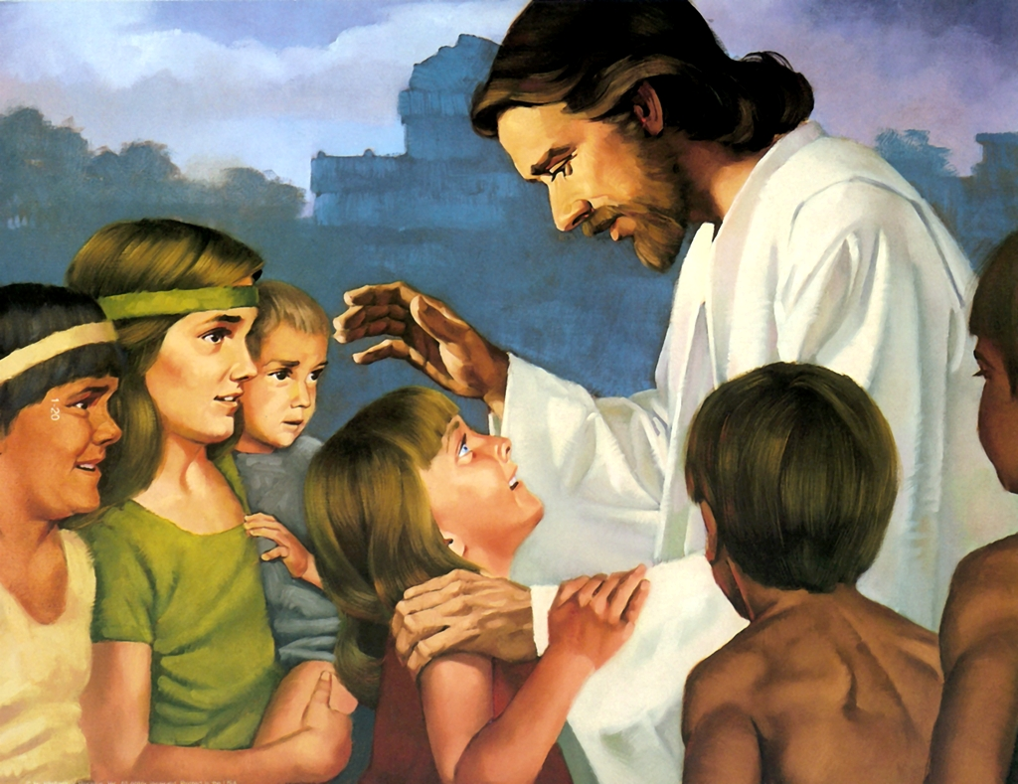
And stood in the midst of them
They fell to the earth
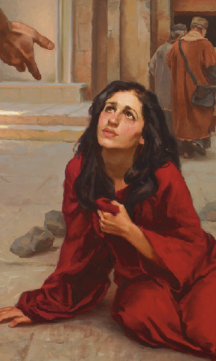
In great rev’rence for Him
The Lord bid
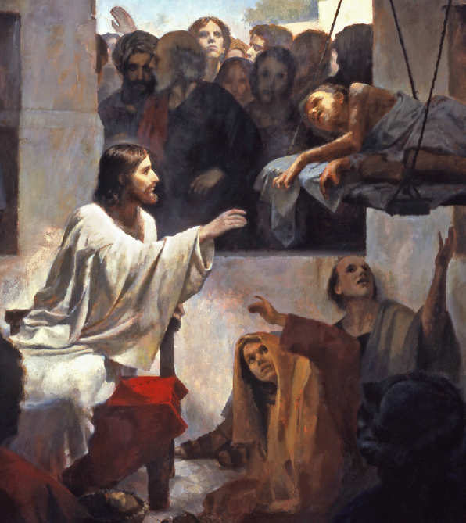
“Arise, and come forth unto me”
With hands they did feel
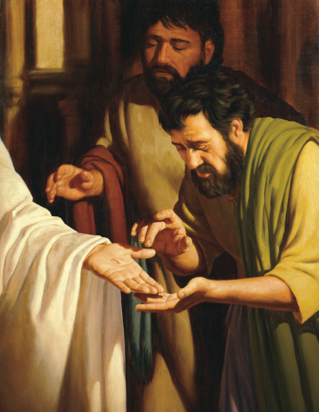
And with eyes they did see
One by one
One by one
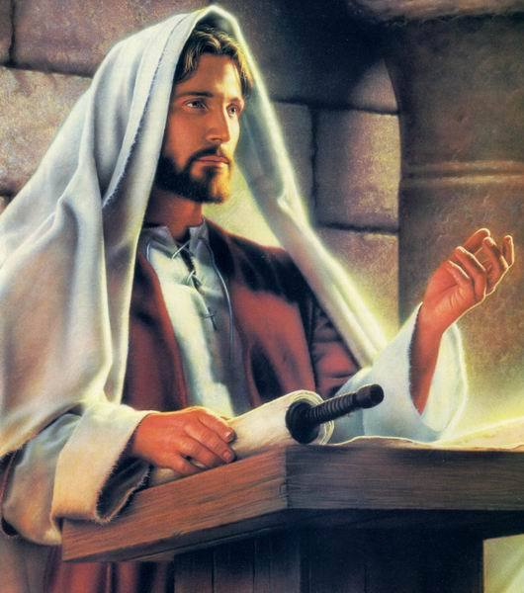
Each knew and bore record, He is our Lord
One by one
One by one
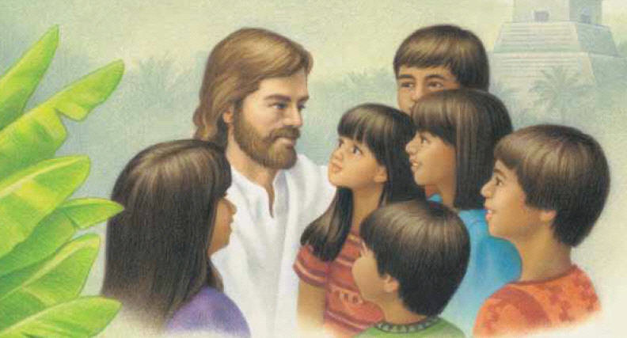
They cried “Hosanna” with one accord
One by one
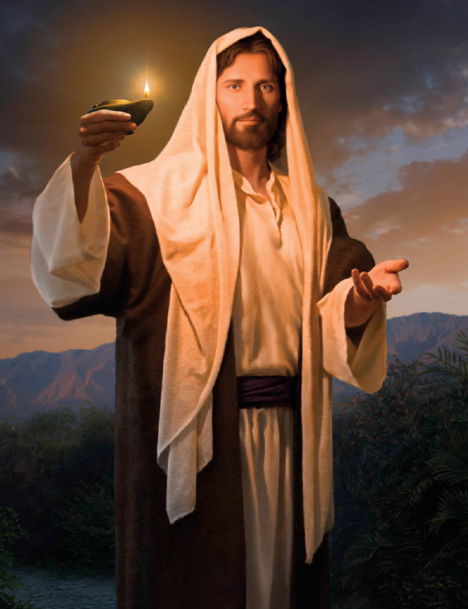
One by one
One by one
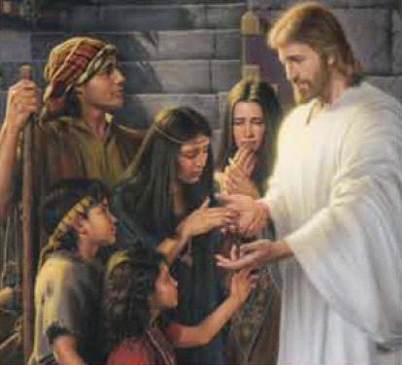
Christ looked around Him and saw their tears
One by one
One by one
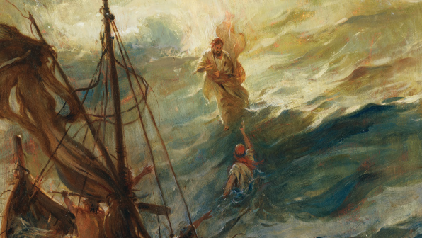
In His compassion
He calmed their fears
Jesus Christ healed each one
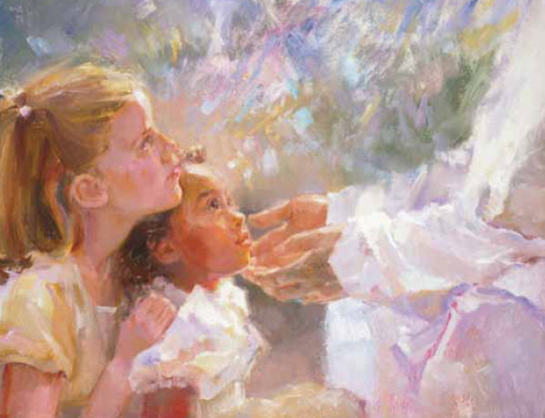
Brought forth unto Him
Then He blessed each precious child
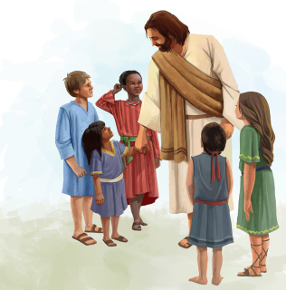
And prayed for them
The angels descended
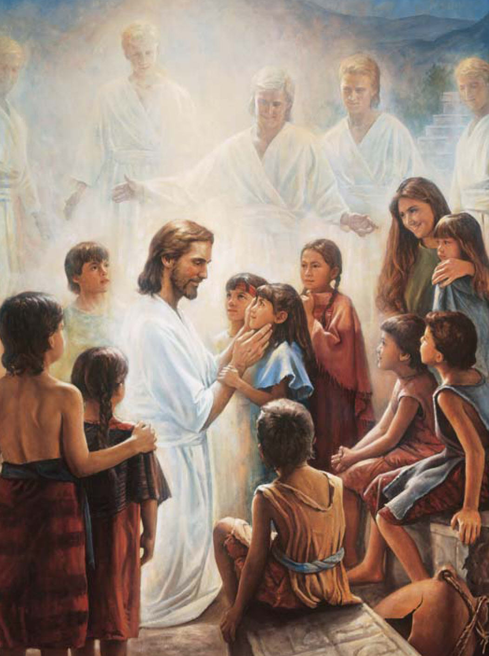
From heaven above
Encircling those little ones
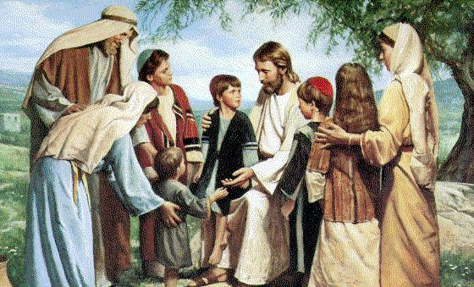
Each felt His love

One by one
One by one
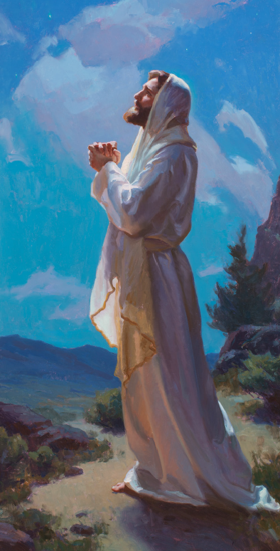
He intercedes for each daughter and son
One by one
One by one
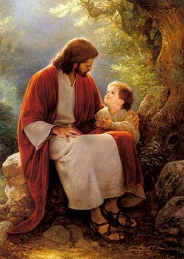
Strength from His grace gives us pow’r to become
One by one
