On the road to Bethlehem
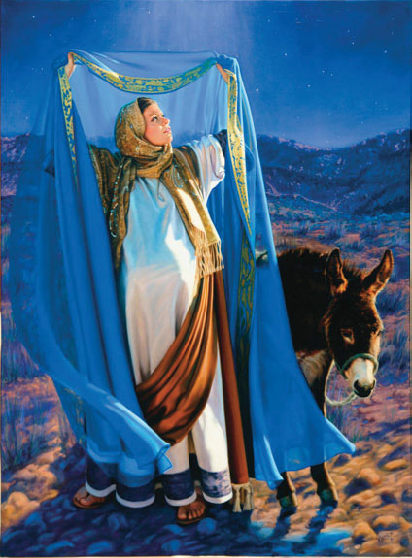
Mary pondered in her heart
Her firstborn babe would be God’s son
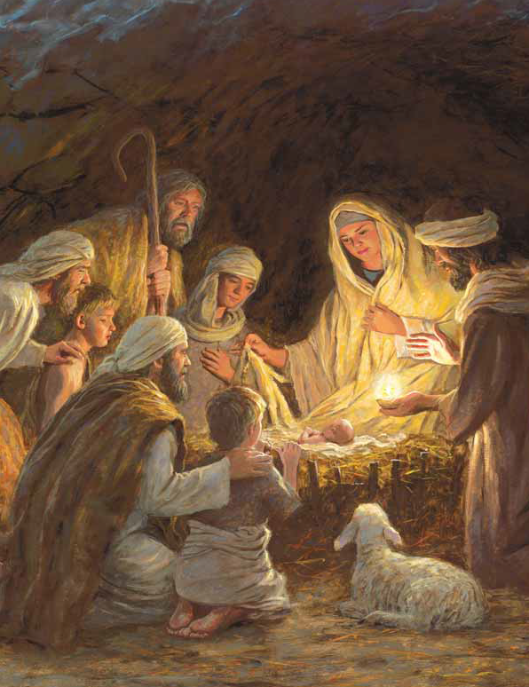
Great blessings to impart
This wondrous child! This Glorious child!
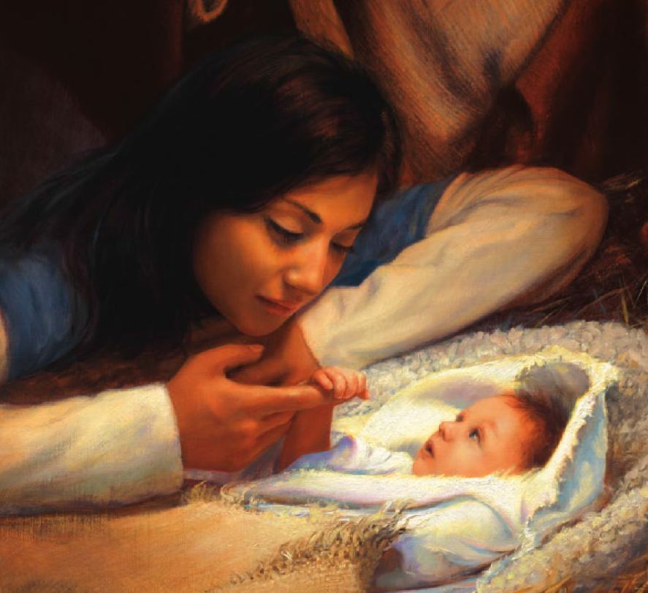
With fervor in His eyes
He will bring forth salvation of mankind
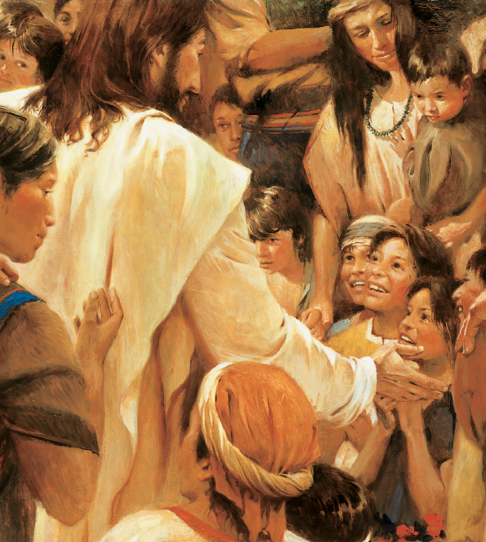
When on the cross He dies
The Savior of mankind
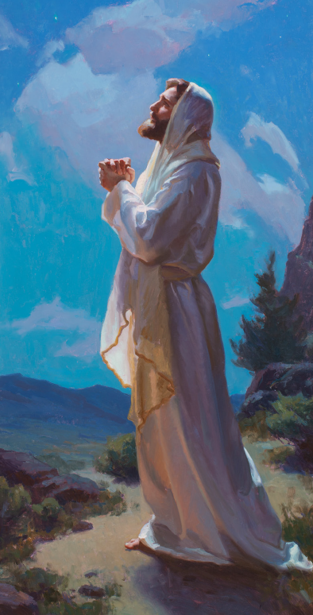
On the road to Bethlehem
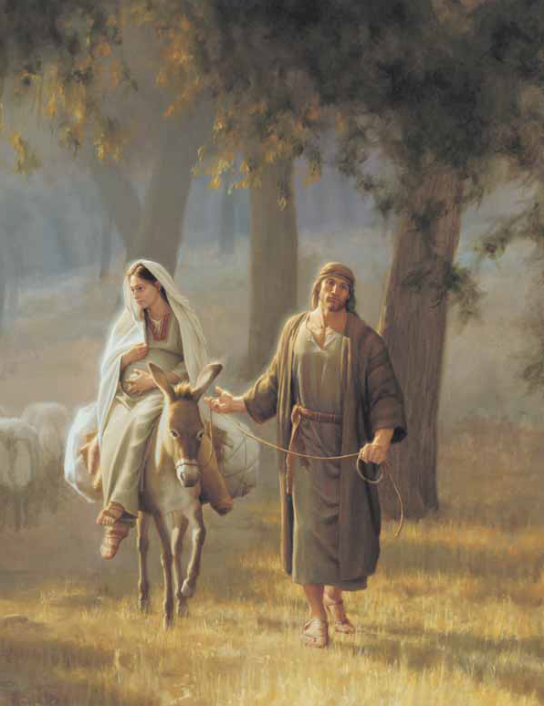
Joseph pondered in his heart
The chosen one to raise God’s son
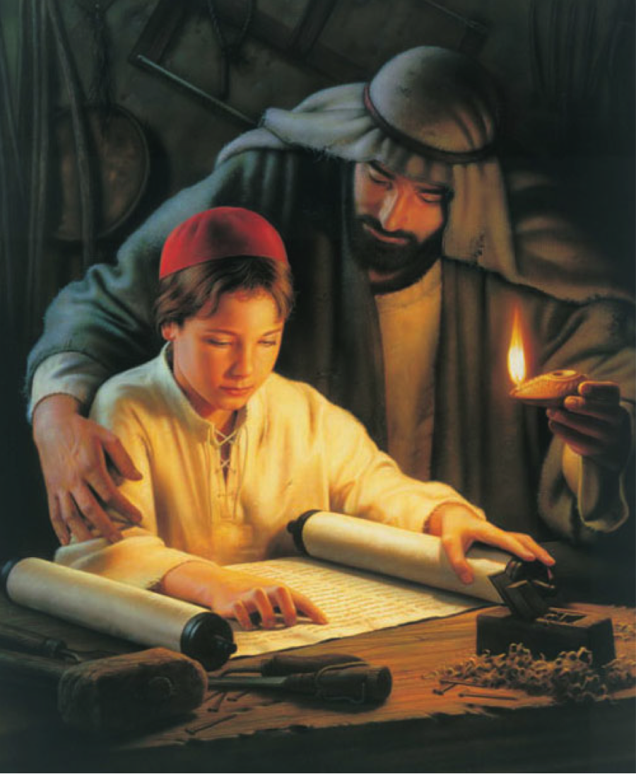
Great blessings to impart

