Oh wondrous night when all the world
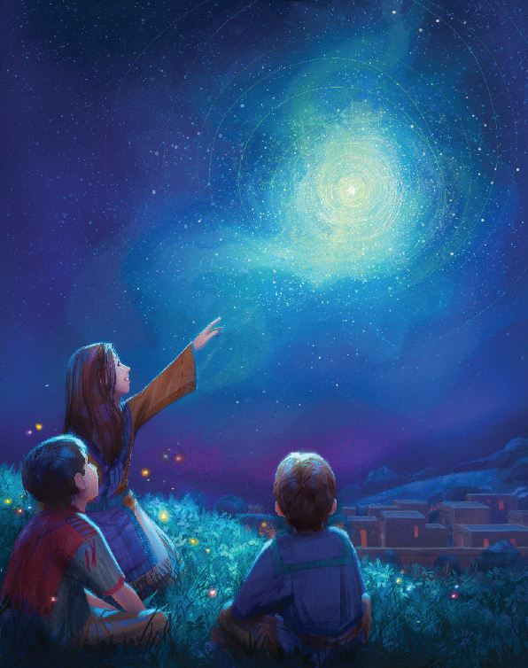
Will waken to the glorious light
The heavens rent
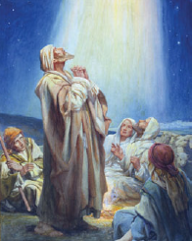
With music angels glory bright
Rejoice this night
Rejoice His light
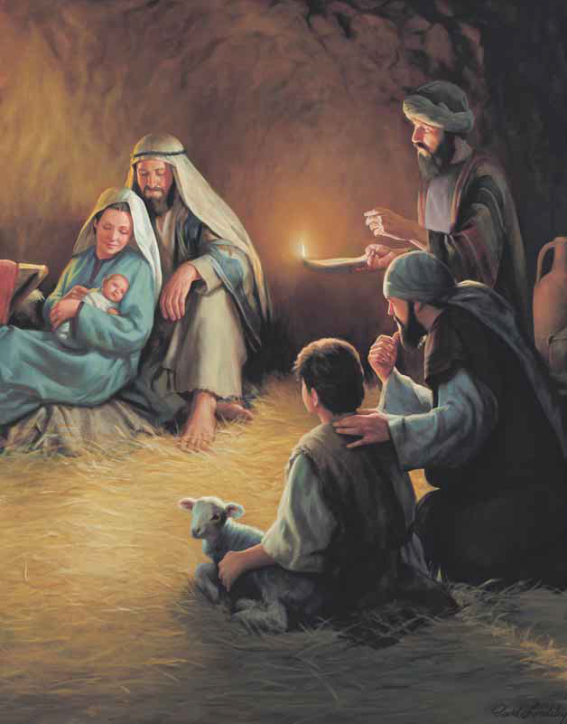
All sing this wondrous night
Oh wondrous night when all the world
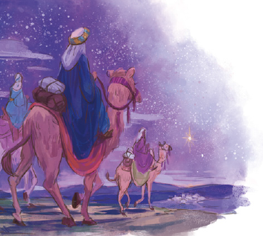
Will see the starlight in the sky
Messiah born
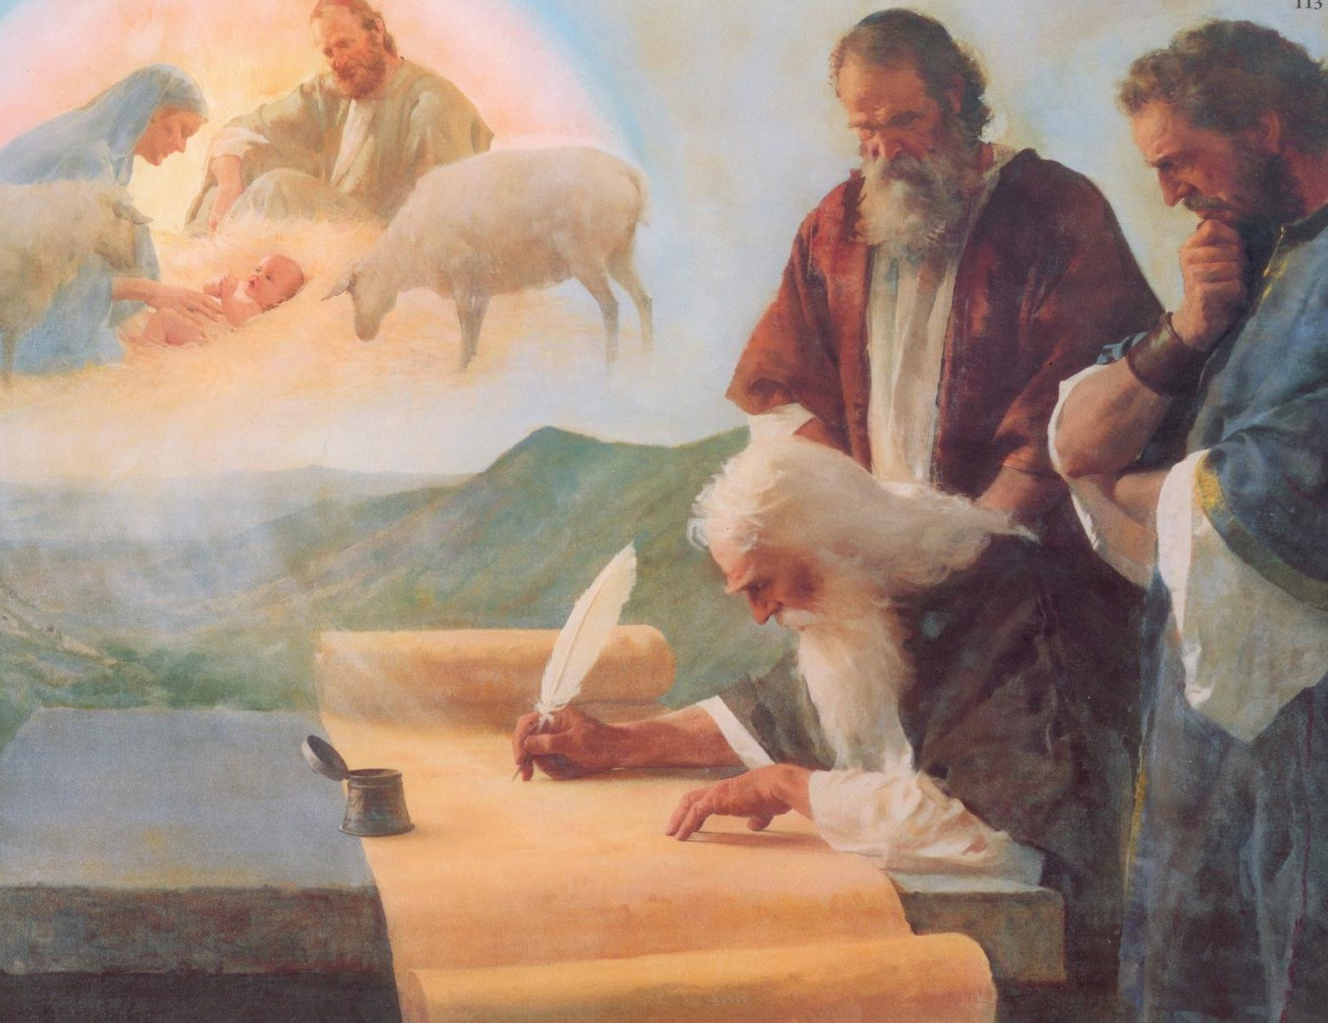
Just as the scriptures prophesy
Rejoice this night
Rejoice His light
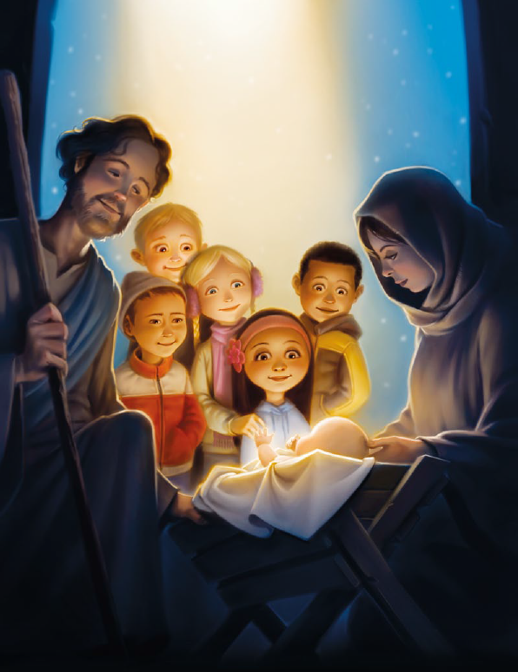
All sing this wondrous night
Oh wondrous night in Bethlehem
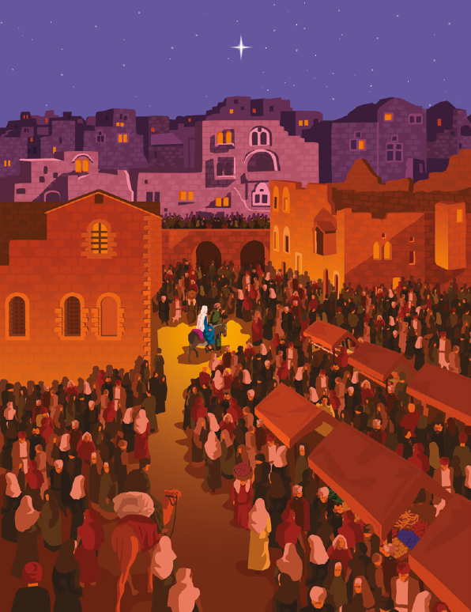
Is born the Savior of mankind
From death and sin
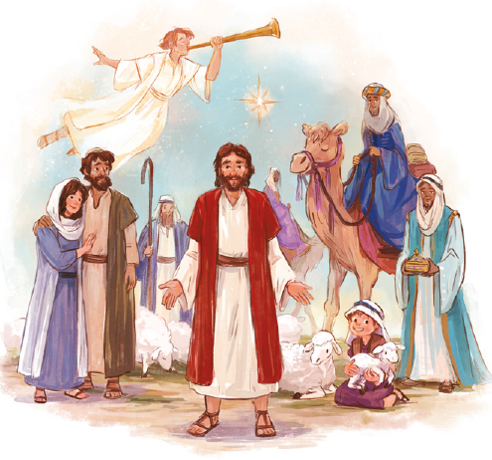
His promised victory we find
Rejoice this night
Rejoice His light
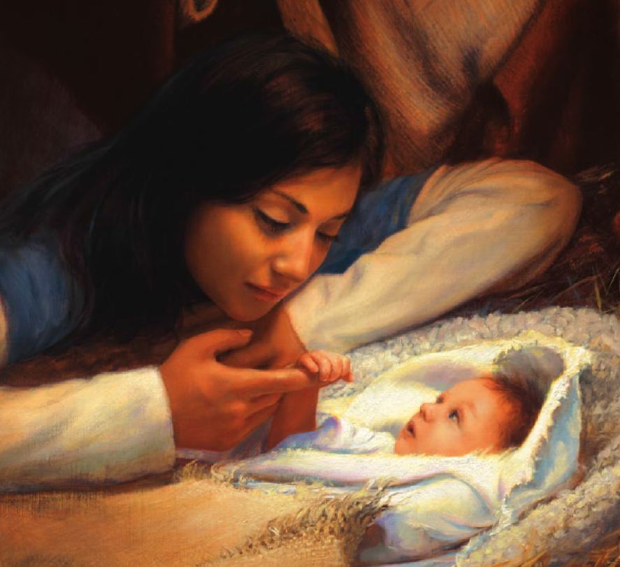
All sing this wondrous night
Rejoice and sing
Rejoice and sing
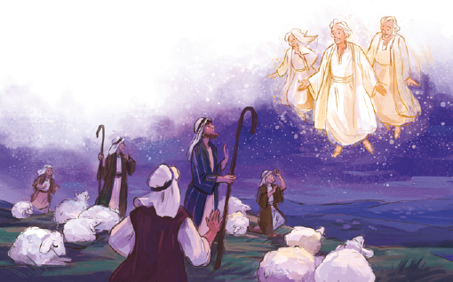
Christ is born
Christ the King
All will sing
