I believe that Heav’nly Father
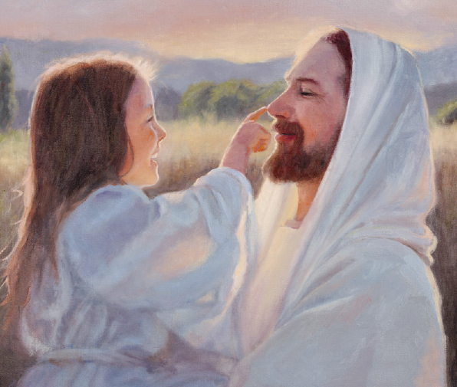
knows me and He cares
For when I ask for help
He gives me answers to my prayers
I believe He loves me too
because He sent His Son
To die for me so I can live
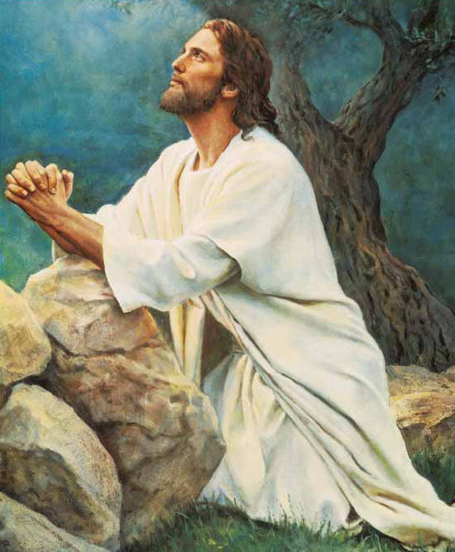
When life on earth is done
I believe that Joseph Smith
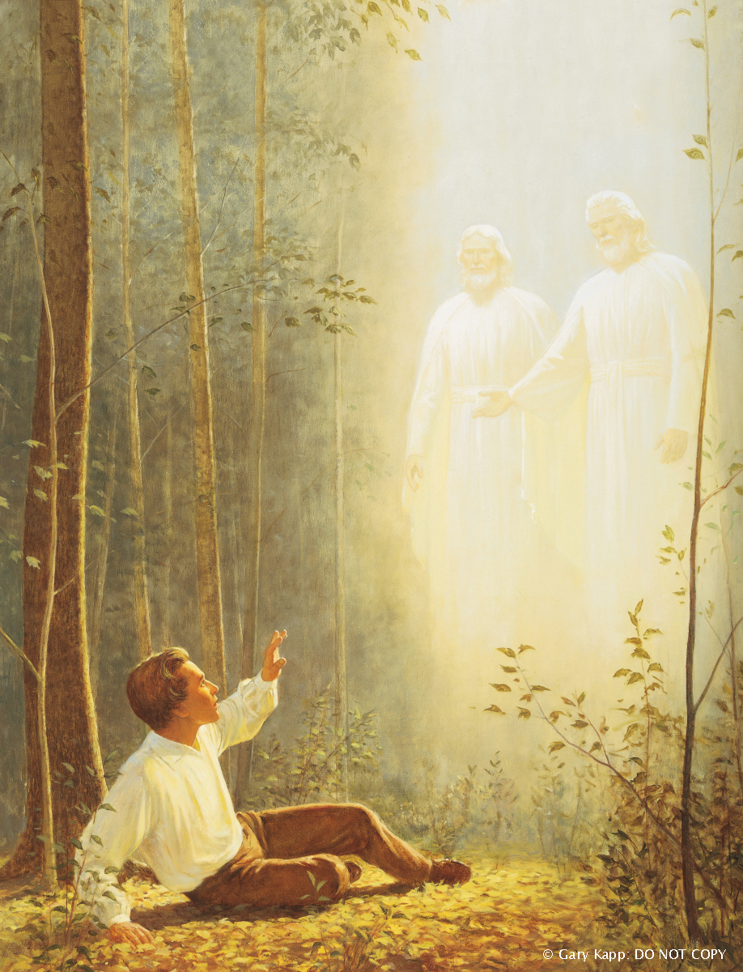
Was chosen by the Lord
To be the one through whom He could reveal
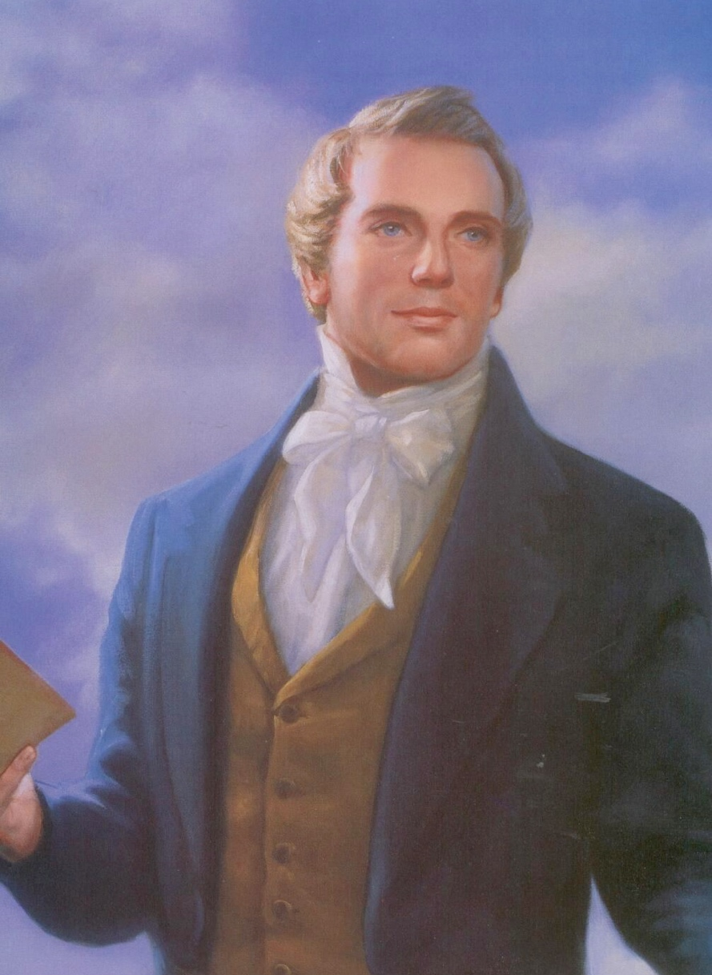
His sacred word
I believe our prophet knows
God’s will for us today
And we must listen carefully
To what he has to say
My testimony is growing
As gospel seeds are sown
My testimony is growing
A witness of my own

