My Own Superhero
By
Shauna Edwards

Sheet Music available
At ShaunaEdwardsMusic.com

When I feel alone or afraid
And nothing is goin' my way
Or when I'm just running
A little low on faith-
That's when I just gotta believe
There's power and courage in me
And whatever happens
Thru good days and bad ones
I will stand and say-
I can climb this mountain
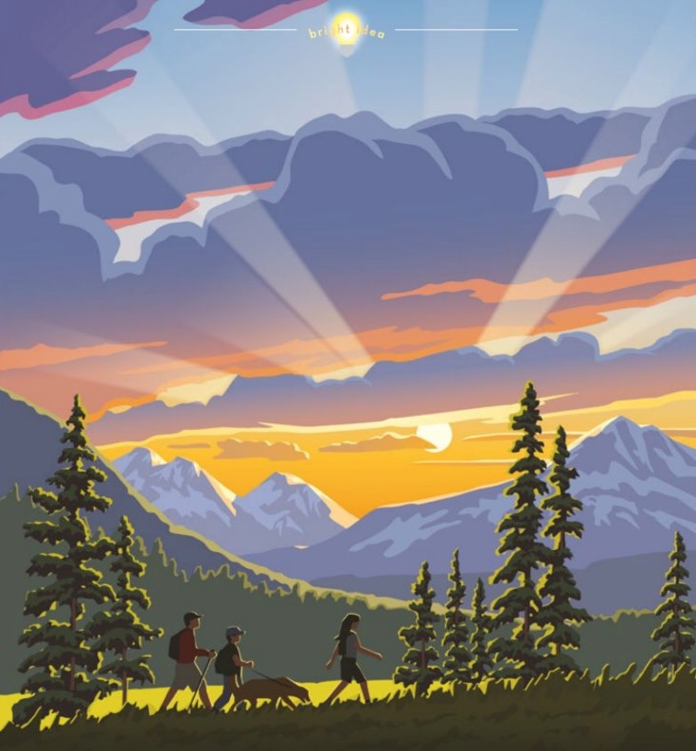
I can brave this storm
I can be amazing
There's no telling now how far I'll go
When the day needs saving
It starts with me, I know
So I will move
I will rise
I will choose
I will try
To be my own superhero
Then I'll be a light in the dark
I'll do the right thing when it's hard
I'll reach out my hand
If we start to drift apart
When you need my help I'll be there
Cuz real super powers are meant to be shared
We're brighter together
And stronger than ever
Hand in hand and heart to heart

I can climb this mountain
I can brave this storm
I can be amazing
There's no telling now how far I'll go...oh
When the day needs saving
It starts with me, I know
So I will move
I will rise
I will choose
I will try
To be my own superhero
I'll be never give up
I'll never give in
And each time I fall
I will rise again
When the day needs saving
It starts with me, I know
So I will move
I will rise
I will choose
I will try
To be my own superhero
I will be my own superhero!

