My Sacred Grove
By

Angie Killian

Music at AngieKillian.com

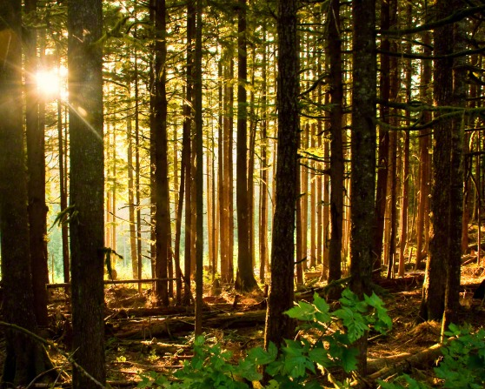
Joseph Smith went to a grove
full of trees
Seeking God’s wisdom
He fell to his knees
As he pled with the heavens
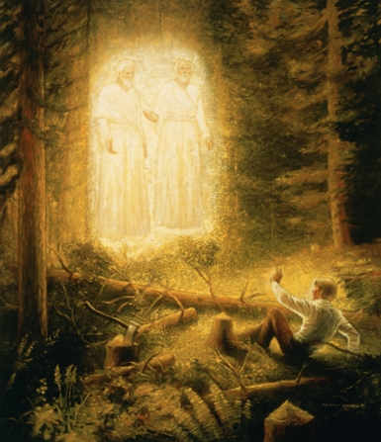
The sky filled with light
And the Father appeared
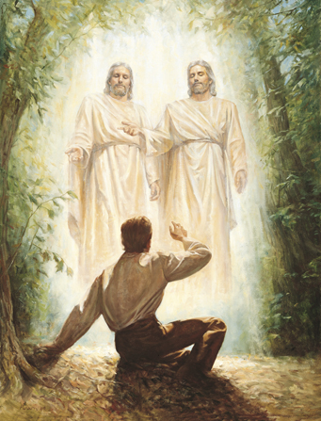
With His Son, Jesus Christ
Standing above in the air
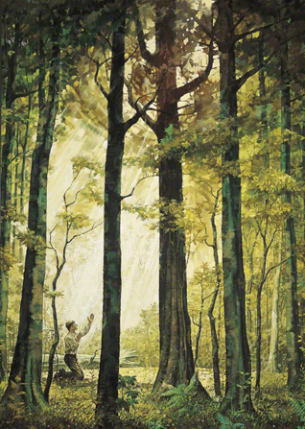
Coming to answer his prayer
I will find my own Sacred Grove
Away from all of the noise of the world
I will turn to prayer

For I know he’s there
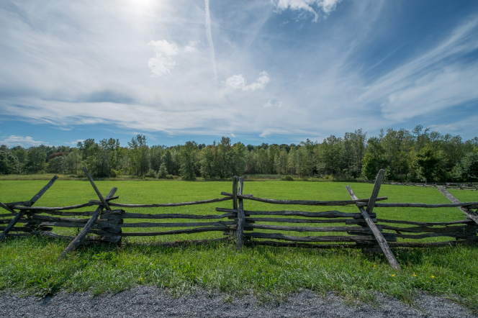
I will find my own Sacred Grove

I will find my own
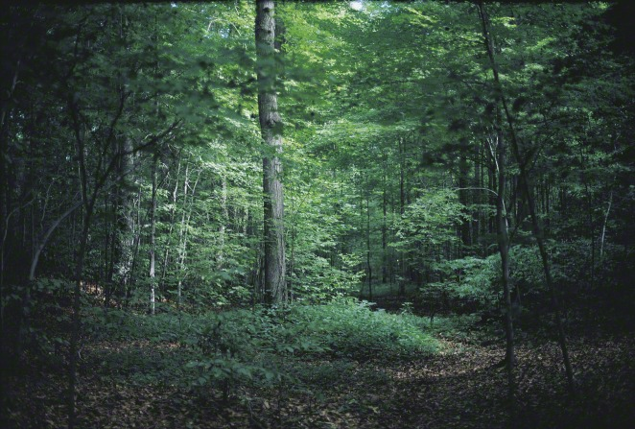
Sacred Grove

So many choices

With so much at stake
Life’s full of pathways
But which should I take?
If I lift up in prayer
In the name of the Son
Through the pow’r of the Holy Ghost answers will come

Heavenly Father is there
Ready to answer my prayer
Sometimes the answers take time
So we’ll listen in heart and mind
Revelation will come my way
As I wait patiently in faith

