Whenever I hear the song of a bird
Or look at the
blue, blue sky
Whenever I feel
the rain on my face
Or the wind
as it rushes by
Whenever I touch
a velvet rose
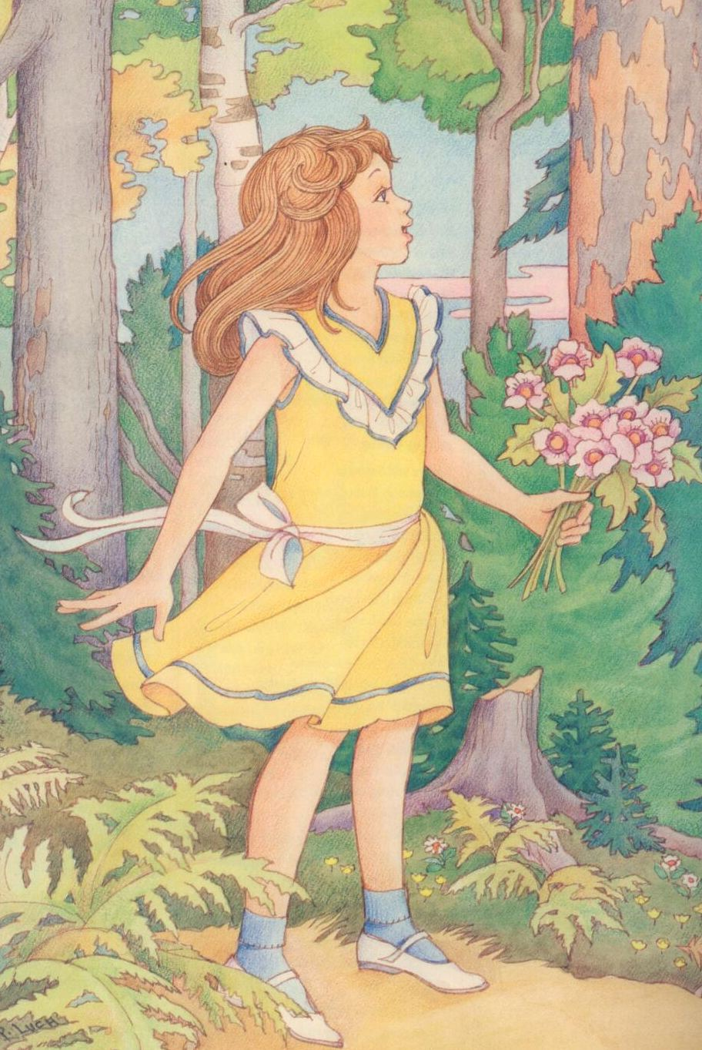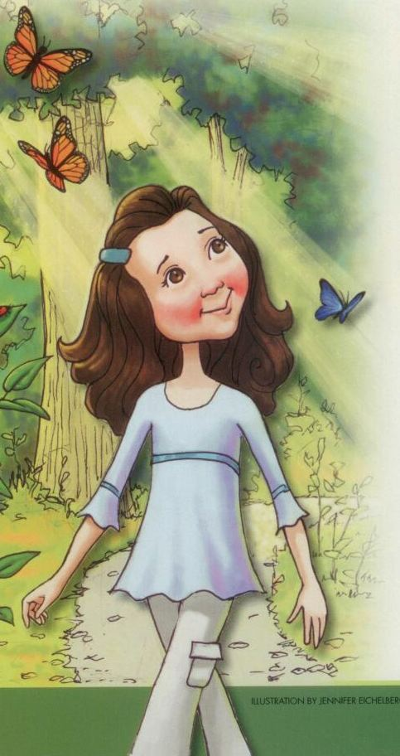
Or walk by a lilac tree
I’m glad that I live in this beautiful world
Heavenly Father
created for me
He gave my eyes
that I might see
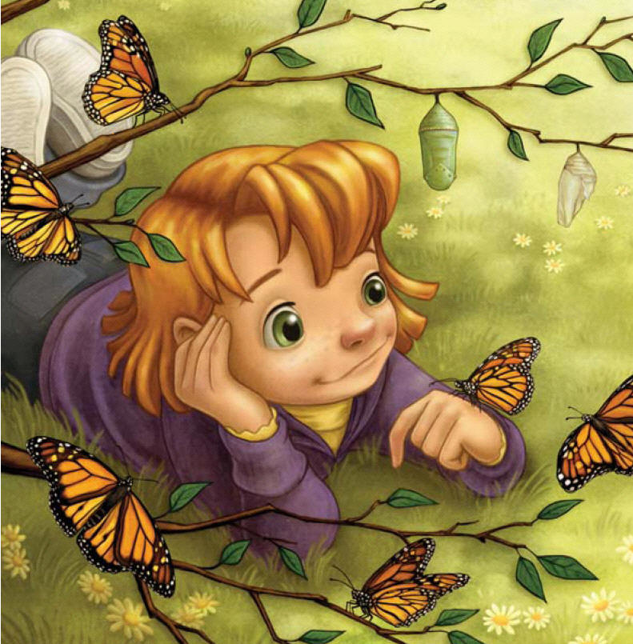
The color of
butterfly wings
He gave my ears
that I might hear

The magical sound of things

He gave my life,
my mind, my heart
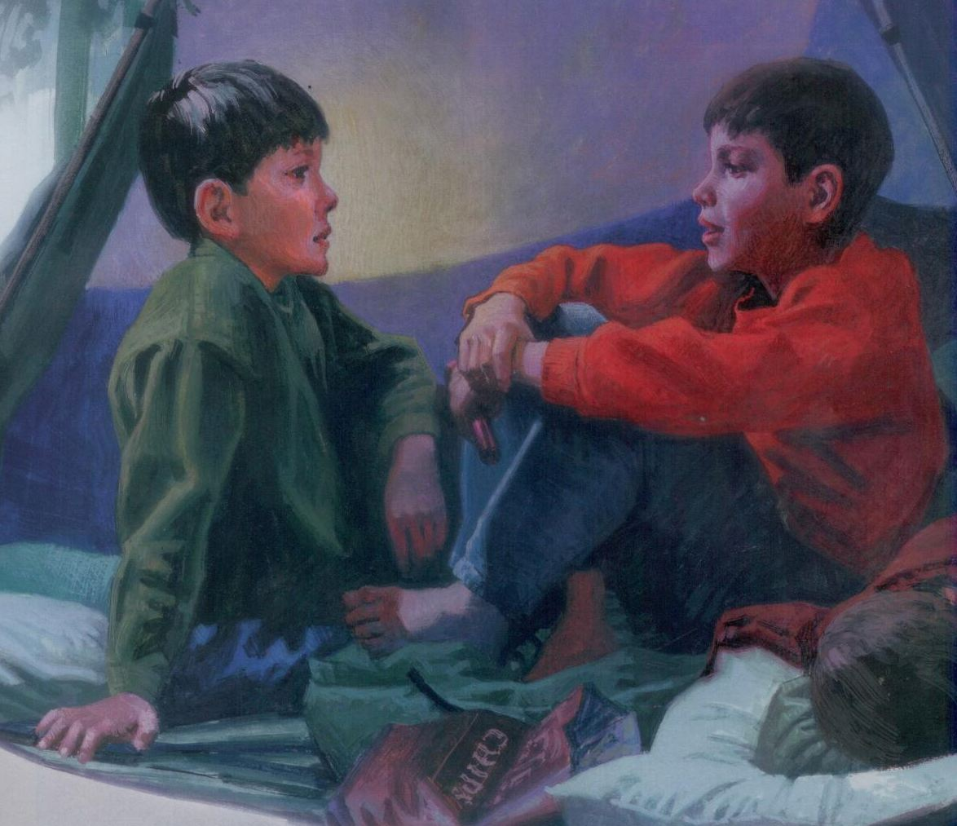
I thank him rev’rently
For all his creations, of which I’m a part
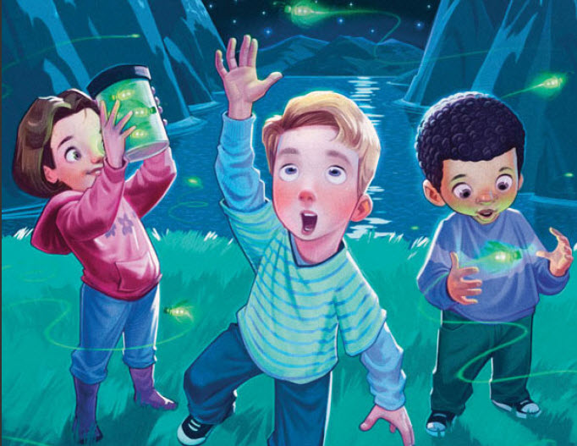
Yes, I know Heav’nly Father loves me

