My hands upon my head I’ll place
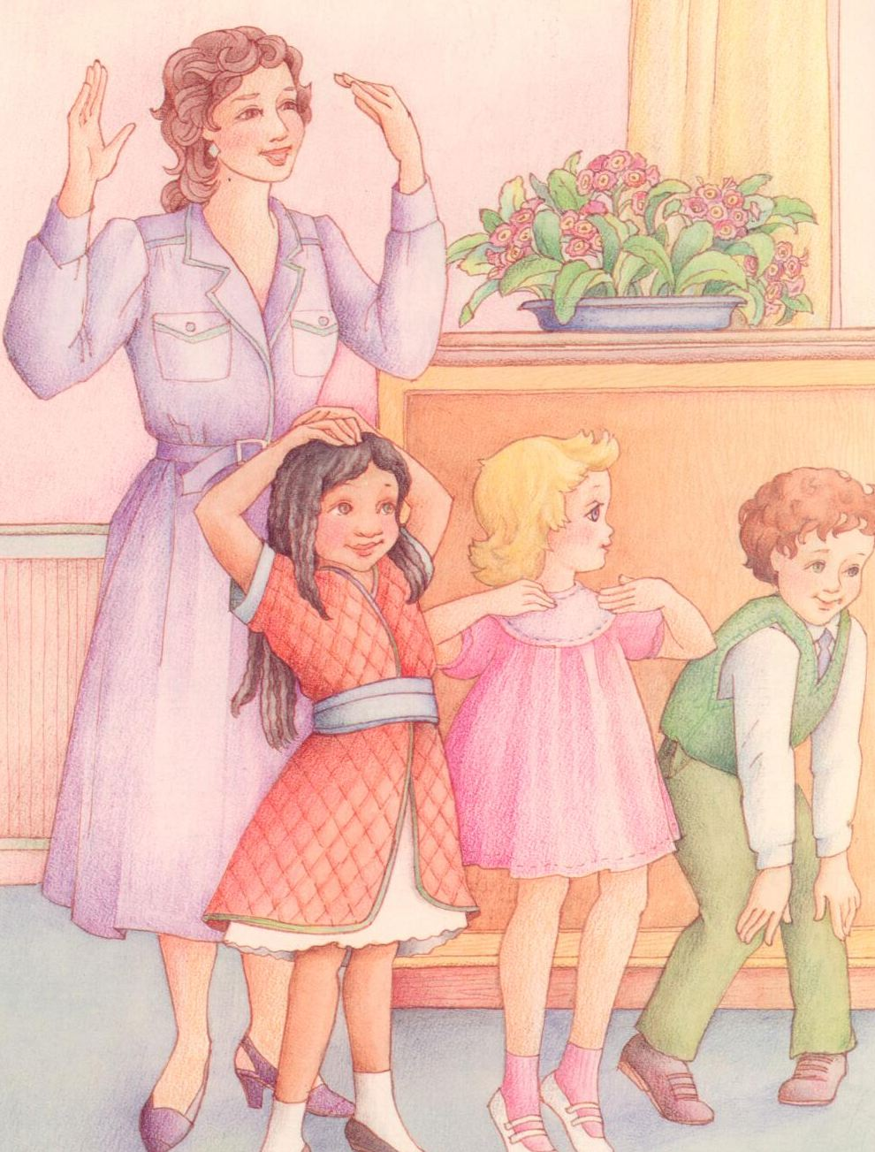
Upon my shoulders, on my face
At my waist, and by my side
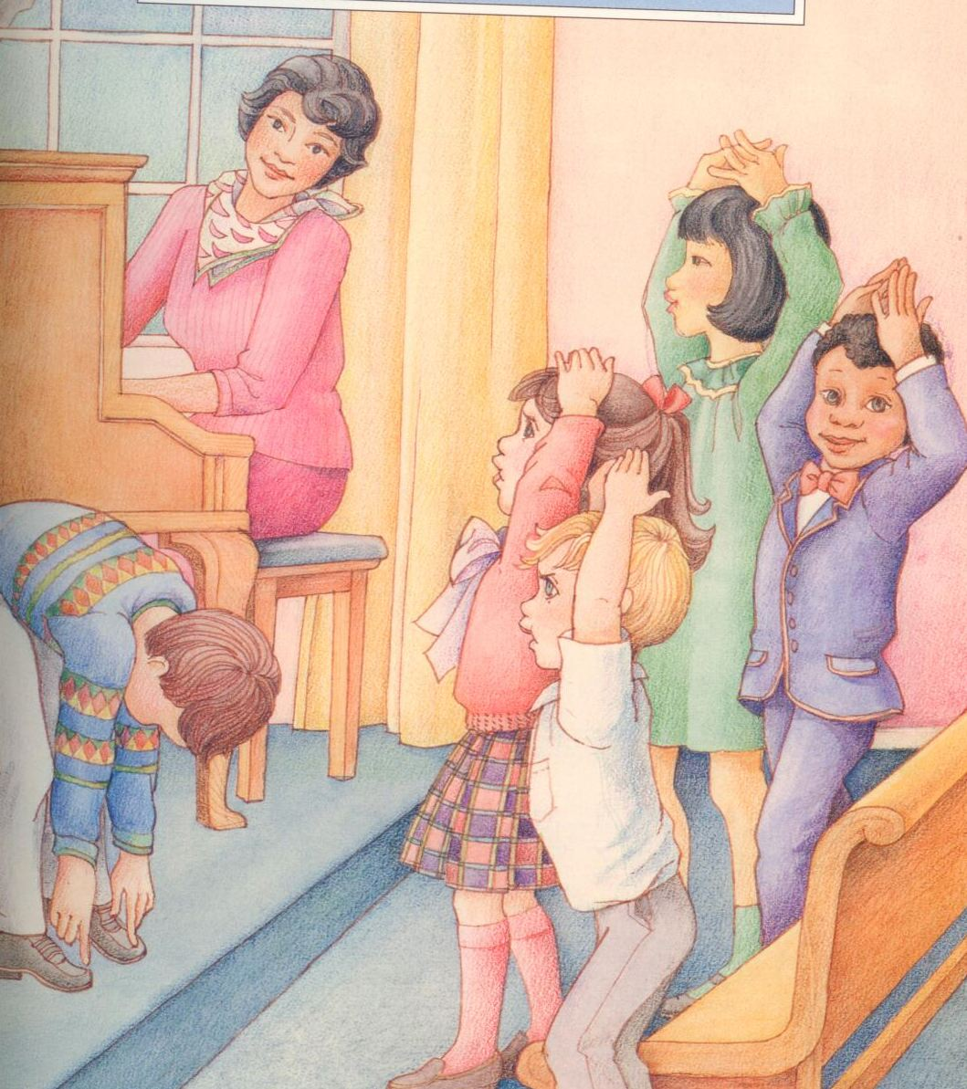
And then behind me they will hide
Then I will raise them way up high
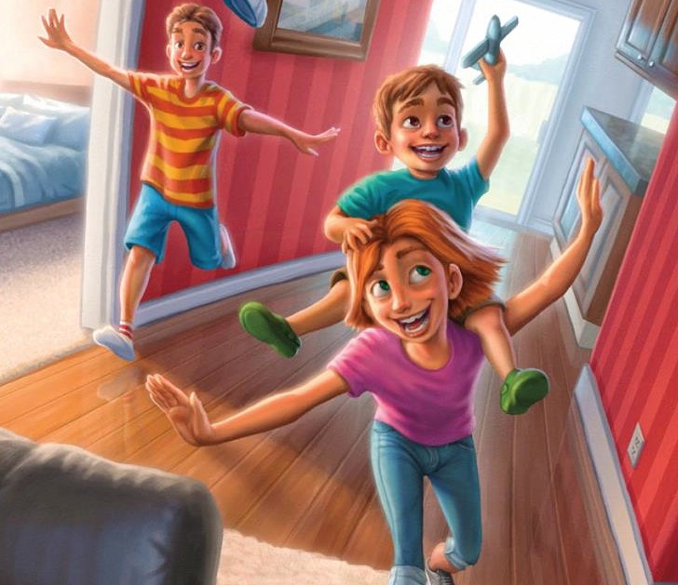
And let my fingers fly, fly, fly
Then clap, clap, clap, and one, two three
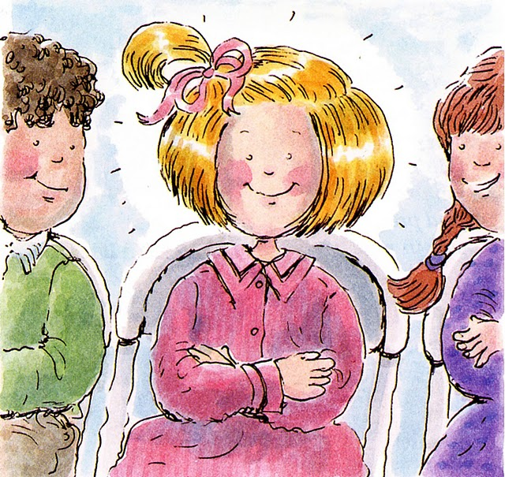
Just see how quiet they can be

