My country, 'tis of thee
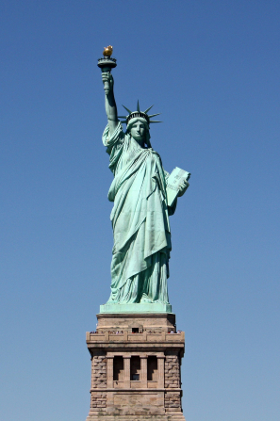
Sweet land of liberty Of thee I sing
Land where my fathers died
Land of the pilgrims' pride
From ev'ry mountainside
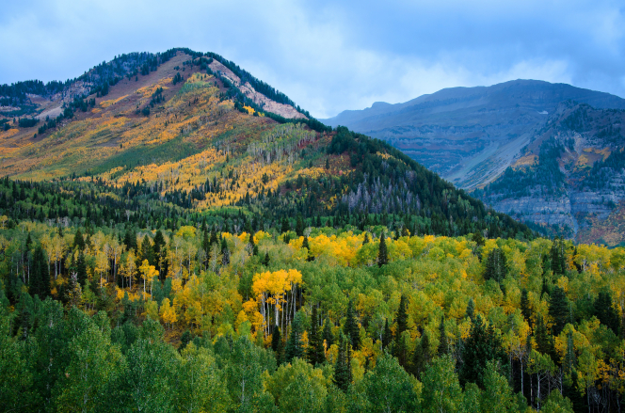
Let freedom ring!
My native country, thee
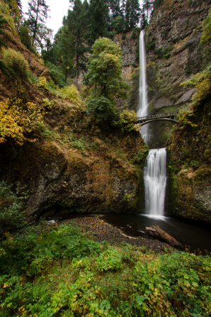
Land of the noble free
Thy name I love

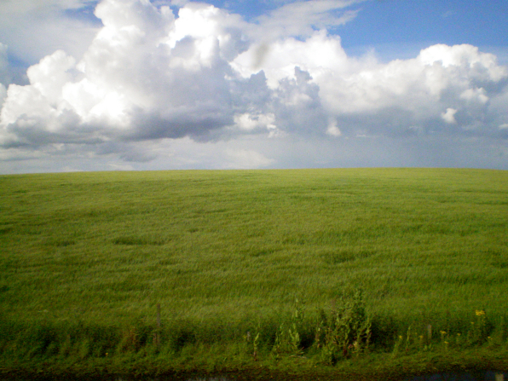

I love thy rocks and rills
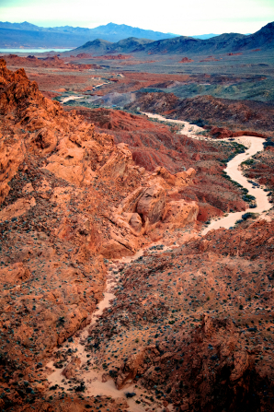
Thy woods and templed hills
My heart with rapture thrills
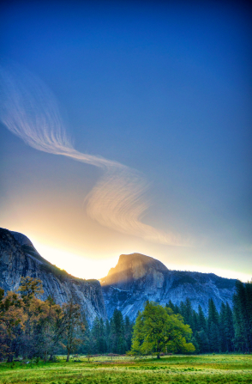
Like that above
Let music swell the breeze
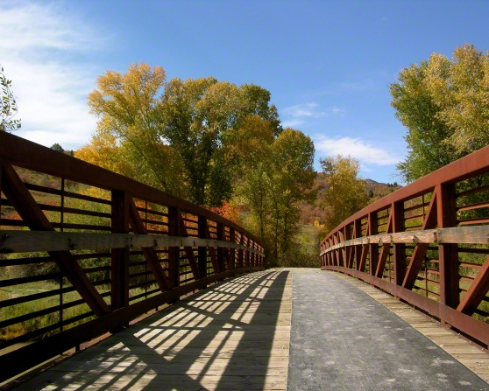
And ring from all the trees
Sweet freedom's song

Let mortal tongues awake
Let all that breathe partake
Let rocks their silence break
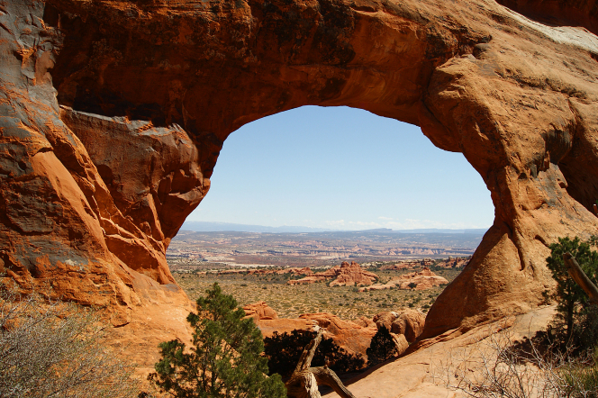
The sound prolong
Our fathers' God, to thee
Author of liberty
To thee we sing
Long may our land be bright
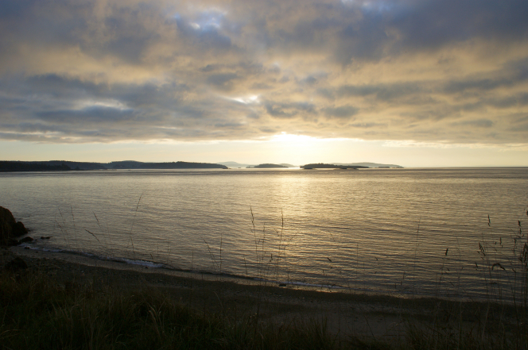
With freedom's holy light
Protect us by thy might
Great God, our King!

