Master, the tempest is raging!
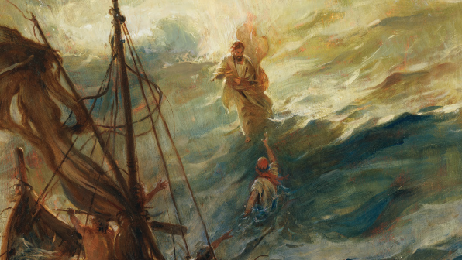
The billows are tossing high!

The sky is o’ershadowed with blackness
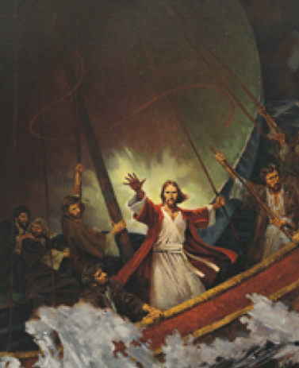
No shelter or help is nigh
Carest thou not that we perish?
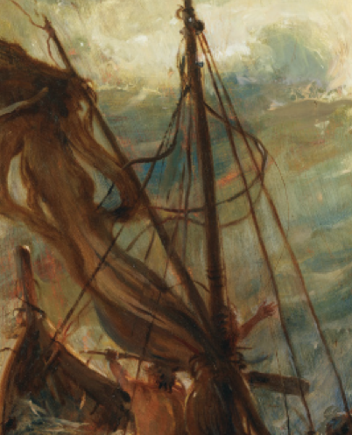
How canst thou lie asleep
When each moment so madly is threat’ning
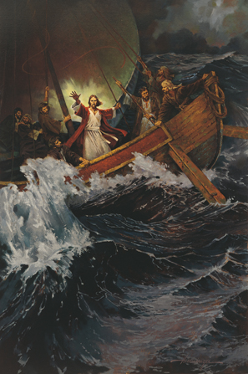
A grave in the angry deep?
The winds and the waves shall obey thy will

Peace, be still
Whether the wrath of the storm-tossed sea
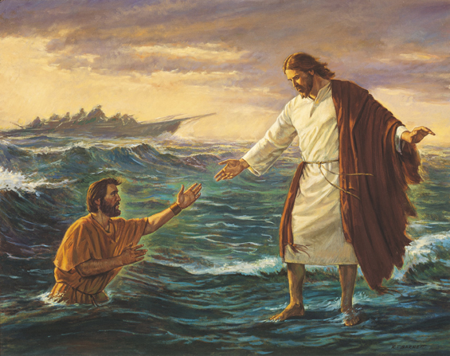
Or demons or men or whatever it be
No waters can swallow the ship where lies
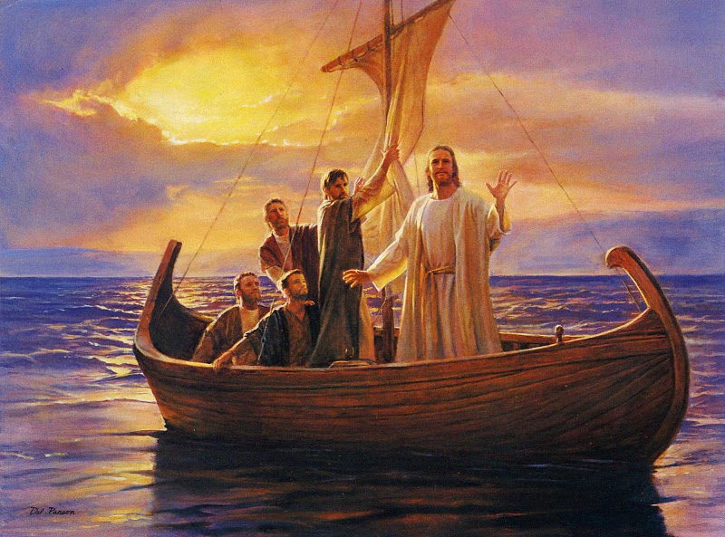
The Master of ocean and earth and skies
They all shall sweetly obey thy will:

Peace, be still
Peace, be still
They all shall sweetly obey thy will:
Peace, peace, be still
Master, with anguish of spirit
I bow in my grief today
The depths of my sad heart are troubled
Oh, waken and save, I pray!
Torrents of sin and of anguish
Sweep o’er my sinking soul
And I perish! I perish! dear Master
Oh, hasten and take control!
Master, the terror is over
The elements sweetly rest
Earth’s sun in the calm lake is mirrored
And heaven’s within my breast
Linger, O blessed Redeemer!
Leave me alone no more
And with joy I shall make the blest harbor
And rest on the blissful shore

