Mary sings to her child
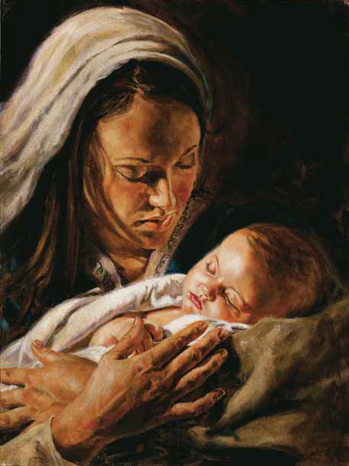
Sleeping soft in her arms
Heavens gift born as prophets said
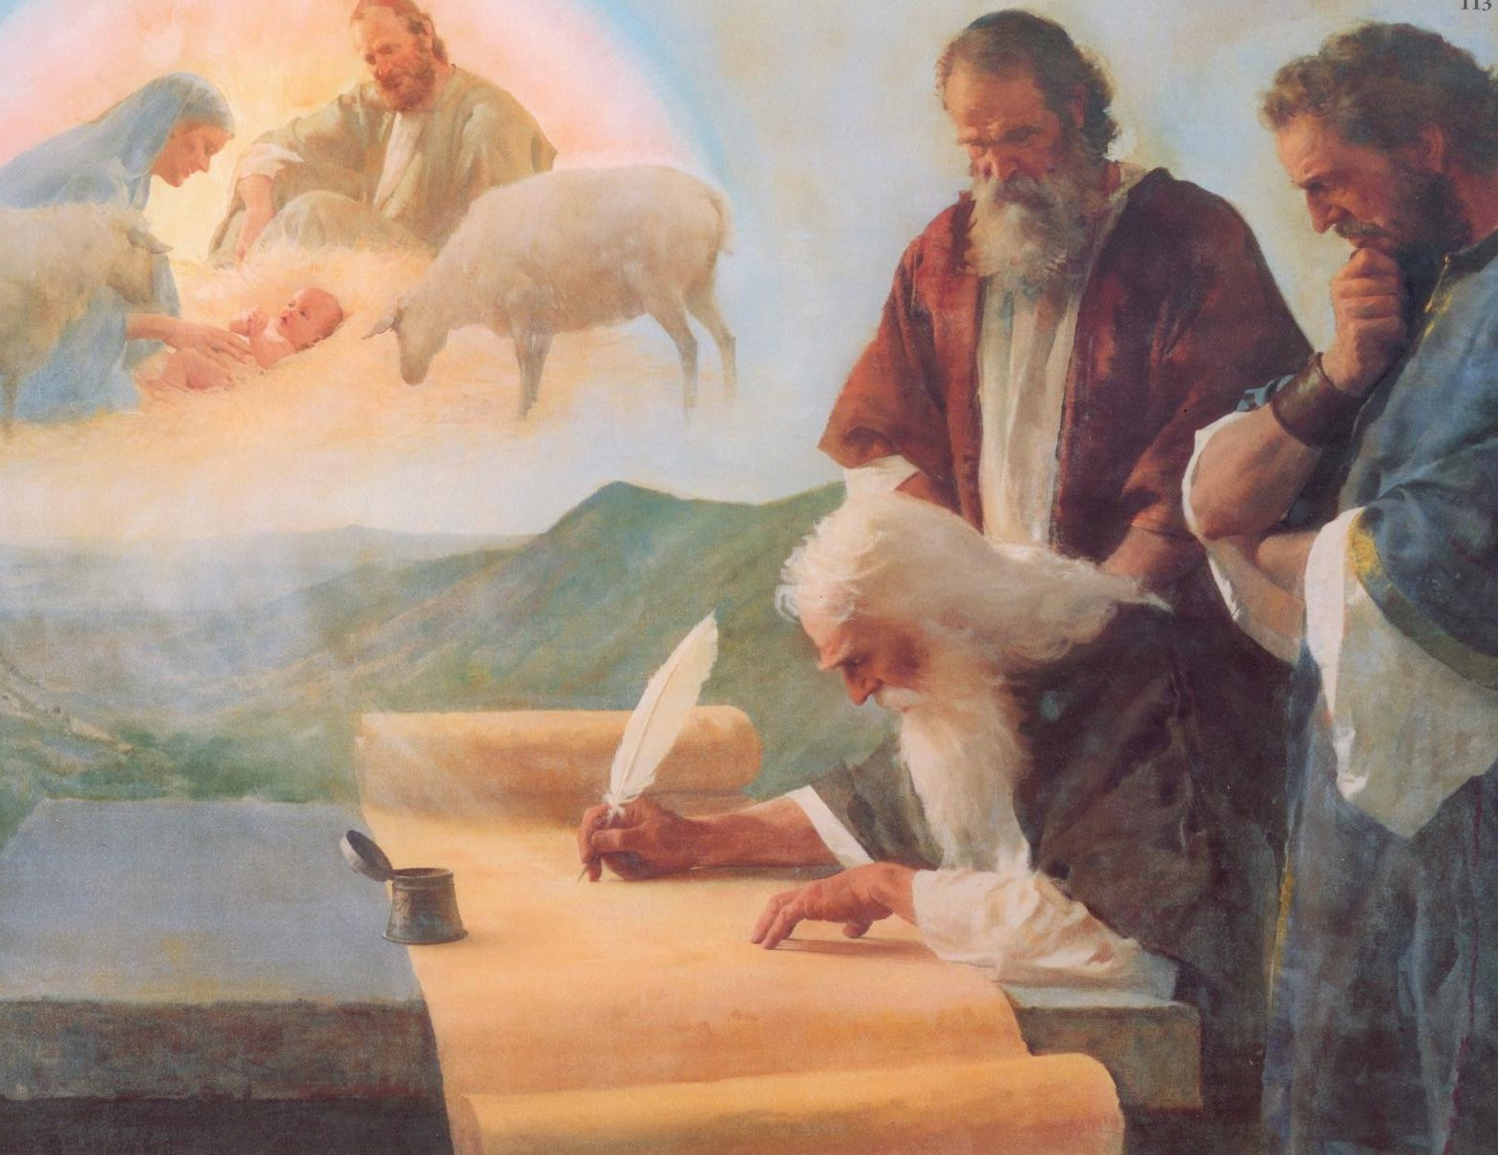

His life one of grace
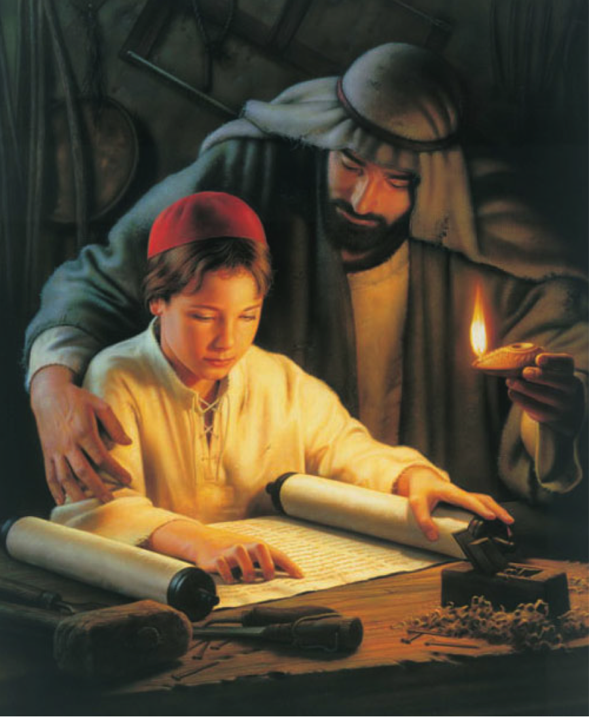
Not of mansion and gold
Born in a manger bed
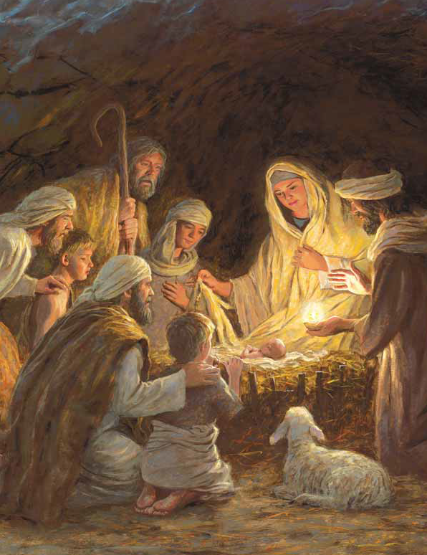
Mary will sing to Him soft lullabies
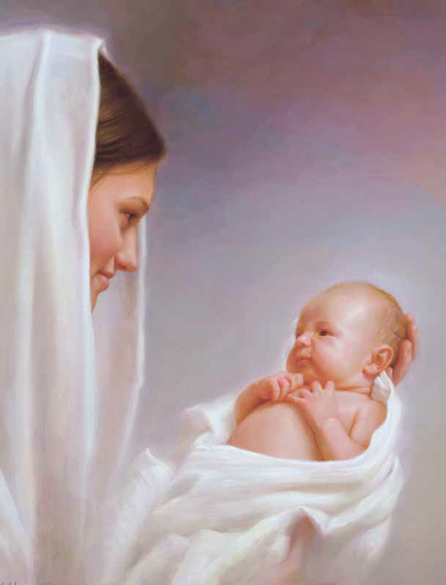
Mary will sing of this night
Mary will sing to her beautiful child
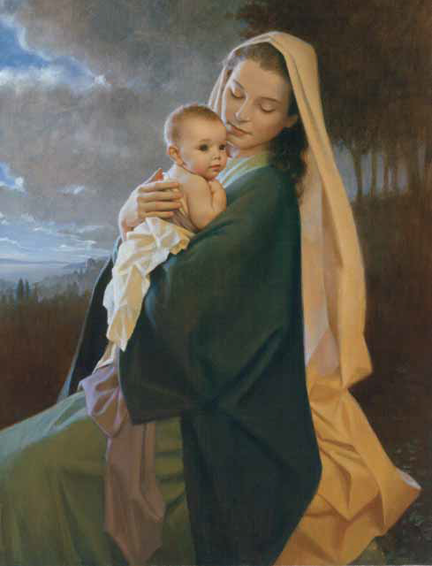
Mary will sing of God’s light

