Jesus said that He
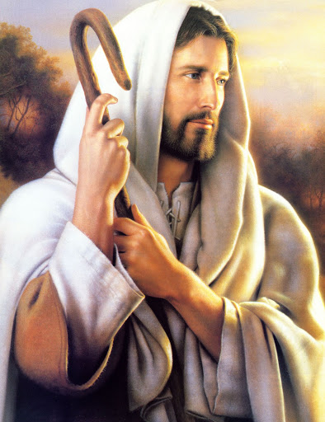
Would be my Shepherd
Jesus said that I
Would be His lamb
He calms my fears
With tender words of comfort
So when He calls
I gladly follow Him
Jesus is my Friend
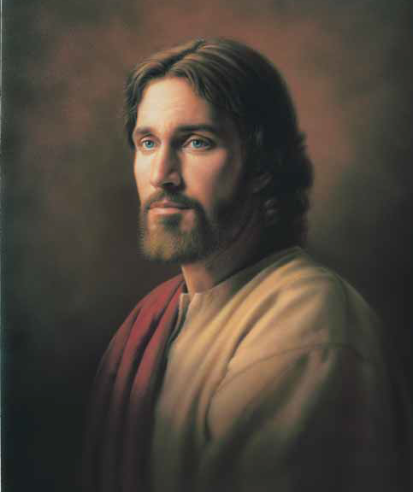
He’s like no other
Jesus is the Son
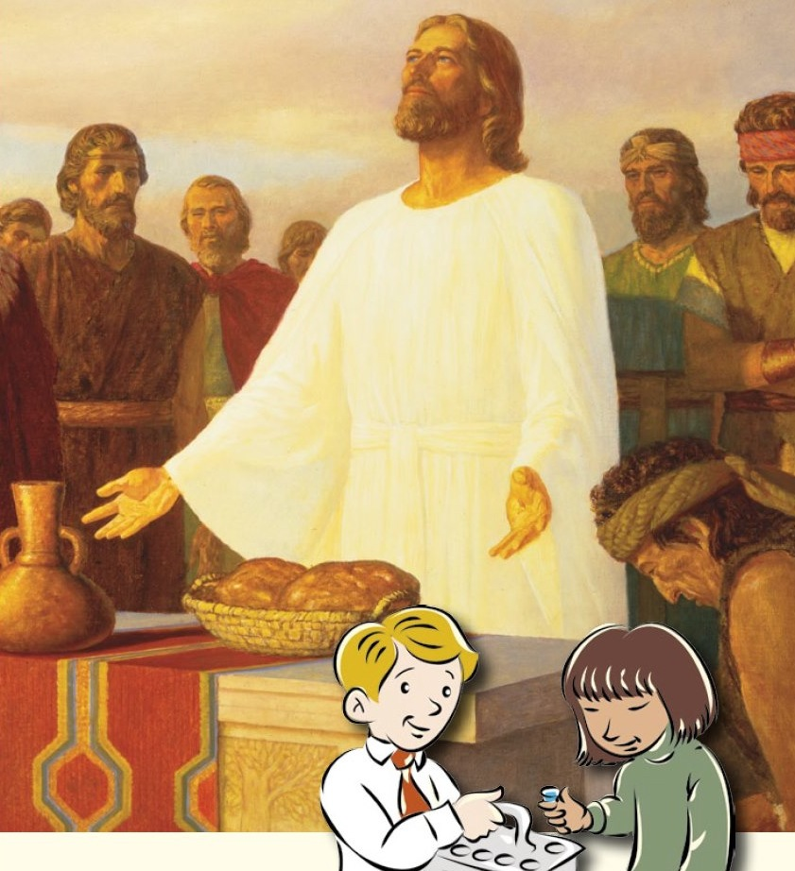
The Bread of Life
With Him I’m not afraid
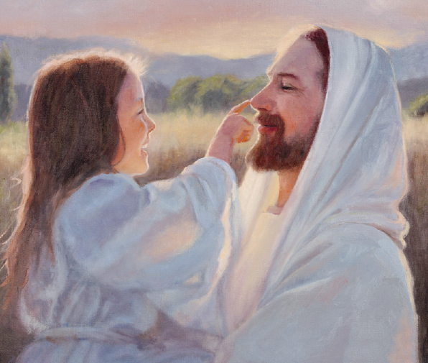
He is my Brother
He knows my heart
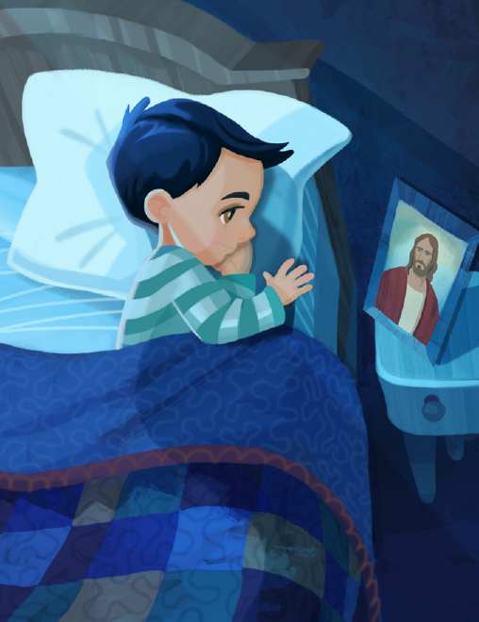
He helps me choose the right
Jesus said that He would be my Savior
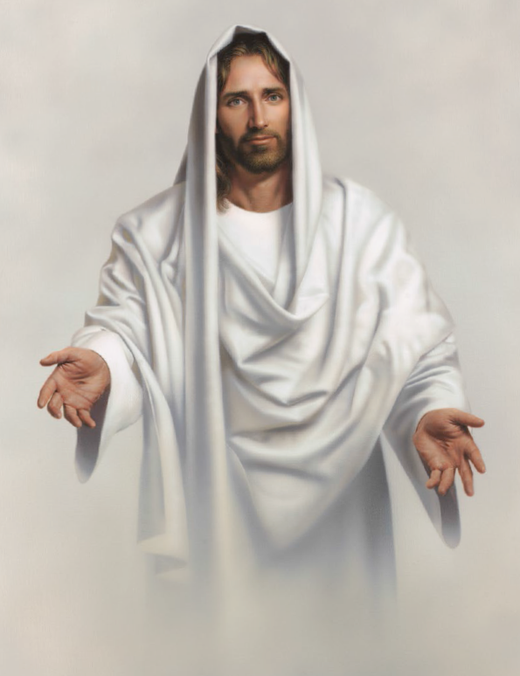
Jesus said that He would be my Light
He made the stars the oceans
My Creator
Redeemer Lord the Way
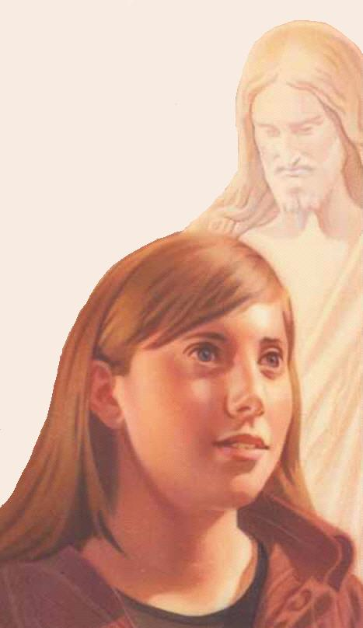
The Truth the Life
So many names of Jesus
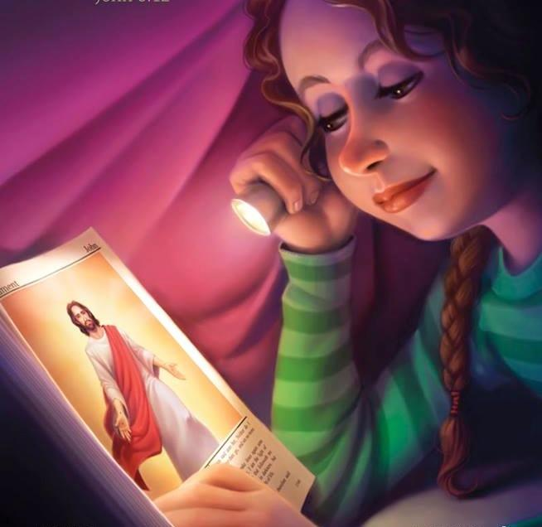
So many ways to know Him
And every name means “I love you”

The Prince of Peace the King of Kings
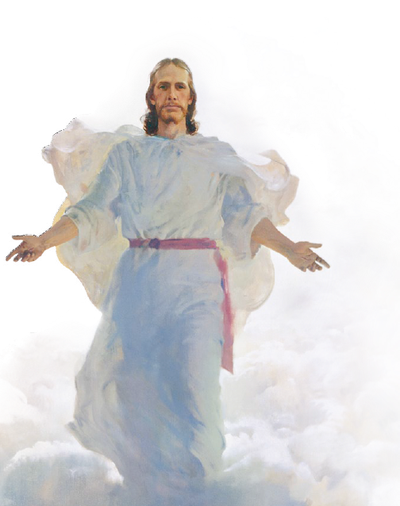
Jesus Christ salvation brings

