When Baby Jesus came to earth
So many years ago
The inn was full, no room to spare
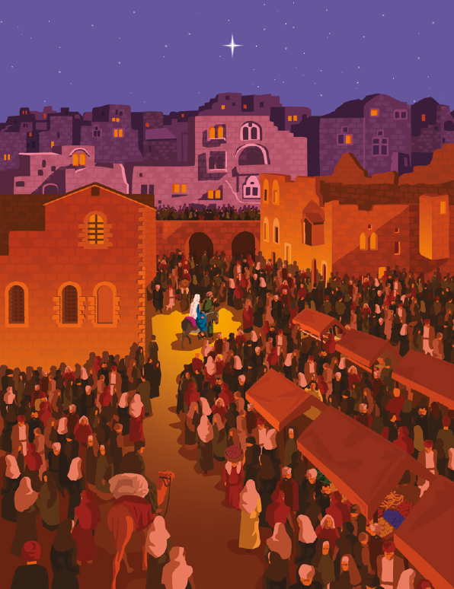
Poor Mary found no safe place there
For our dear Savior’s birth
Just like the inn of Bethlehem
Our lives can be so full
Of all the busy things we do
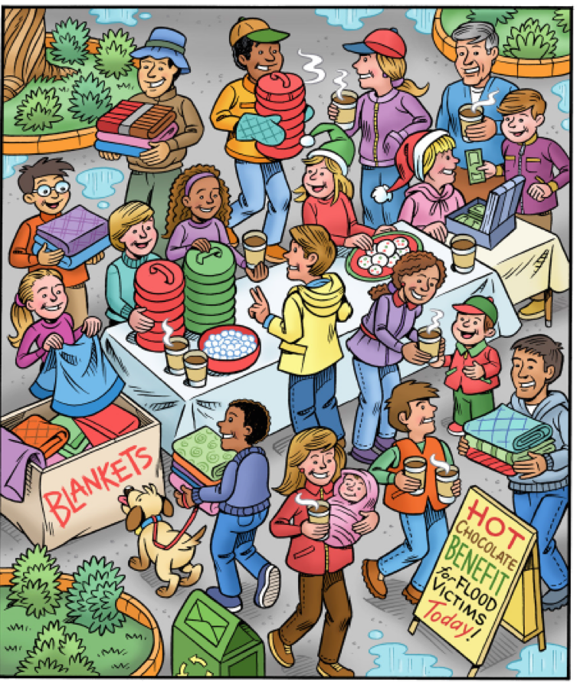
That sometimes without meaning to
We don’t leave room for Him
We can’t go back to Bethlehem
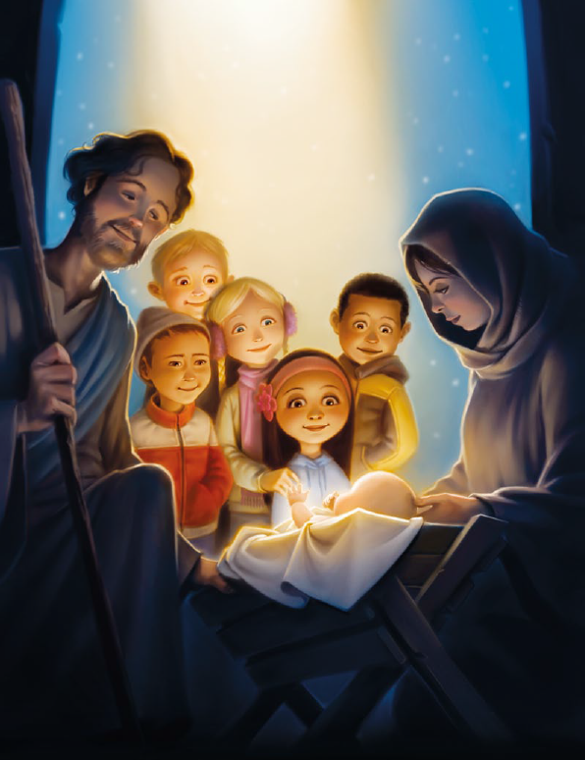
To let the
Dear Child in
But we can open our heart’s door
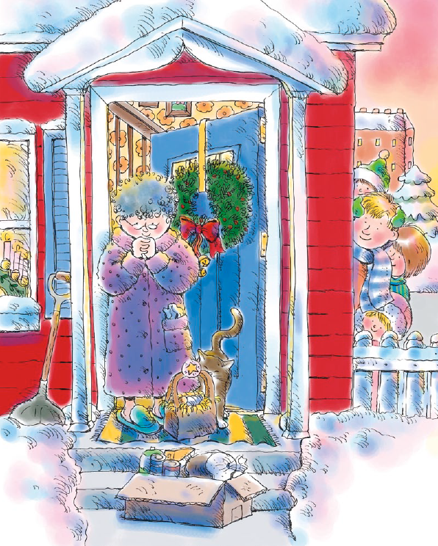
To young and old
to rich and poor
And share Christ’s love with them

