Little One

By

Rebecca Woodworth

New Era Dec 1986

Little One, sleeping so peacefully

In a stable so bare

Not a sound

in the air

Little One, master of all the world,

Did you know that God's plan for you

Will save all men some day?

Little One, Little King,

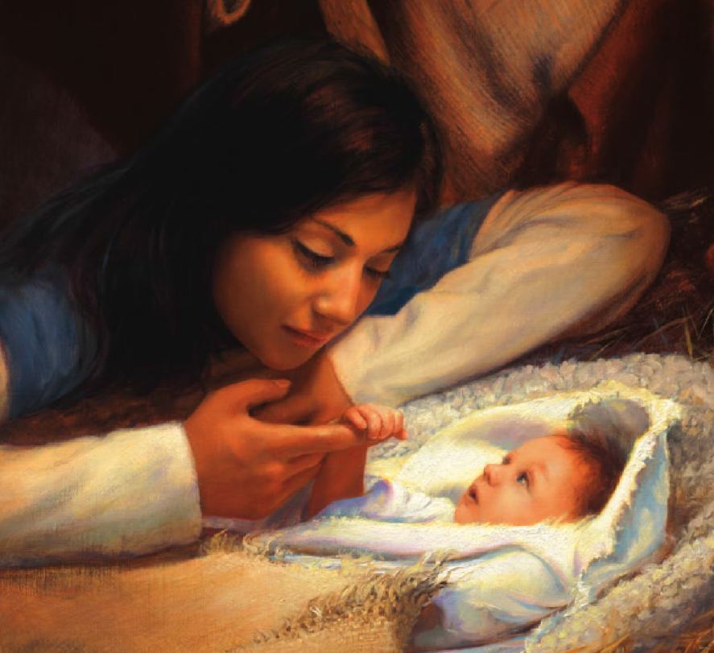

The love of God is my quest

All my life Little One