I want to be kind to ev'ryone
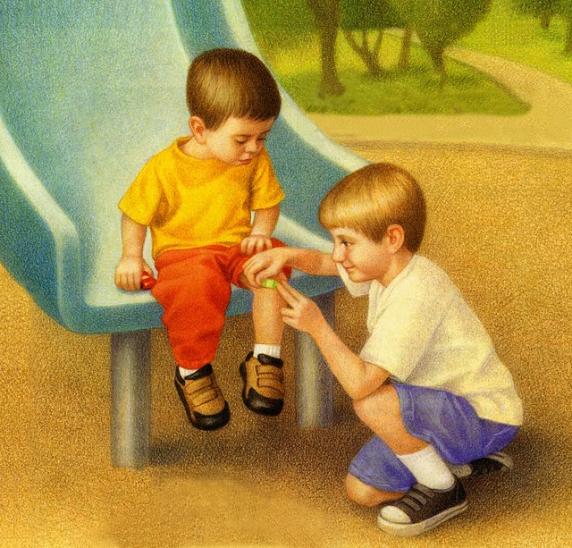
For that is right you see
So I say to myself, Remember this:
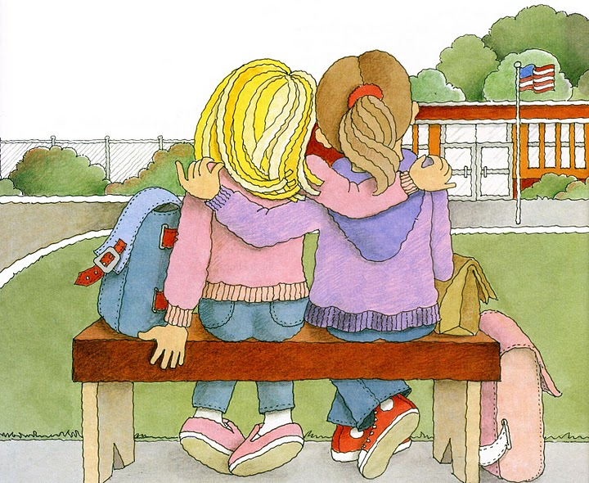
Kindness begins with me

