If the Savior stood beside me
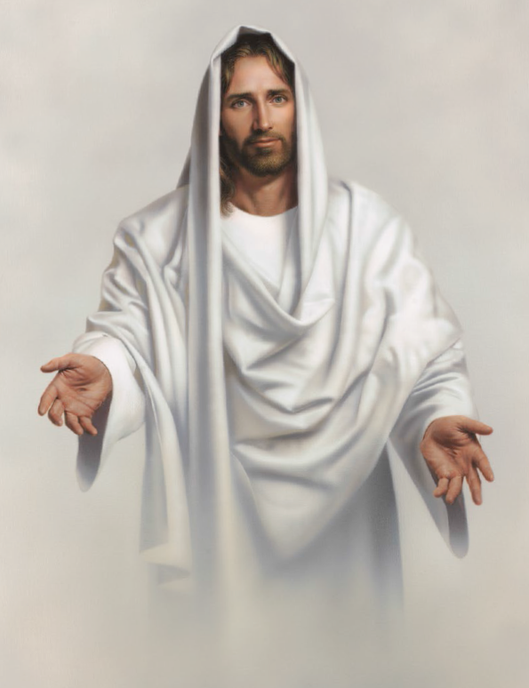

Would I do
The things I do
Would I think of his commandments
And try harder to be true?
Would I follow his example?
Would I live more righteously?
If I could see the Savior standing nigh
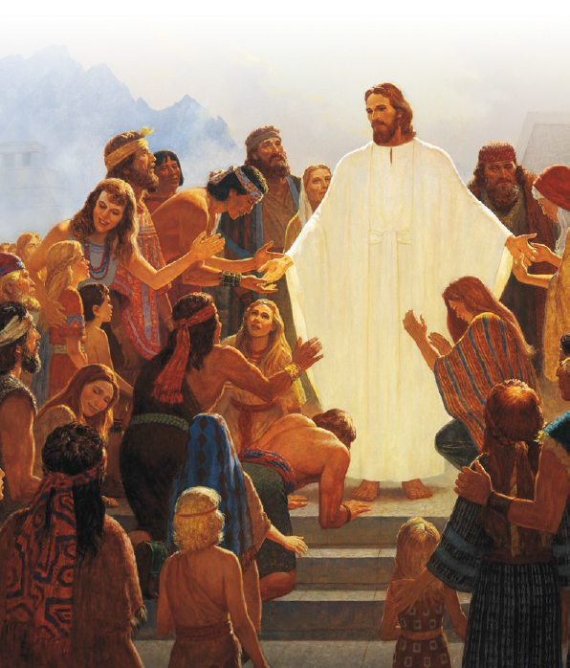
Watching over me
I want to be kind to ev'ryone
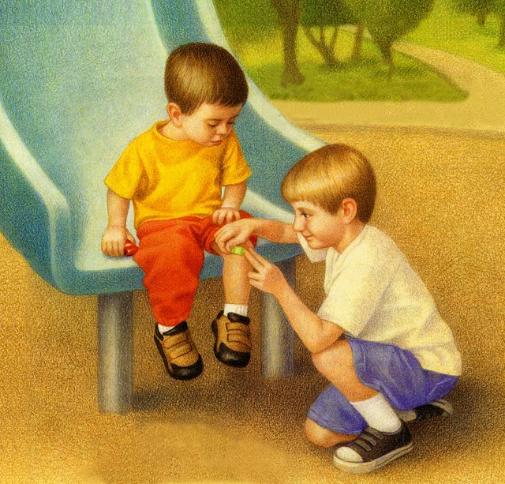
For that is right you see
So I say to myself, Remember this:
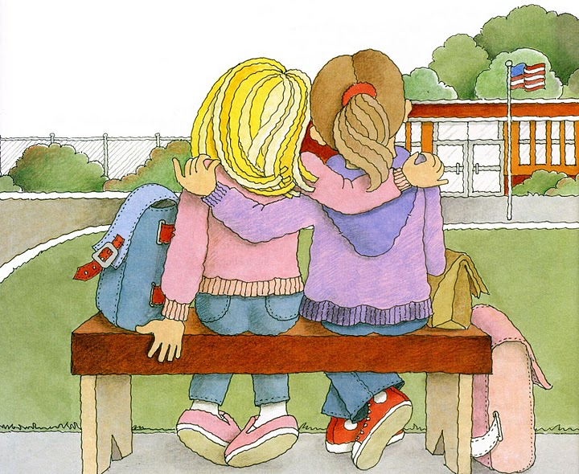
Kindness begins with me
If the Savior stood beside me

Would I say
The things I say
Would my words be true and kind
If he were never far away?
Would I try to share the gospel?

Would I speak more rev’rently?
If I could see the Savior standing nigh
Watching over me

