The Lord commanded Nephi to go and get the plates
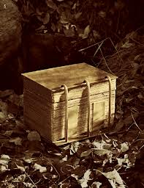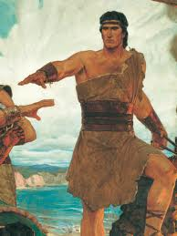
From the wicked Laban inside the city gates

Laman and Lemuel were both afraid to try
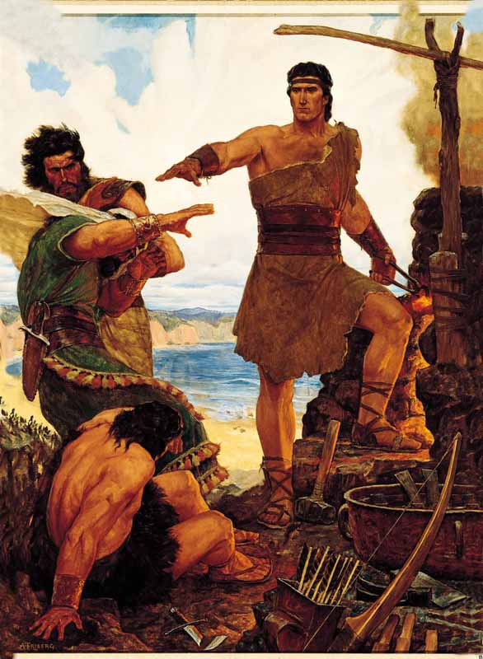
Nephi was courageous
This was his reply
I will go I will do- The thing the Lord commands
I know the Lord provides a way- He wants me to obey
I will go I will do- The thing the Lord commands
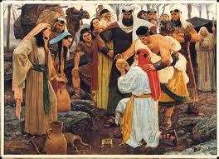
I know the Lord provides a way- He wants me to obey

Keep the commandments
Keep the commandments
In this there is safety
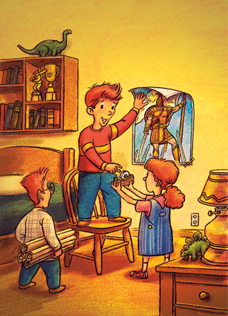
In this there is peace
He will send blessings
He will send blessings
Words of a prophet
Keep the commandments
In this there is safety and peace
I will go I will do- The thing the Lord commands
I know the Lord provides a way- He wants me to obey
I will go I will do- The thing the Lord commands

I know the Lord provides a way- He wants me to obey

