Oh, how lovely was the morning!
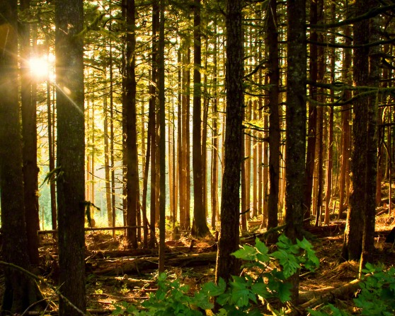
Radiant beamed the sun above
Bees were humming Sweet birds singing
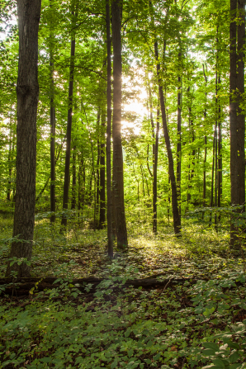
Music ringing thru the grove
When within the shady woodland
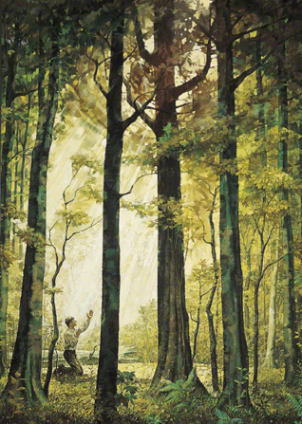
Joseph sought the God of love
When within the shady woodland
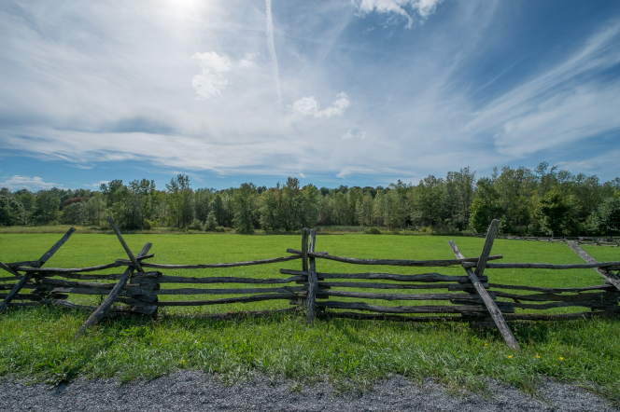
Joseph sought the God of love
Humbly kneeling, sweet appealing—
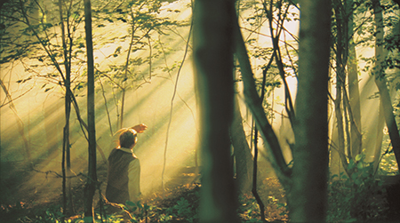
’Twas the boy’s first uttered prayer—
When the pow’rs of sin assailing
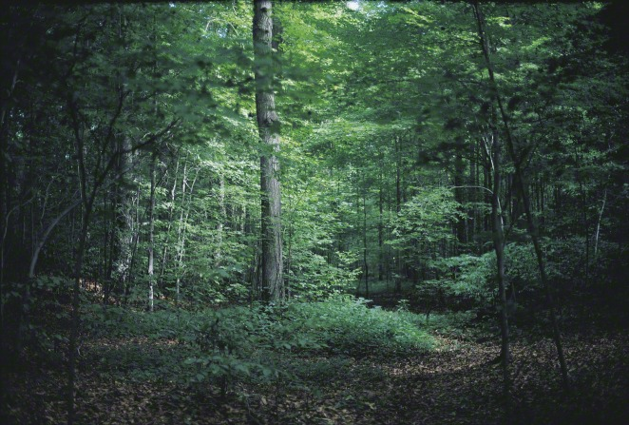
Filled his soul with deep despair
But undaunted, still he trusted
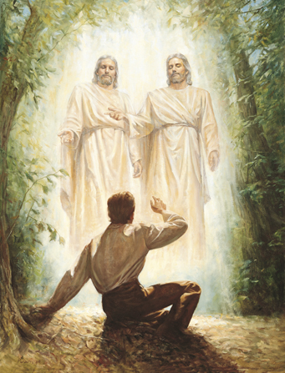
In his Heav’nly Father’s care
But undaunted still he trusted
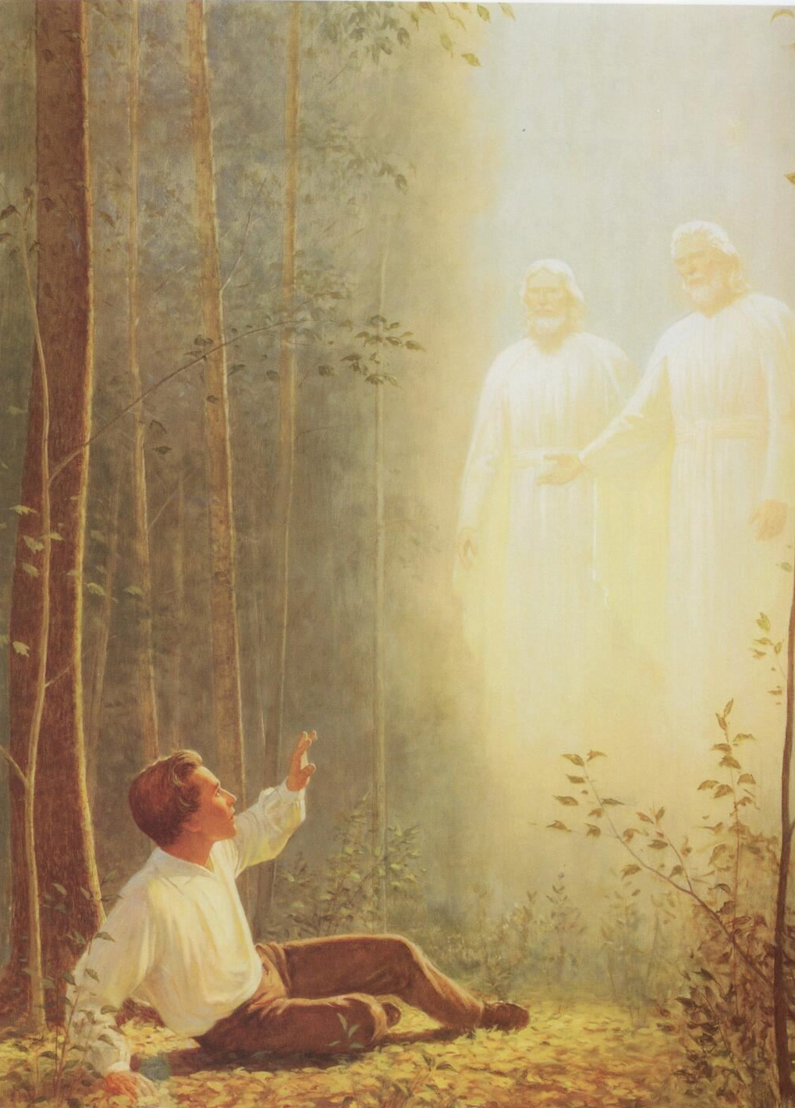
In his Heav’nly Father’s care
Suddenly a light descended
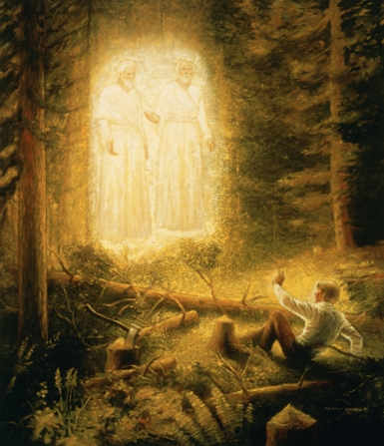
Brighter far than noonday sun
And a shining, glorious pillar
O’er him fell around him shone
While appeared two heav’nly beings
God the Father and the Son
While appeared two heav’nly beings
God the Father and the Son
“Joseph, this is my Beloved; Hear him!”
Oh, how sweet the word!
Joseph’s humble prayer was answered
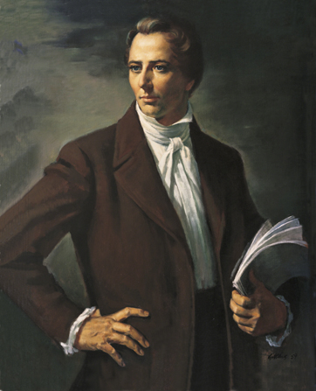
And he listened to the Lord
Oh, what rapture filled his bosom,
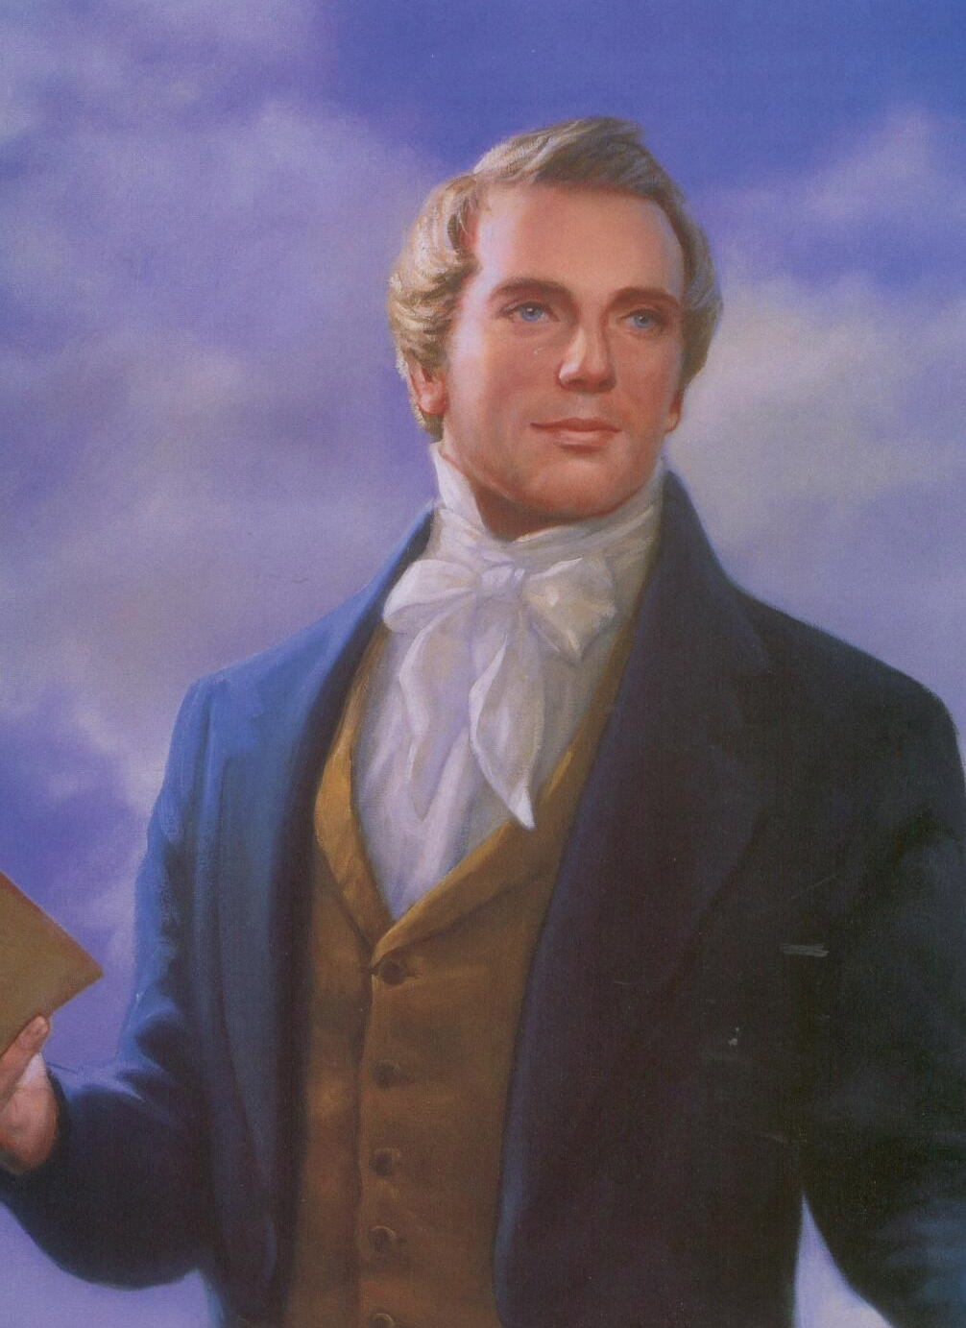
For he saw the living God
Oh, what rapture filled his bosom,
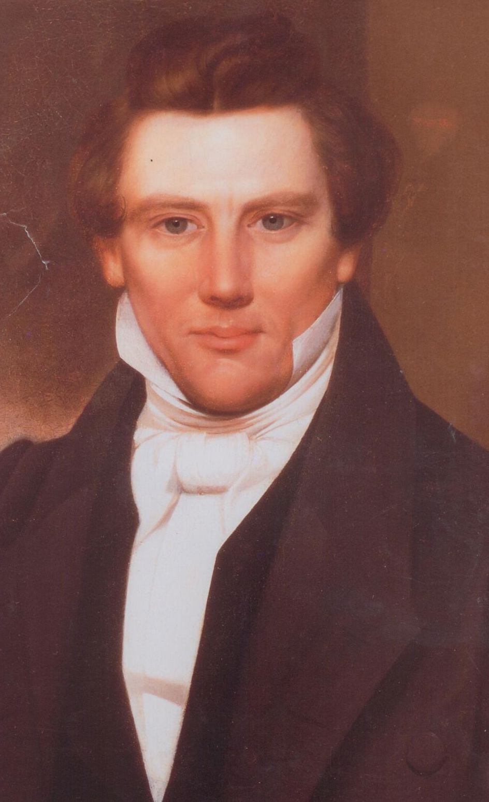
For he saw the living God

