Joseph had a question
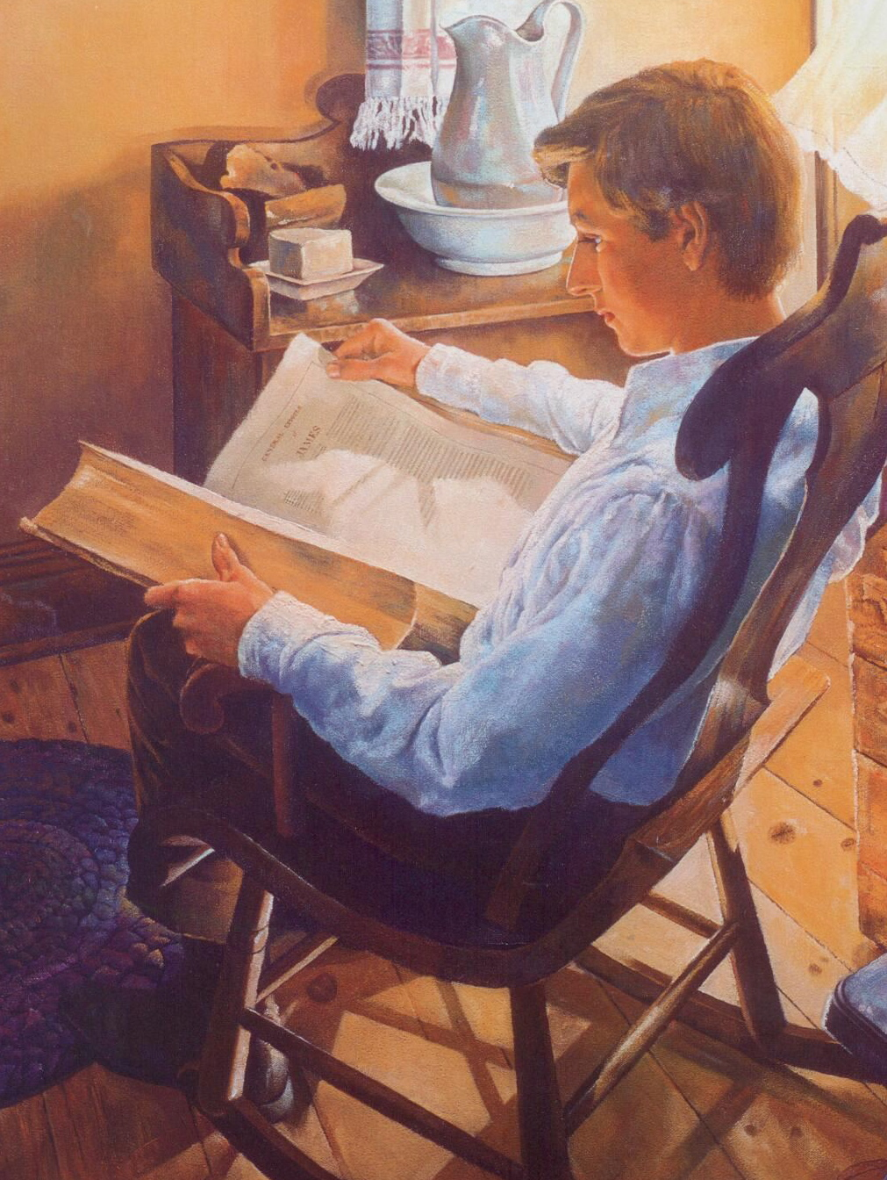
So he read God’s word
There he learned that he could
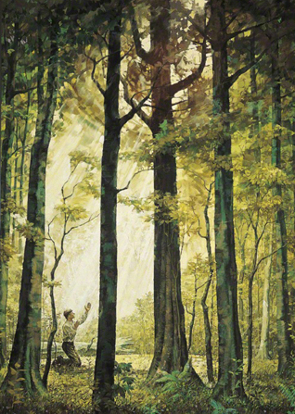
Always ask the Lord
Joseph needed wisdom
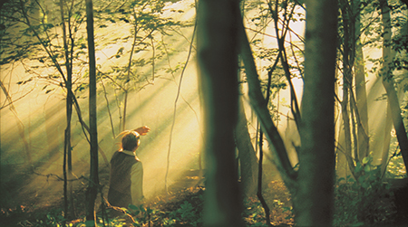
So he knelt to pray

Trusting God would answer him
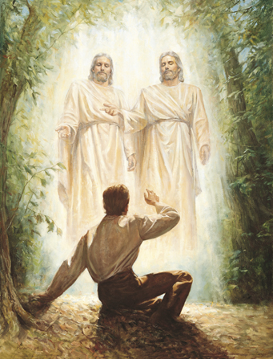
And show the way
In a light above him
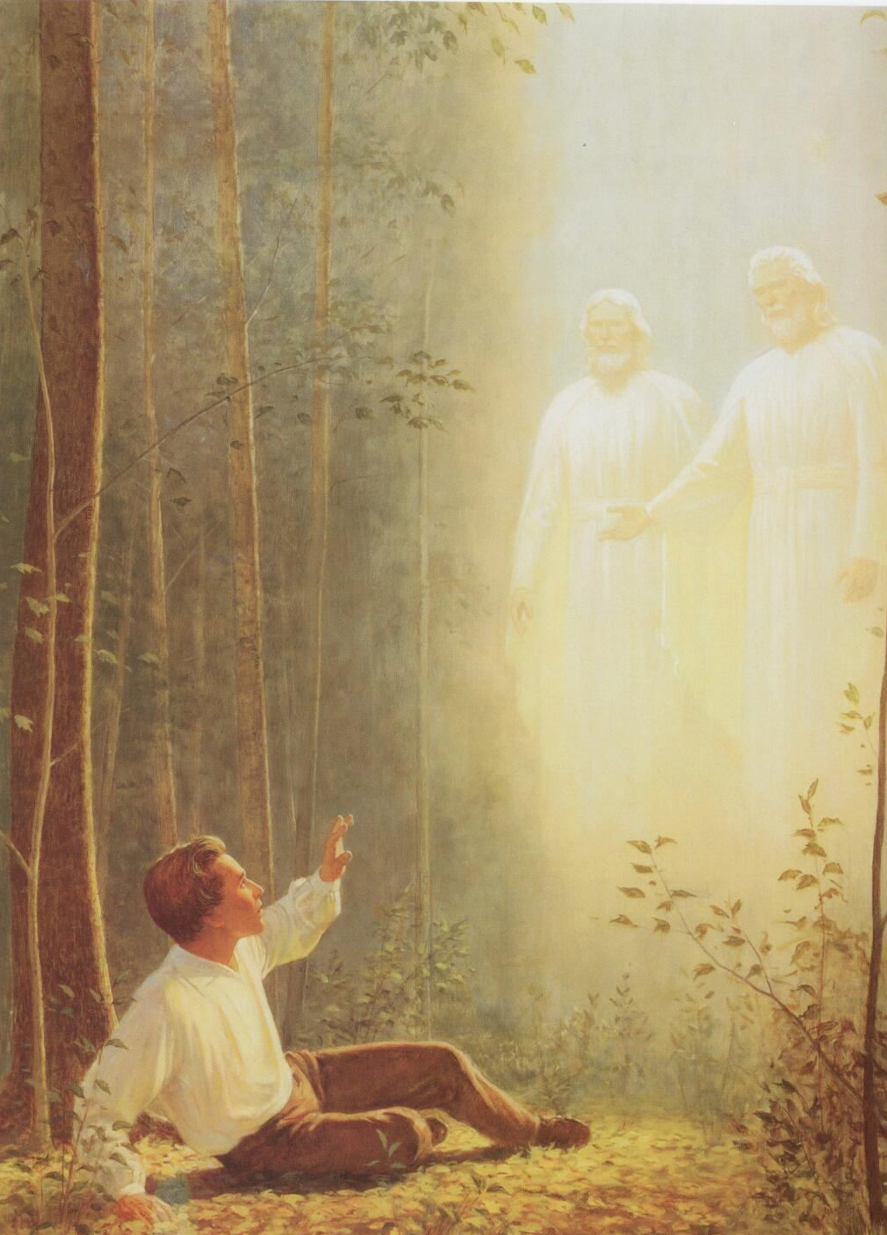
Brighter than the sun
Joseph saw our Father
And His Holy Son
When I’m needing wisdom
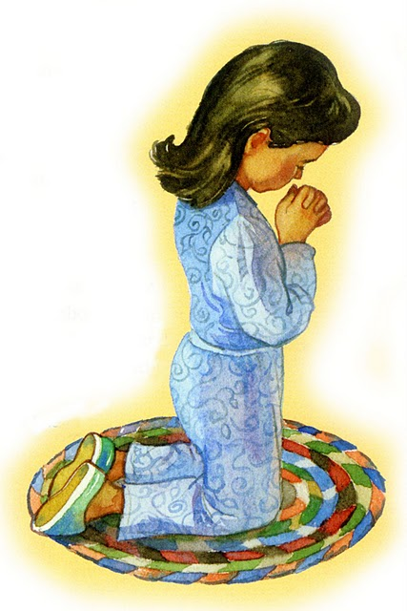
I can kneel and pray
God, who answered Joseph
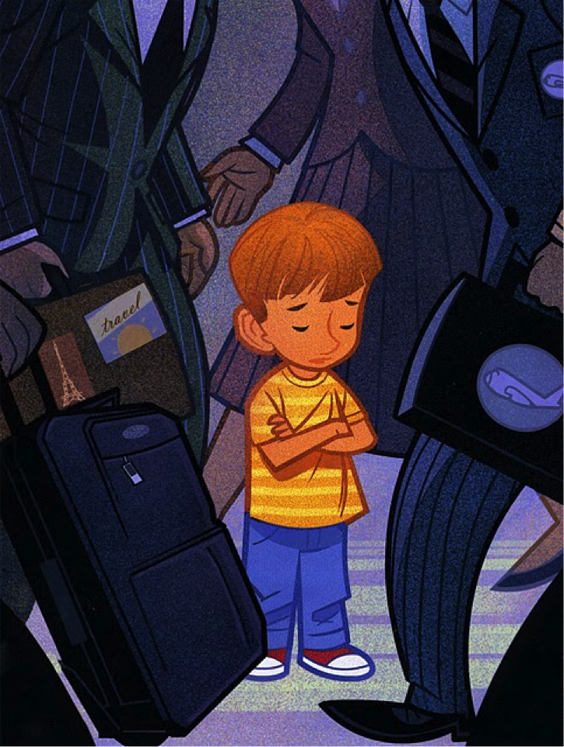
Answers me today
I may not see a vision
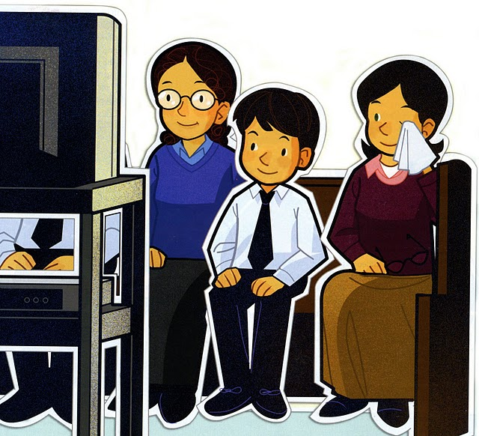
But I can know and feel
That God our Heav’nly Father
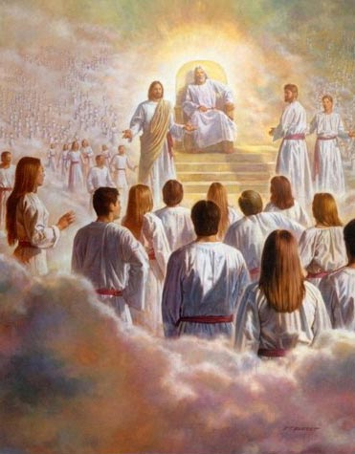
And His Son are real
They always love and hear me
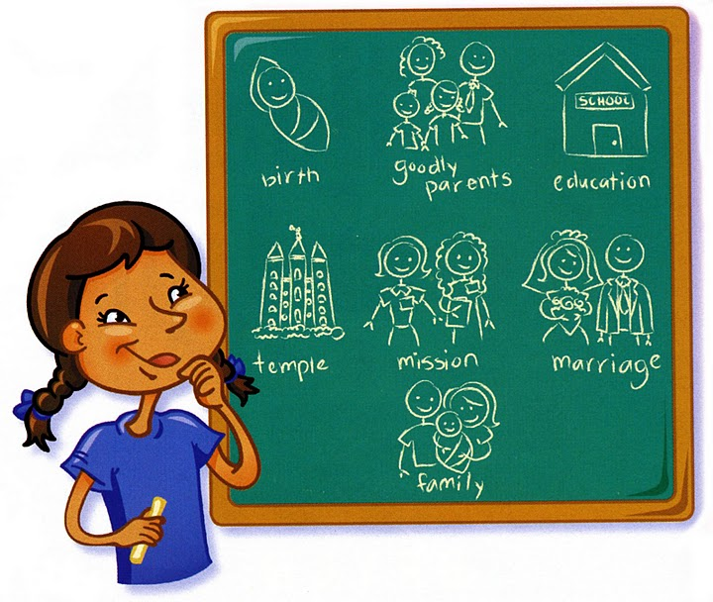

I know this is true
Joseph prayed in faith
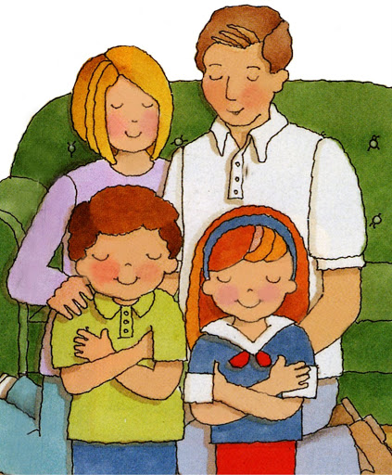
And I can too

