Joseph had a question
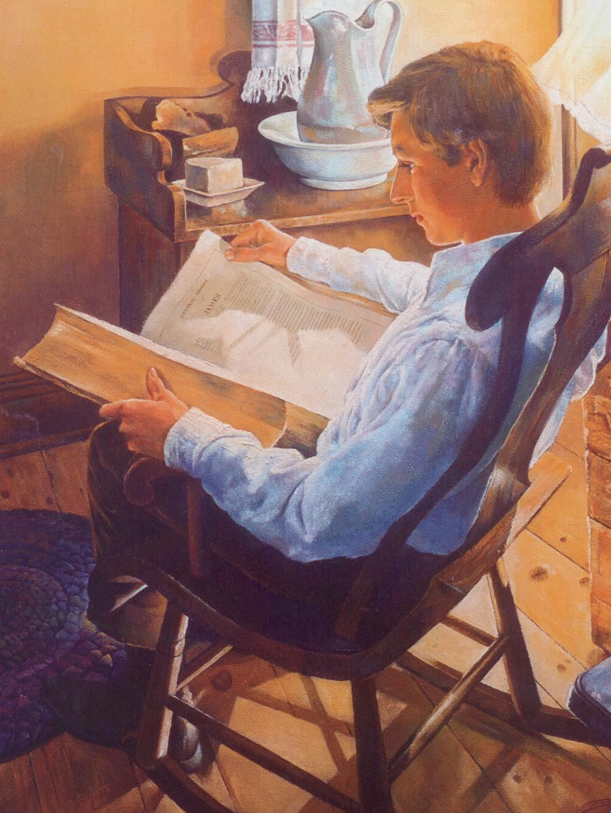
So he read God’s word
If you’re lacking wisdom
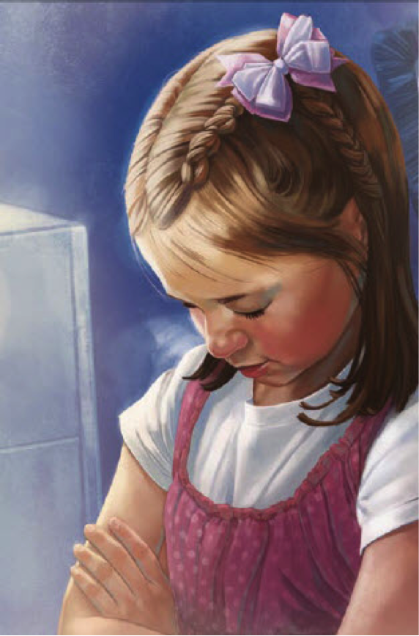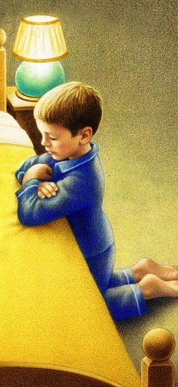
You can ask of God
Joseph wanted wisdom
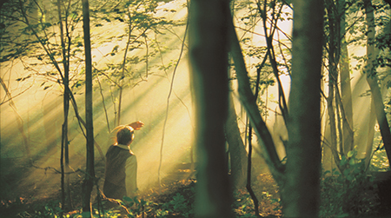
So he knelt and prayed
Darkness came around him
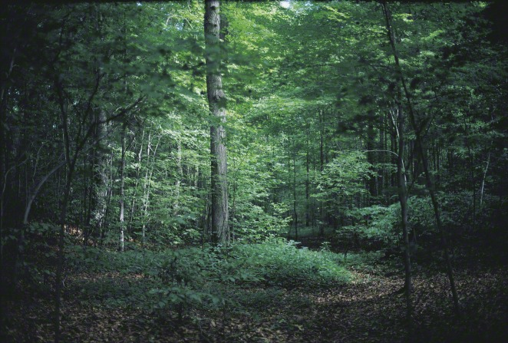
And he felt afraid

In a light above him
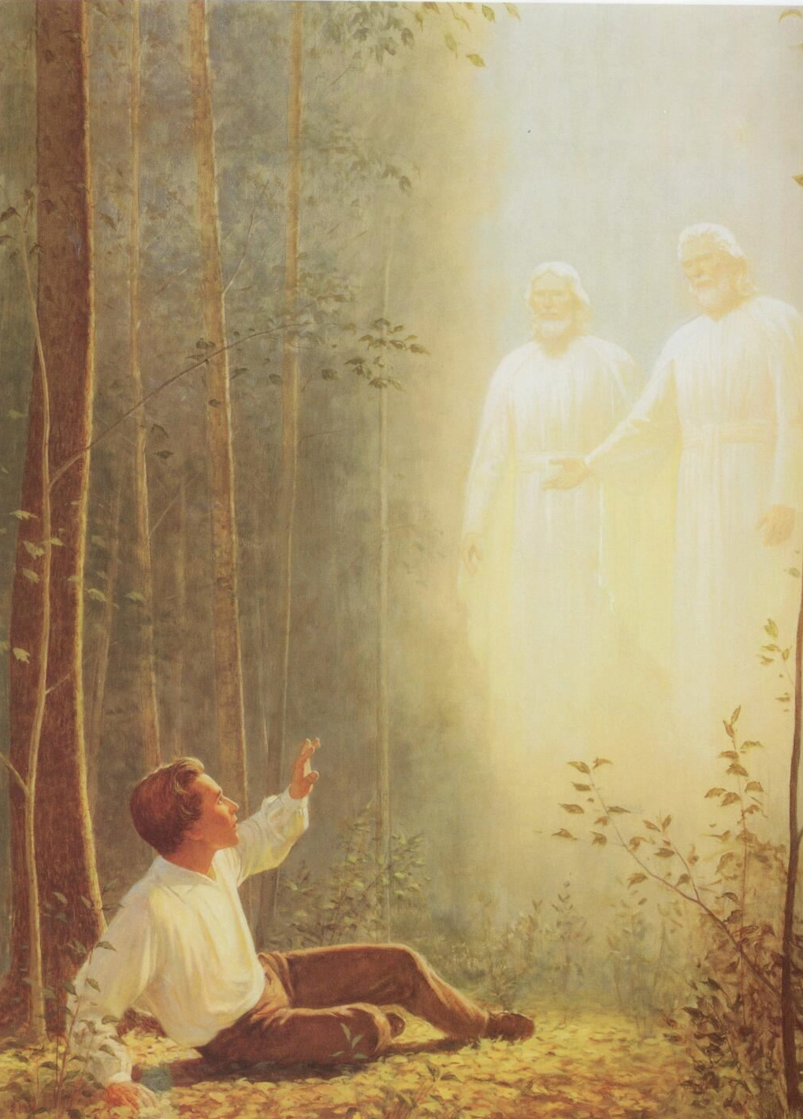
Brighter than the sun
Joseph saw our Father
And His Holy Son
When I feel confusion
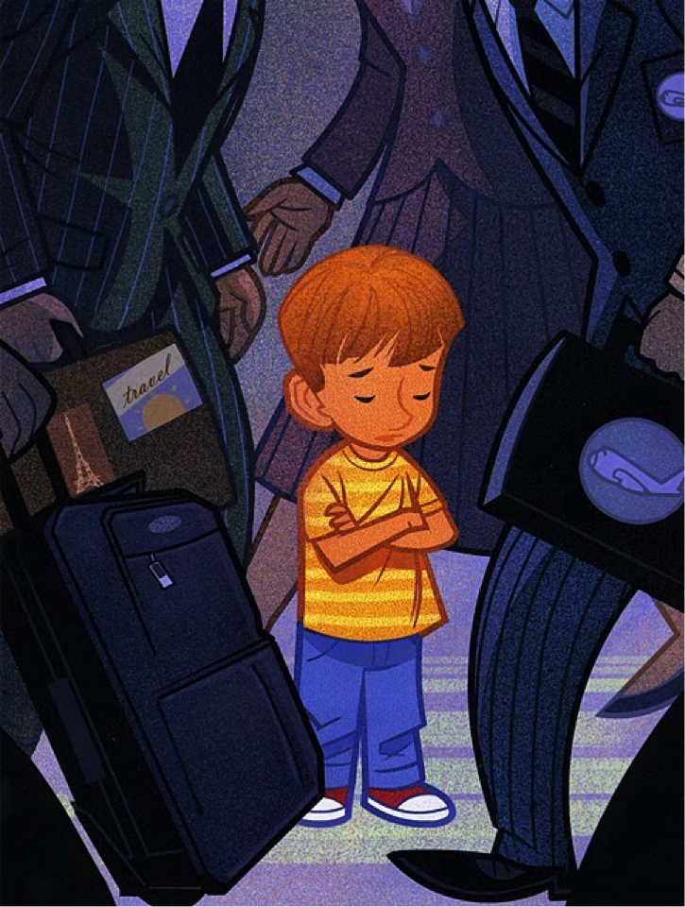
I can kneel and pray
God, who answered Joseph
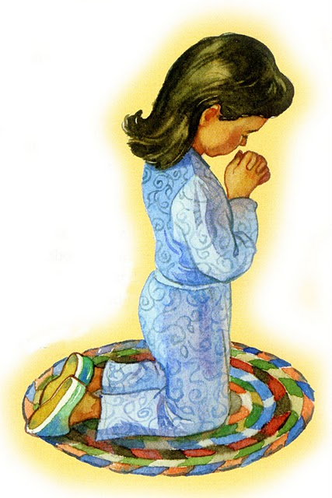
Answers me today
I may not see a vision
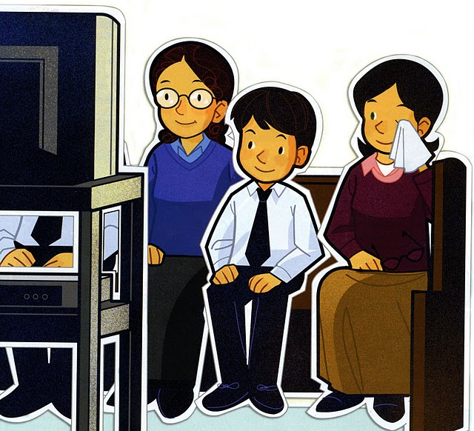
But I can know and feel
That God our Heav’nly Father
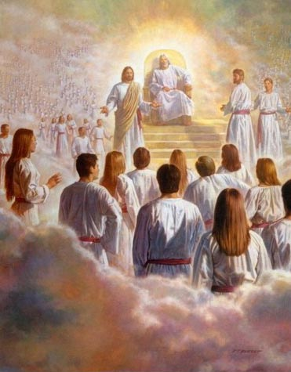
And His Son are real
It isn’t just a story
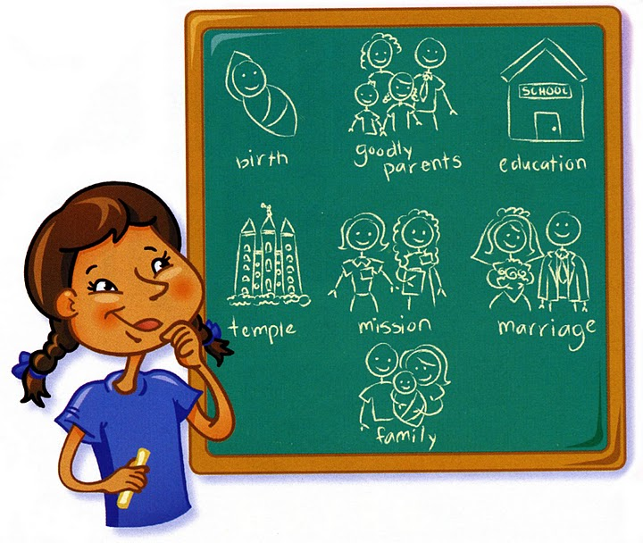

For I know it’s true
Joseph prayed in faith
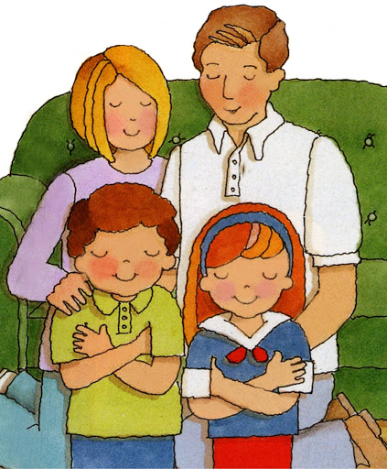
And I can too

