Jesus was no ordinary man
But there were some who did not understand
They saw him working miracles
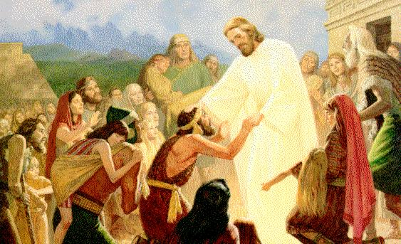
But some were still deceived
Why did they not believe?
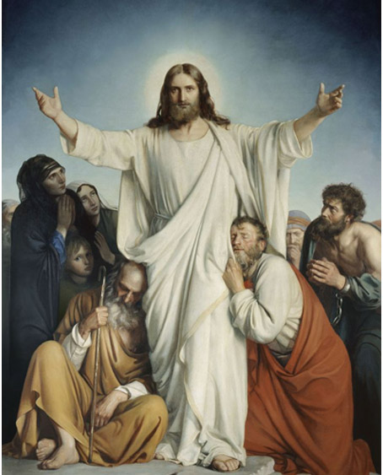
When with few loaves and fishes
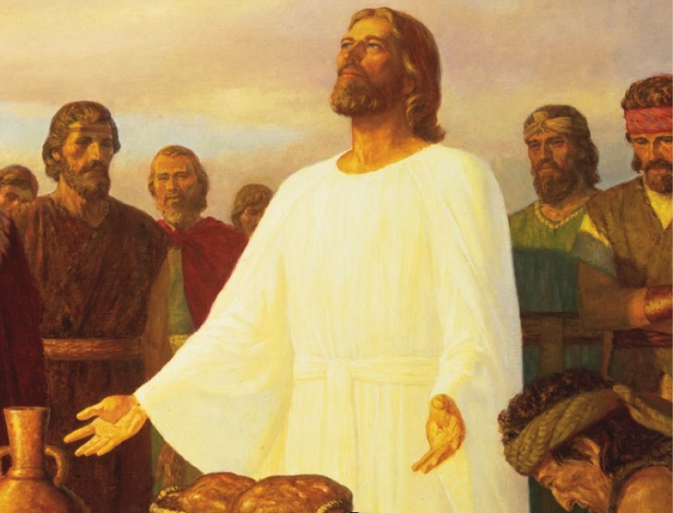
The multitude were fed
When he showed them his pow'r to heal
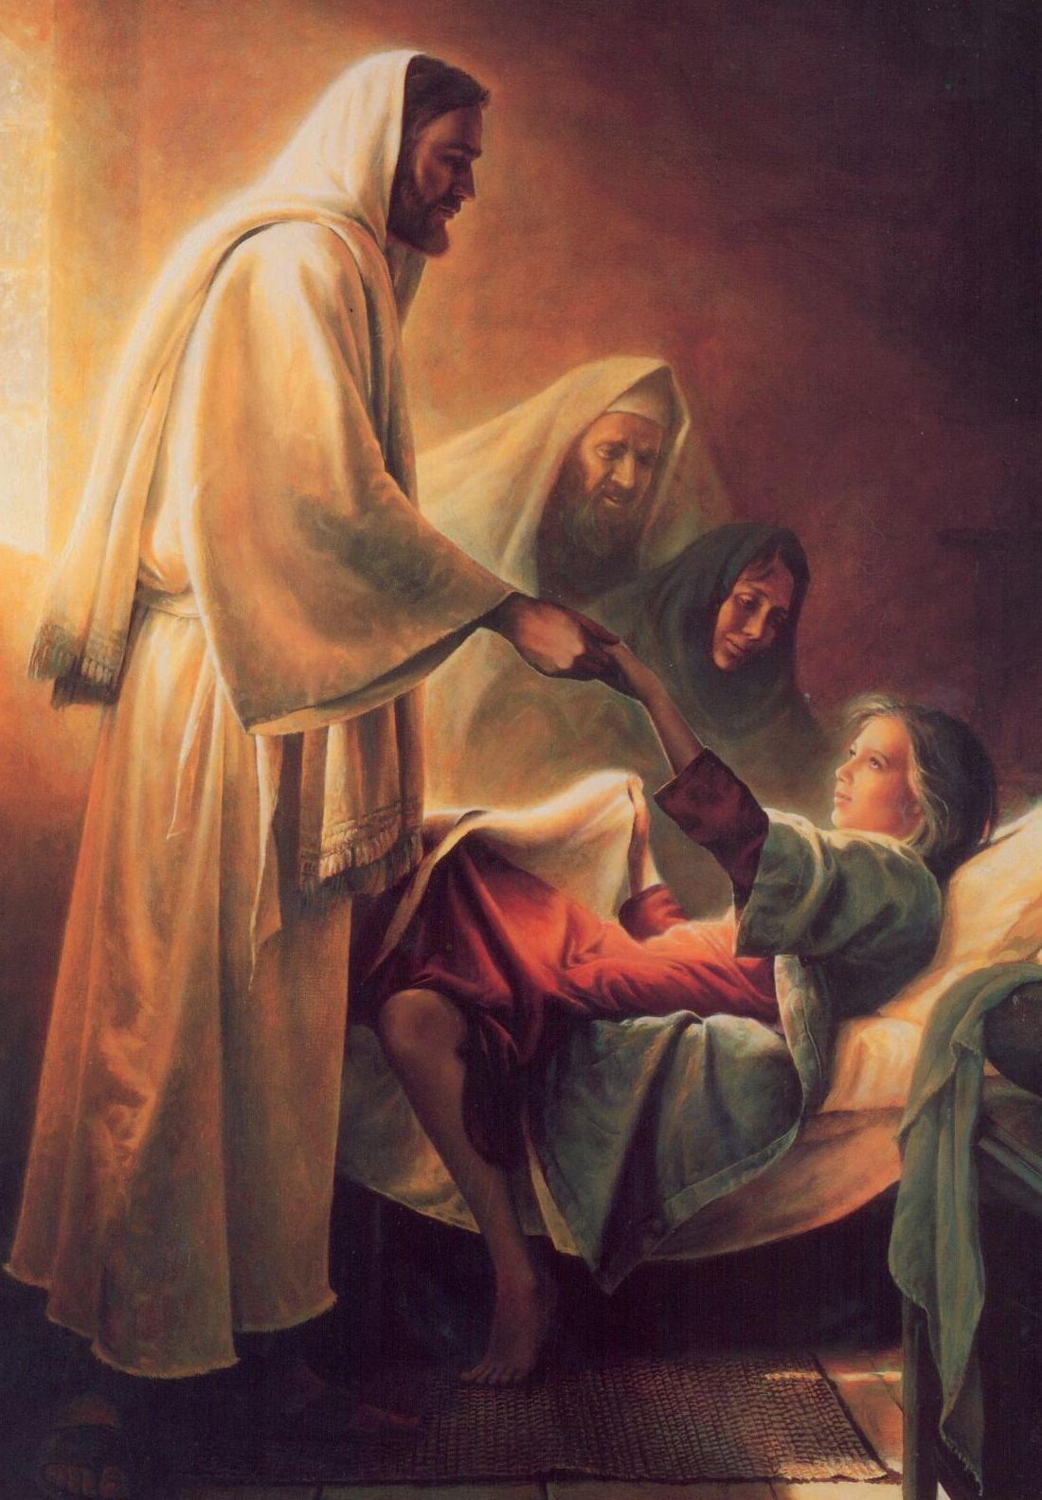
And even raised the dead
When he walked upon the water
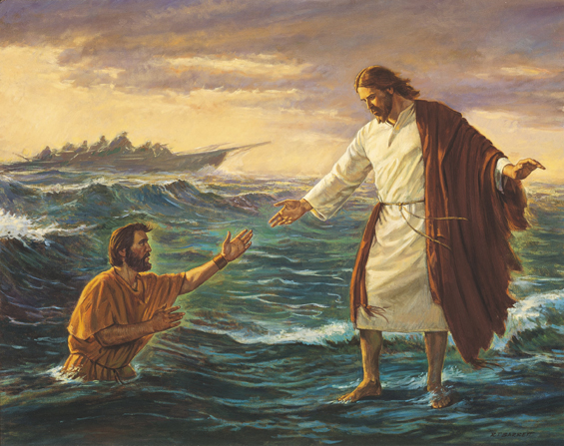
And he calmed the raging sea
Why did they not believe?
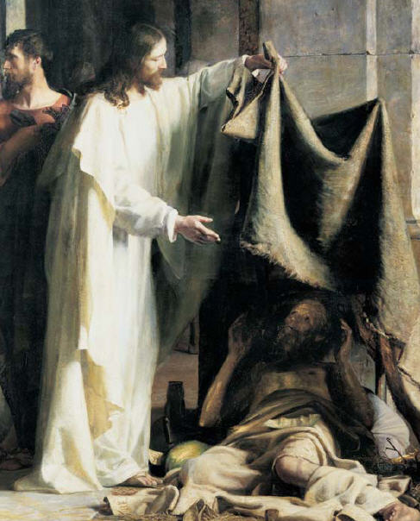
Jesus was no ordinary man.
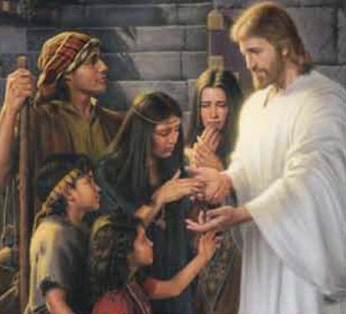
But there were some who did not understand
They saw him working miracles
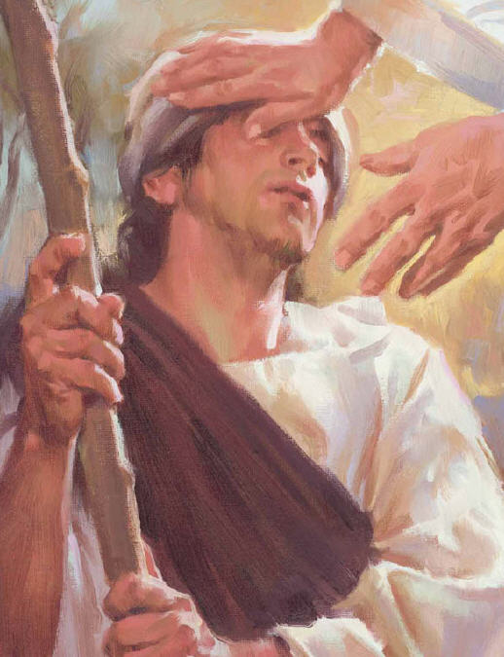
but some were still deceived
Why did they not believe?
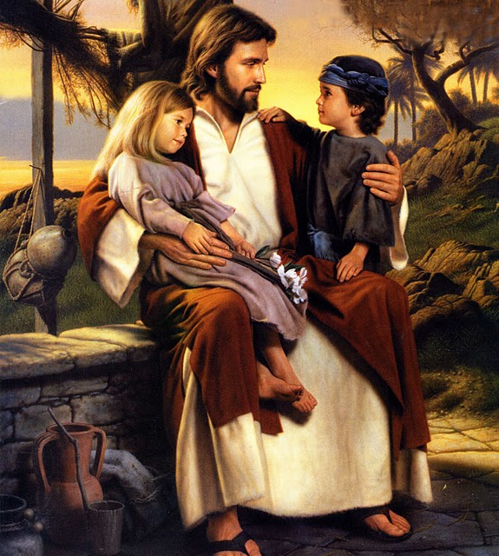

When his faith filled the fish-nets
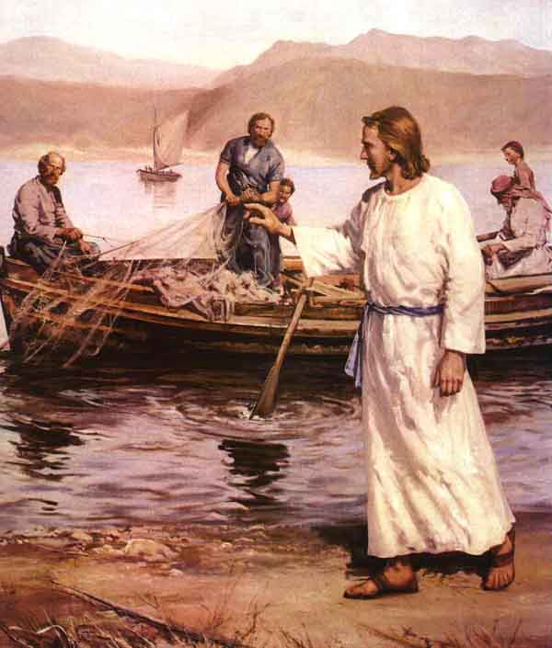
Gave sight unto the blind
When they saw at his bidding
Even water turned to wine
When he offered all he had to them
If they would but receive
Why did they not believe?
Jesus was no ordinary man
The pow'r to bless and heal was in his hands
They saw him cleanse the leper
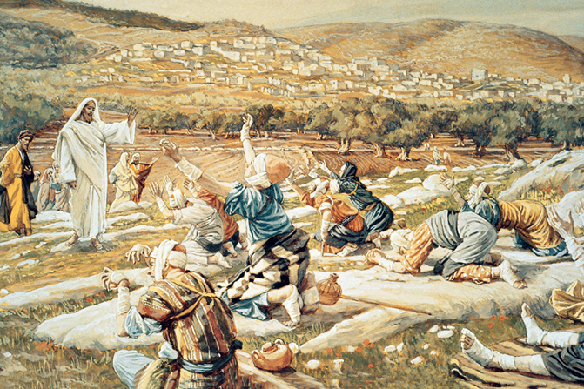
They saw him heal the lame
They must have sensed divinity
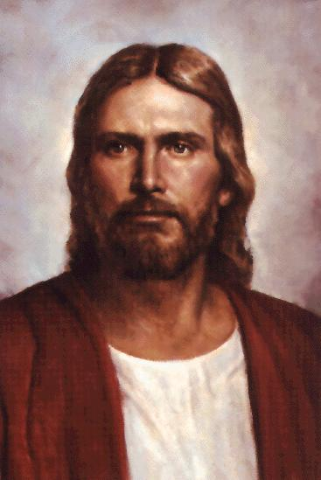
And known from whence he came
But understanding not his cause
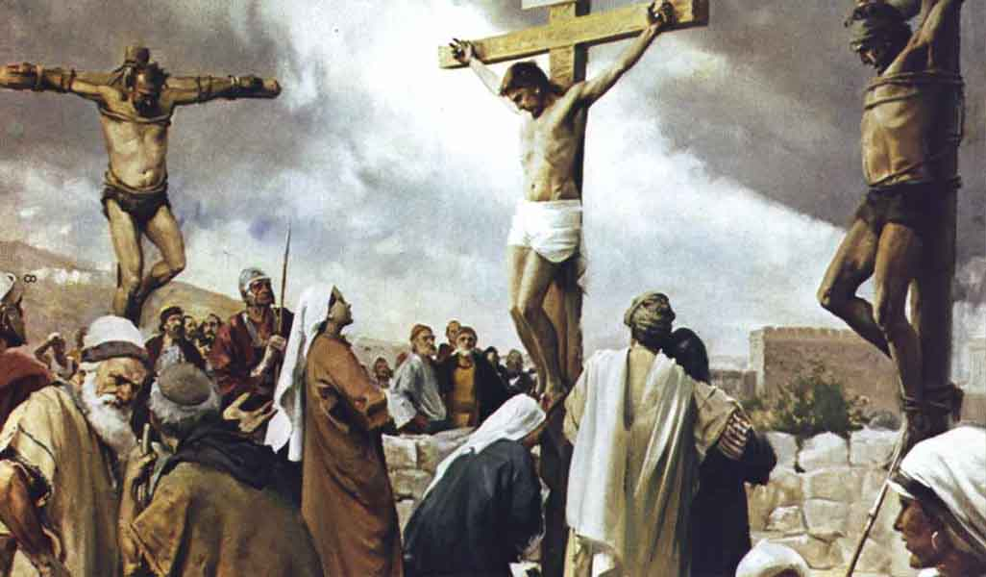
They crucified the Son of God
And even then they did not understand
that Jesus was no ordinary man

