At night when darkness fills my room
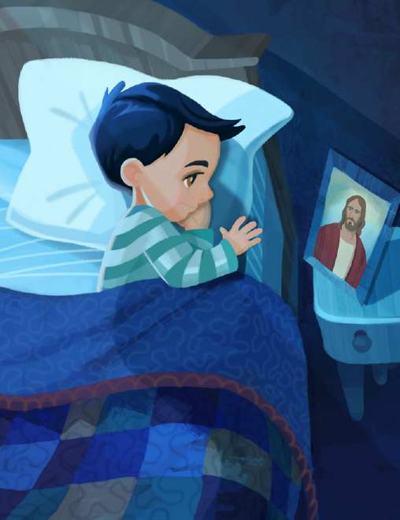
I do not need to fear
I think of Jesus’ love for me
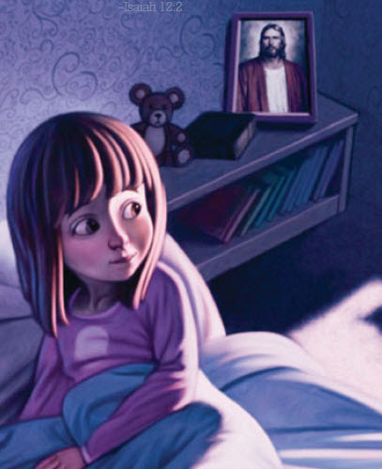
And know that He is near
When I am tempted to do wrong
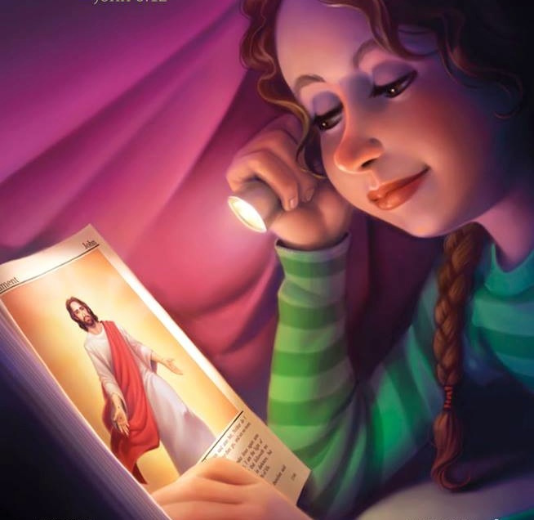
I seek the Savior’s light
And as I think of all He’s done
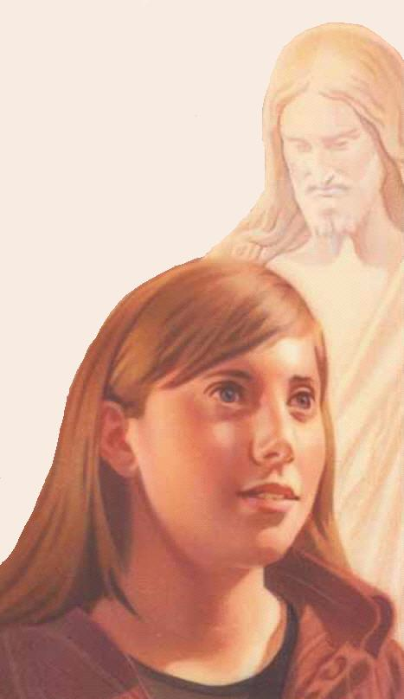
I want to do what’s right
For Jesus is my true light
He protects me day and night
He helps me choose the right
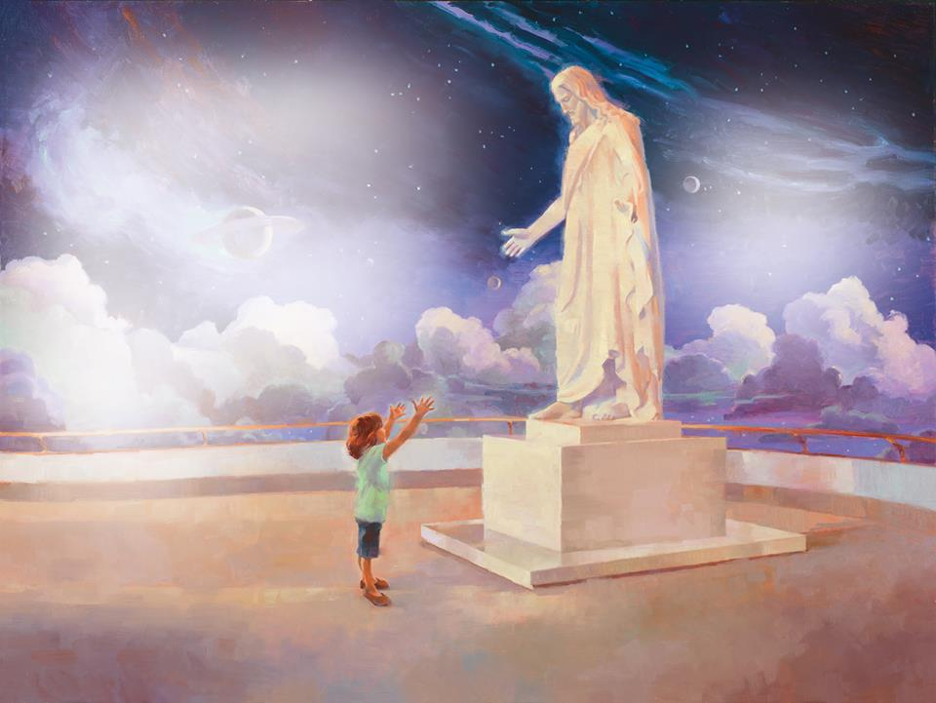
I will follow in His light

