Jesus once of humble birth
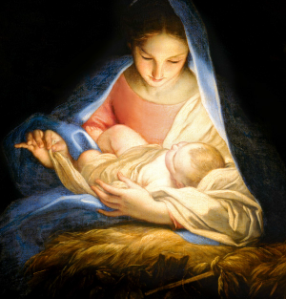
Now in glory comes to earth
Once he suffered grief and pain
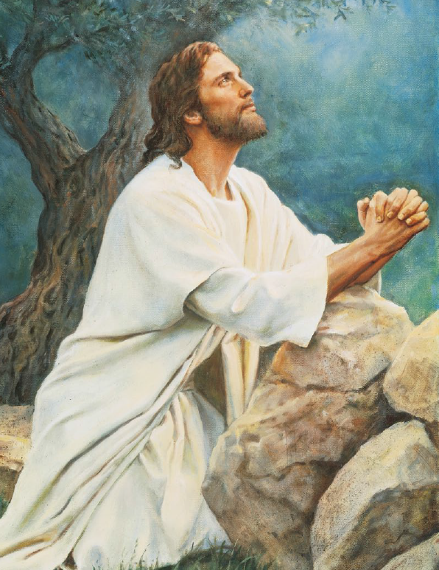
Now he comes on earth to reign
Now he comes on earth to reign
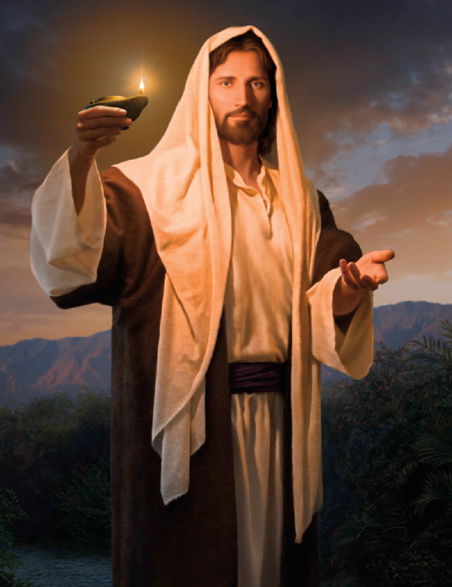
Once a meek and lowly Lamb
Now the Lord
The great I Am
Once upon the cross he bowed
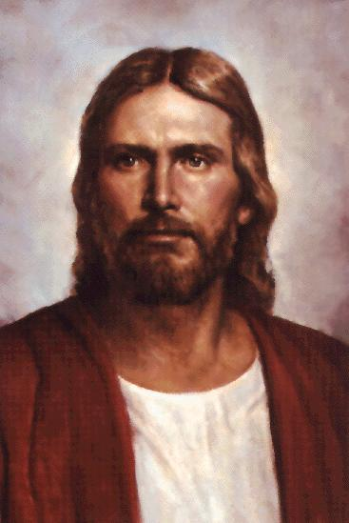
Now his chariot is the cloud
Now his chariot is the cloud
Once he groaned in blood and tears
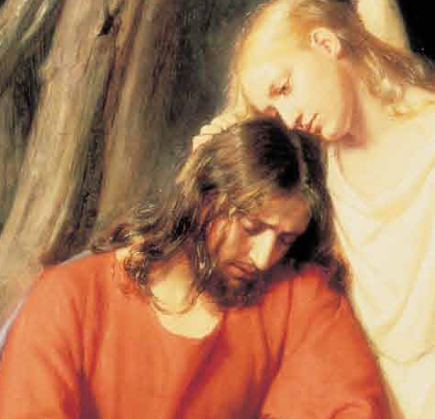
Now in glory he appears
Once rejected by his own
Now their King he shall be known
Now their King he shall be known
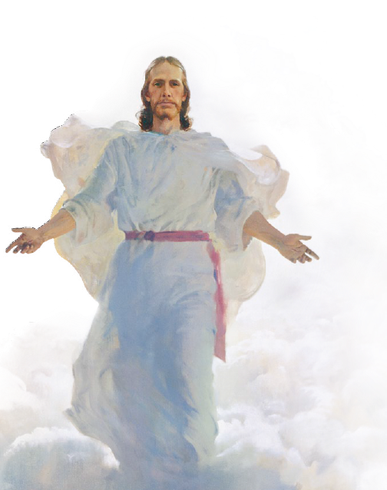
Once forsaken left alone
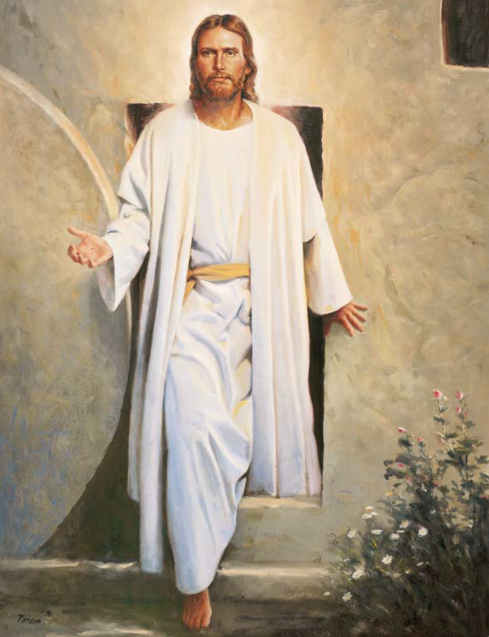
Now exalted to a throne
Once all things he meekly bore
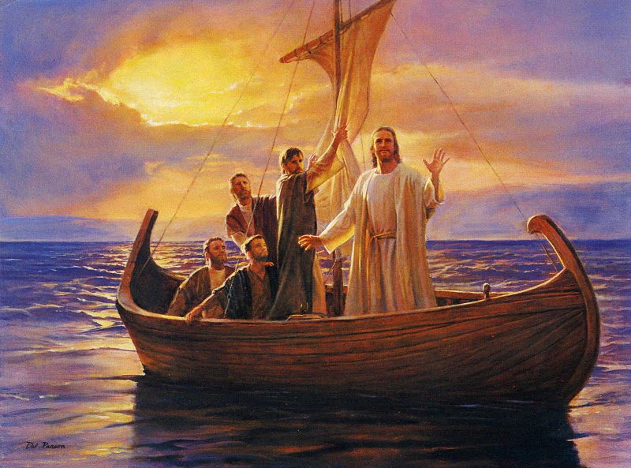
But he now will bear no more
But he now will bear no more
