I’m a Miracle Lord

Purchase the Sheet Music at

http://www.capitolcmglicensing.com

There are times
When I wonder what you see in me
Lord I know

I’m not all that I could hope to be
But when you reached
Your hand out Lord to mend and heal
I was moved
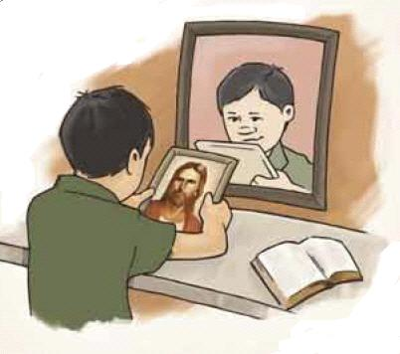
By the love that you must feel
I’m a miracle Lord
I’m a miracle Lord
I’m a miracle Lord because of you
For the rest of my days
I will give you the praise
I’m a miracle Lord because of you
I was lost to the skills of men
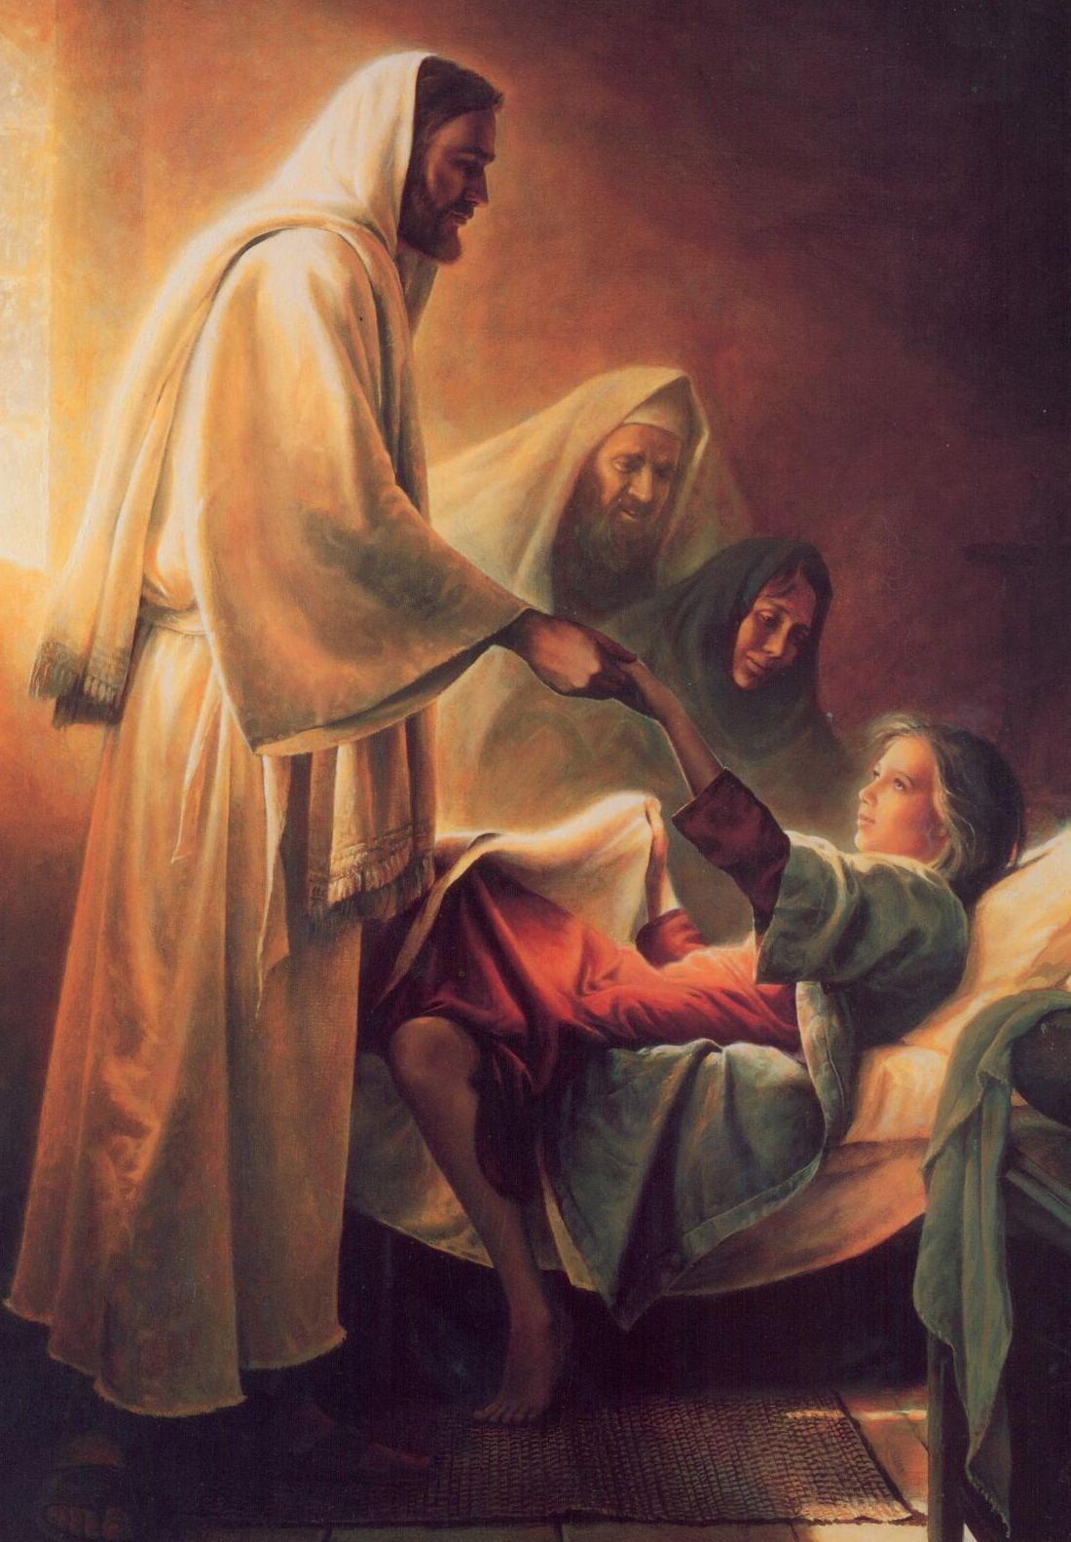
And bound to die
But because of your plan for me
You heard my cry
And you came in response to prayer
And eased the pain
So I won’t live
The rest of my life in vain

