I’ll Know For Myself

By Blake Gillette

Music Available in the Songbook
I Will Be What I Believe

Young boy from New York
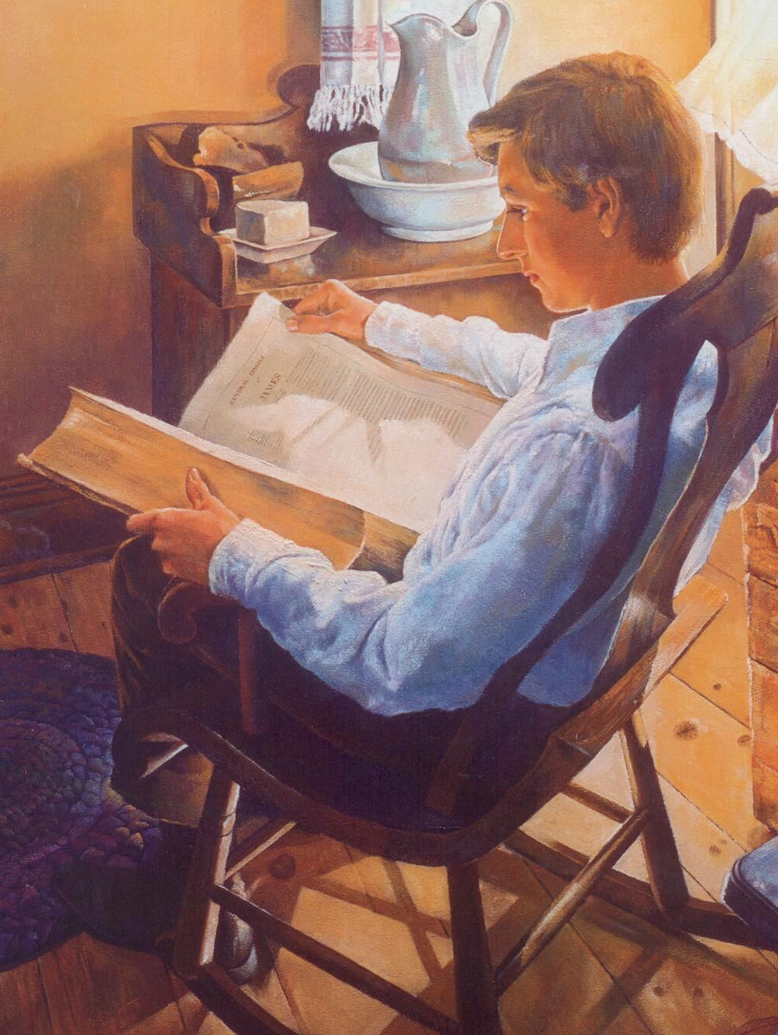
With a simple question
“If you lack wisdom let him ask of God.”
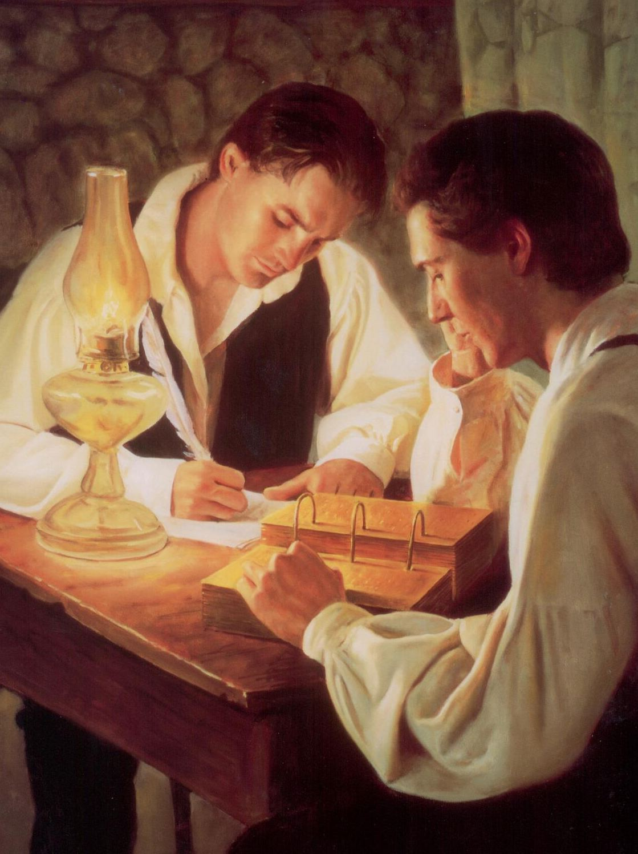
He read, then he knew
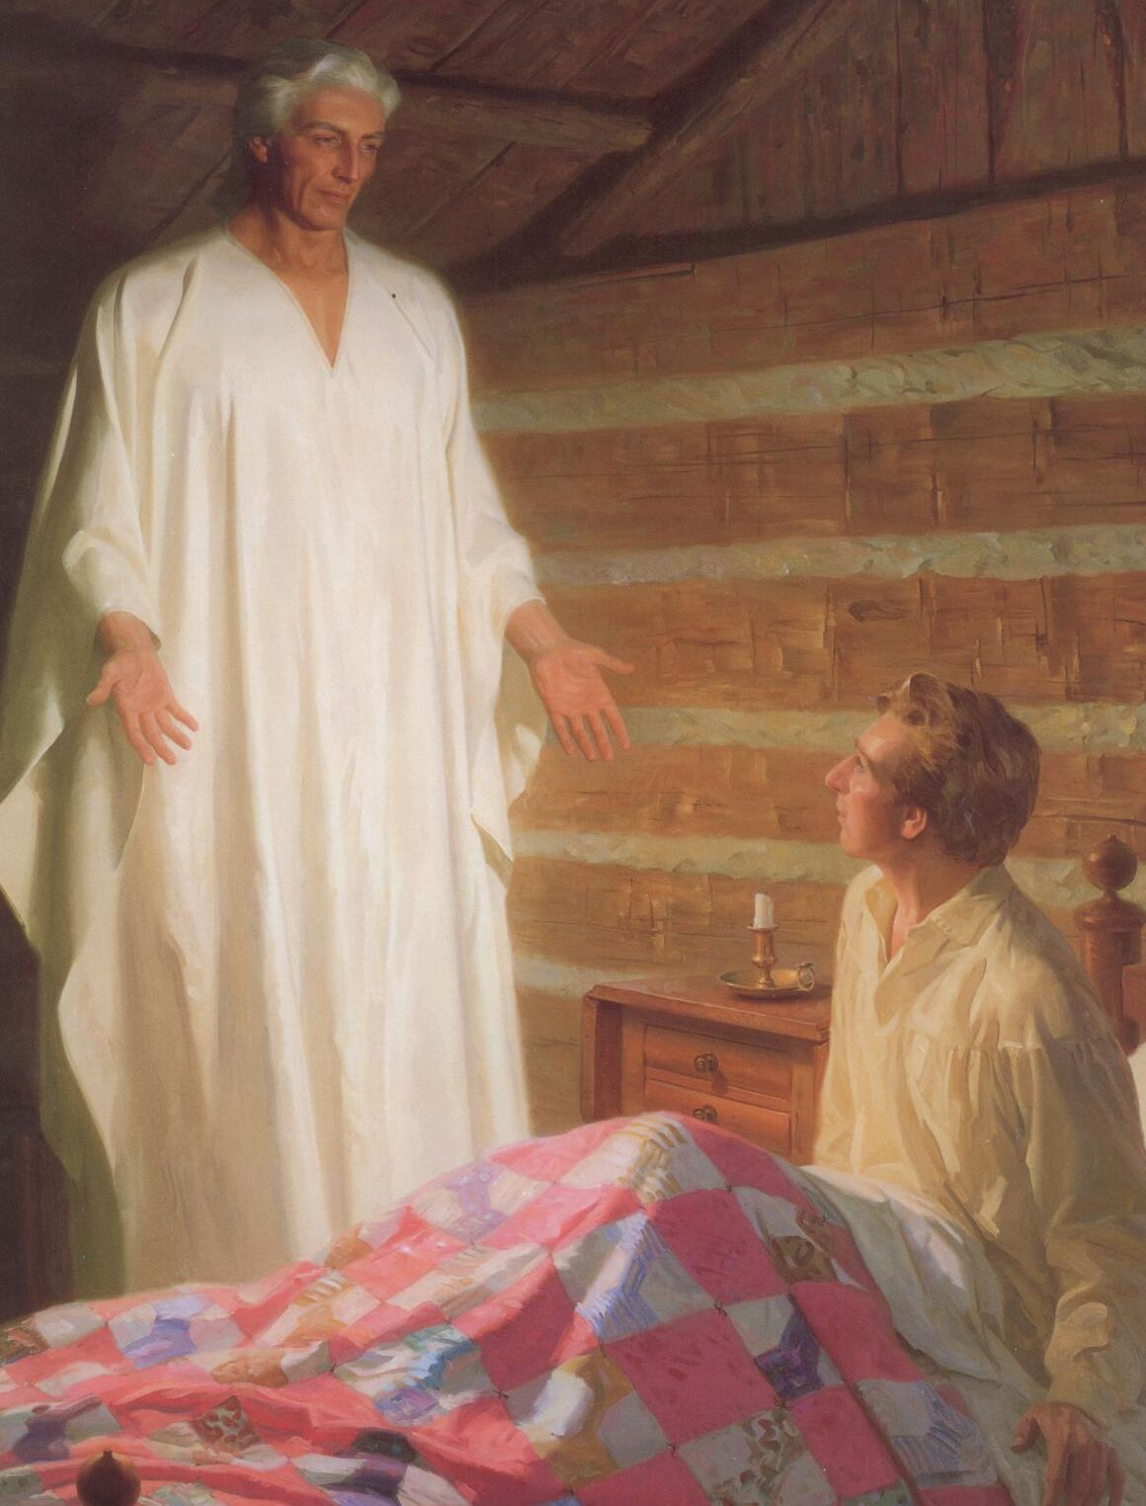
Spring eighteen twenty
In the Sacred Grove
Young Joseph prayed
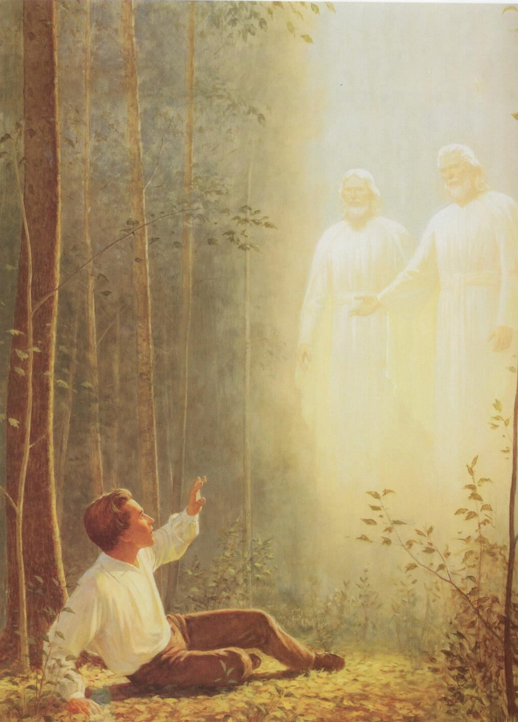
And a pillar of light appeared
Then he knew
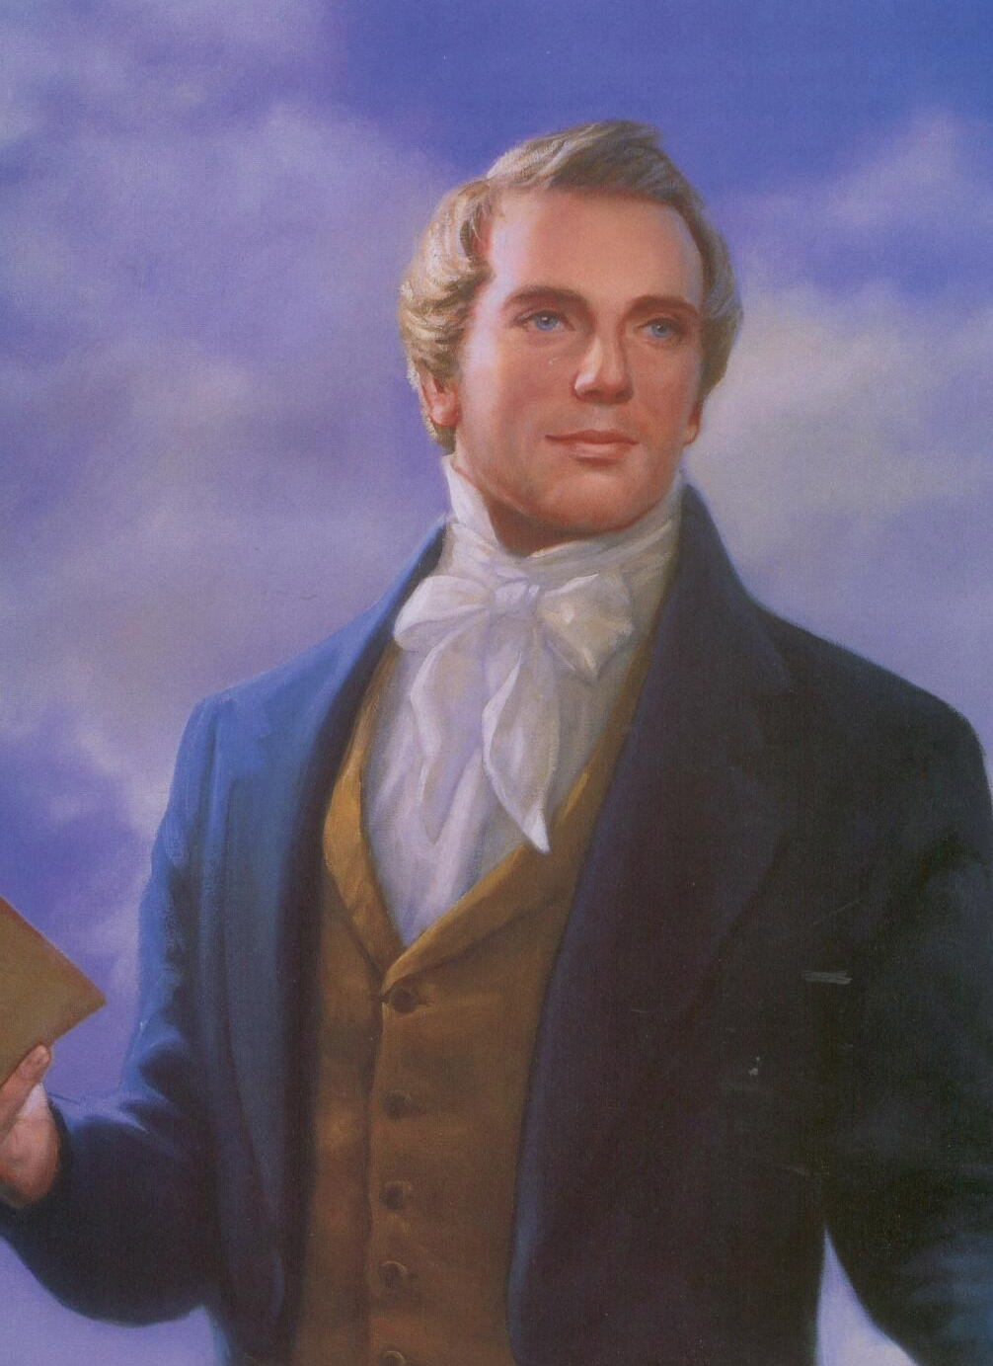
Like him I will pray
I’ll ask of the Lord
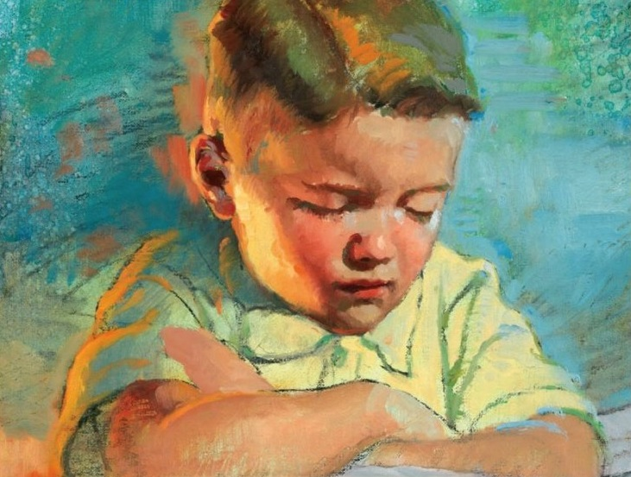
Like him I’ll have faith to know
That if I will offer
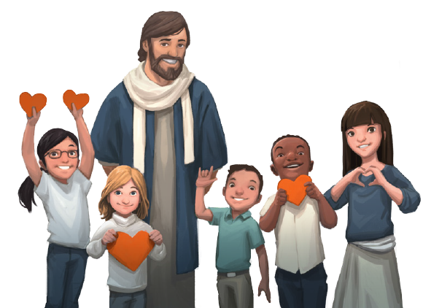
The thoughts of my heart
Then I’ll know for myself
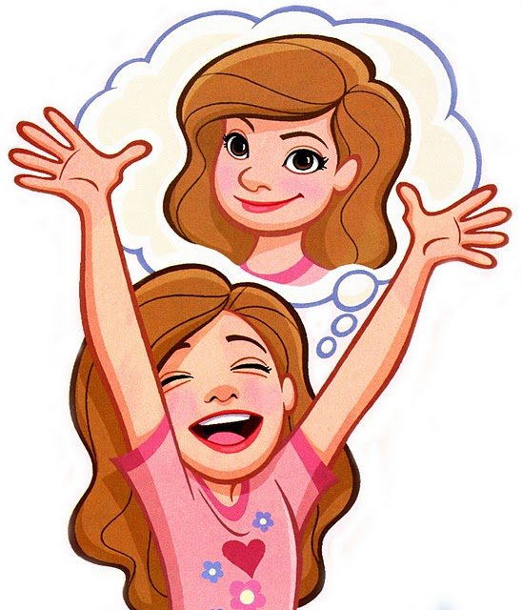
Humbly kneeling, sweet appealing
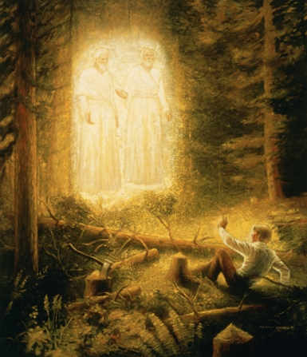
T’was the boy’s first uttered prayer
Joseph’s humble prayer was answered
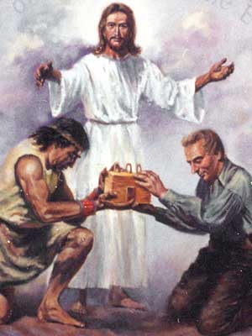
And he listened to the Lord
While appeared two Heav’nly beings
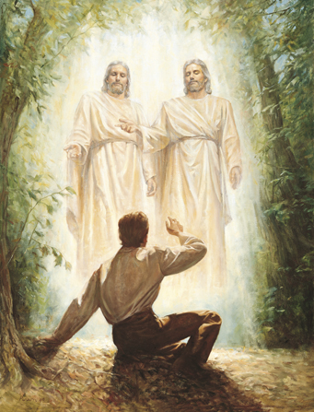
God the Father and the Son
Oh, what rapture filled his bosom
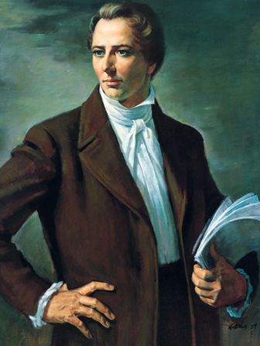
For he saw the living God

Part 1:

Each day is dif’rent,
Full of dif’rent questions
Then I’ll know
Like him I will pray
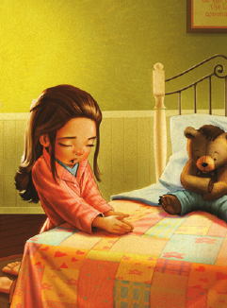
I’ll ask of the Lord
Like him I’ll have faith to know
That if I will offer
The thoughts of my heart
Then I’ll know for myself
I’ll know for myself

Part 2:

I’ll find my own grove
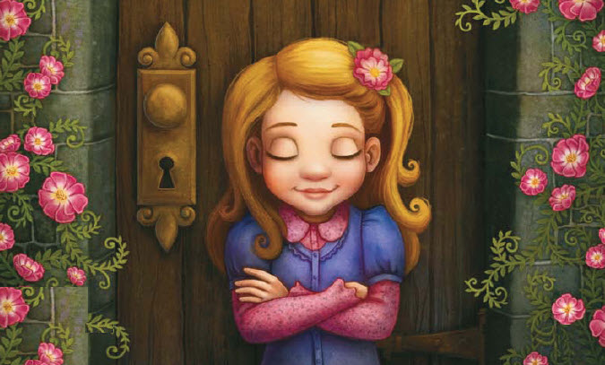
And I’ll quietly pray to God
Then I’ll know
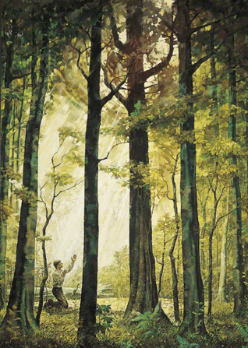
Oh how lovely was the morning
Radiant beamed the sun above
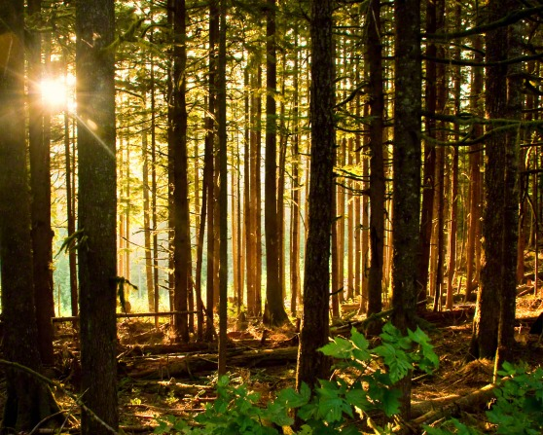

That if I will offer
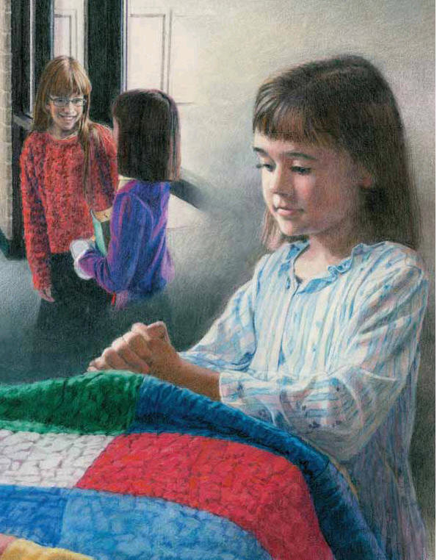
The thoughts of my heart
I’ll know for
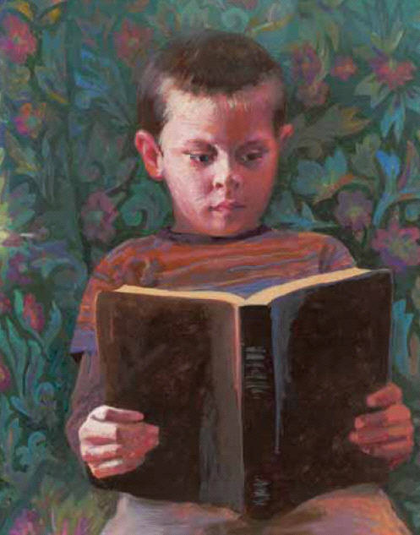
I’ll know for myself

