I’m learning each day
To be caring and kind
I think of good deeds
In my heart and my mind
I try ev’ry day to give love away
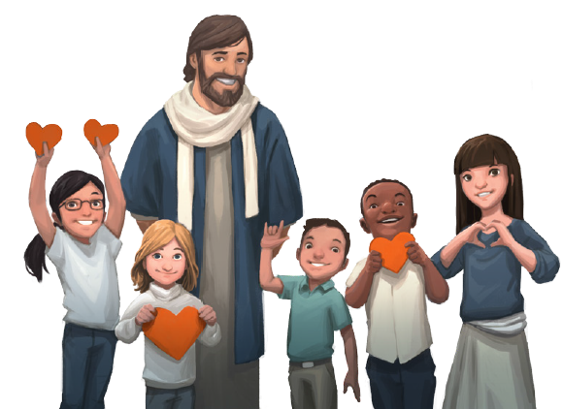
I’m learning the ways of Jesus
So if I see someone

Who’s lost or afraid

I’ll offer to help
That’s a choice I have made
Or if I see someone
Who just needs a friend
I’ll speak to them kindly
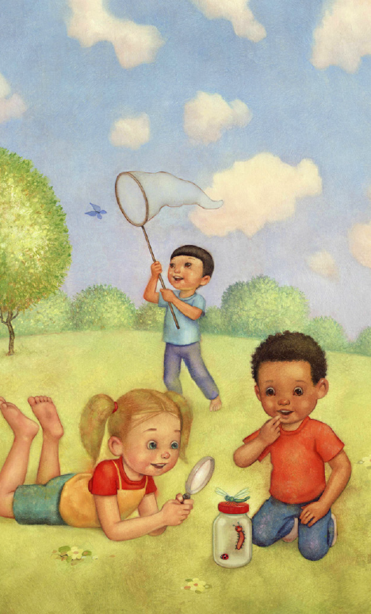
And spend time with them
I try ev’ry day to give love away
I’m learning the ways of Jesus
I’m learning each day
To be friendly and fair
I try to help others
I willingly share
I try ev’ry day to give love away
I’m learning the ways of Jesus
So if I see someone
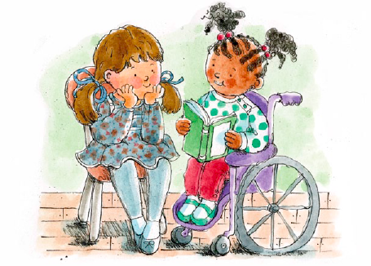
Who can’t walk or run
I’ll think of some ways
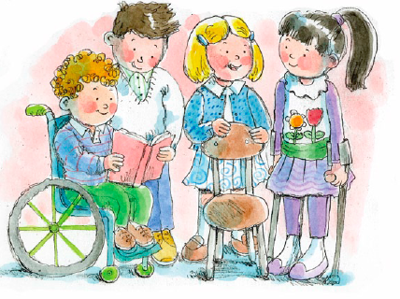
I can help them have fun
Or if I see someone
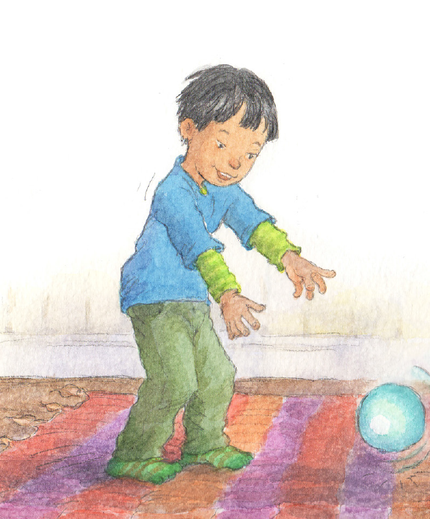
Who can’t see or hear
I’ll tell them that I’ll
Be their eyes or their ears
I try ev’ry day to give love away
I’m learning the ways of Jesus

