If you don’t walk as most people do

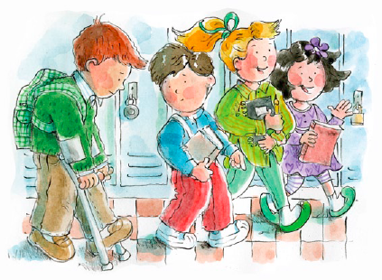

Some people walk away from you

But I won’t!

I won’t!

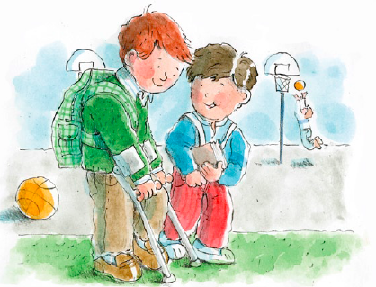

If you don’t talk as most people do

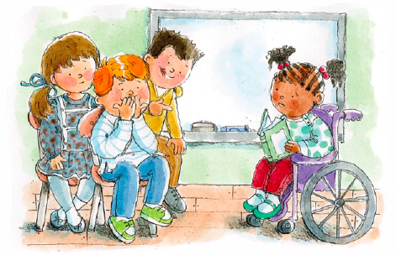

Some people talk and laugh at you

But I won’t!

I won’t!

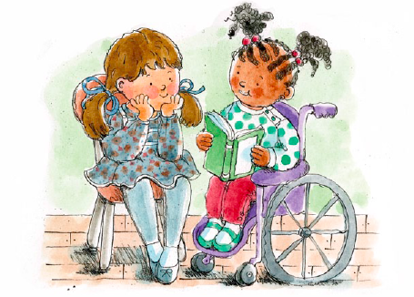

I’ll walk with you



I’ll talk with you

That’s how I’ll show

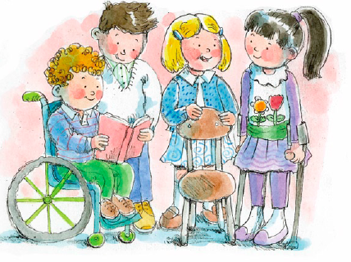

My love for you

Jesus walked away from none



He gave his love to ev’ryone

So I will!

I will!

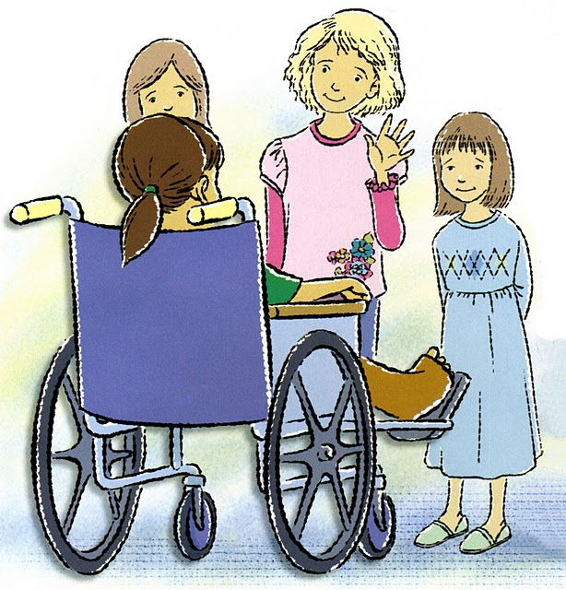

Jesus blessed all he could see



Then turned and said, “Come follow me.”

And I will!

I will!



I’ll walk with you



I’ll talk with you

That’s how I’ll show



My love for you