If the Savior stood beside me
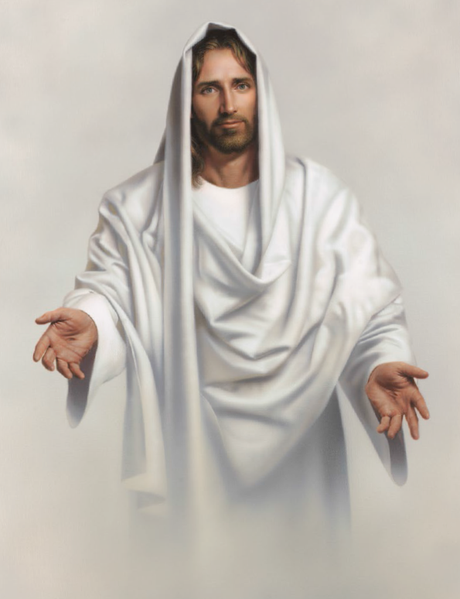
Would I do
The things I do
Would I think of his commandments and try harder to be true?
Would I follow his example?
Would I live more righteously?
If I could see the Savior standing nigh
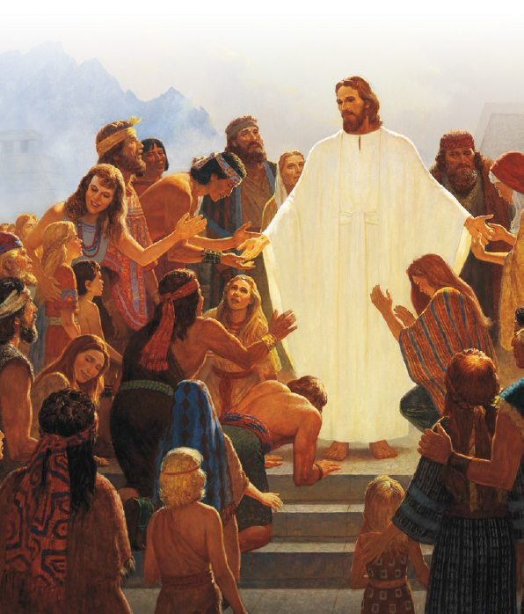
Watching over me
If the Savior stood beside me
Would I say
The things I say
Would my words be true and kind if he were never far away?
Would I try to share the gospel?

Would I speak more rev’rently?
If I could see the Savior standing nigh
Watching over me
If the Savior stood beside me
Would my thoughts be clean and pure?
Would His presence give me strength
And hope, and courage to endure?
Would His counsel guide my actions?
Would I choose more worthily
If I could see the Savior standing nigh
watching over me?
If the Savior stood beside me
Would I often kneel to pray?
Would I listen to the Spirit’s voice
And hasten to obey?
Would I count my many blessings?
Would I praise Him gratefully
If I could see the Savior standing nigh
Watching over me?
If the Savior stood beside me
Would I comfort those in need?
Would I try to show the Savior’s love
In every word and deed?
Would I give to those who hunger?
Would I serve more willingly
If I could see the Savior standing nigh
Watching over me?
He is always near me
Though I do not see him there
And because he loves me dearly
I am in his watchful care
So I’ll be the kind of person that I know I’d like to be
If I could see the Savior standing nigh
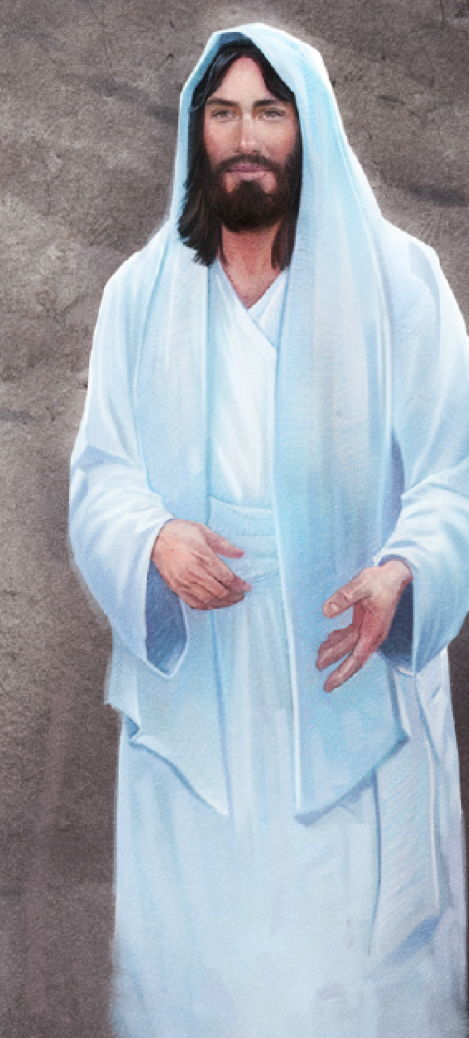
Watch--ing o--ver me

