If I had been a little child
When Jesus lived on earth
I would have liked to walk with Him
And listen to His words
But as I search the scriptures
I can hear His words of peace
And if I listen with my heart
I hear the Savior’s voice
I hear a living prophet speak
The things that Christ would say

If He were here upon the earth
To talk with me today
The prophet teaches how to live
In righteousness and peace
And if I listen with my heart
I hear the Savior’s voice
I feel the Holy Spirit
As He teaches truth and right
He comforts me in times of need
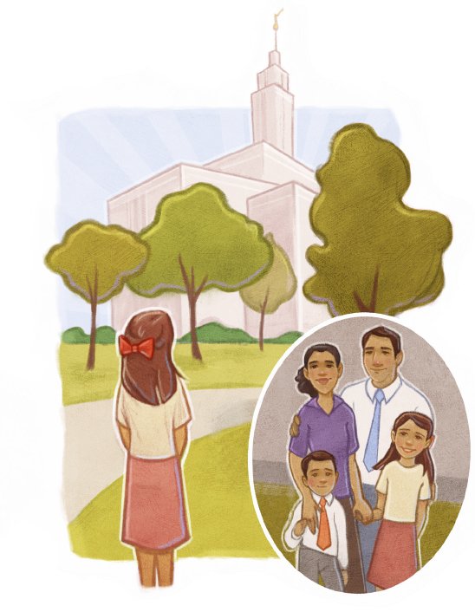
He testifies of Christ
He speaks to me in quiet ways
That fill my soul with peace
And if I listen with my heart
I hear the Savior’s voice

