- I know that my Redeemer lives
- What comfort this sweet sentence gives!
- He lives, he lives, who once was dead
- He lives my ever living Head
- He lives to bless me with his love
- He lives to plead for me above
- He lives my hungry soul to feed
- He lives to bless in time of need
- He lives to grant me rich supply
- He lives to guide me with his eye
- He lives to comfort me when faint
- He lives to hear my soul's complaint
- He lives to silence all my fears
- He lives to wipe away my tears
- He lives to calm my troubled heart
- He lives all blessings to impart
- He lives my kind wise heav'nly Friend
- He lives and loves me to the end
- He lives, and while he lives, I'll sing
- He lives, my Prophet, Priest, and King
- He lives and grants me daily breath
- 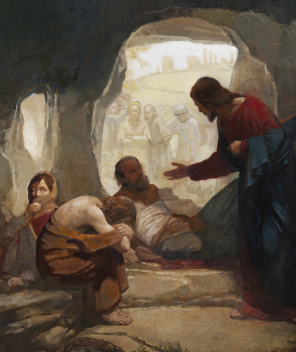
- He lives, and I shall conquer death
- He lives my mansion to prepare
- He lives to bring me safely there
He lives! All glory to his name!
He lives, my Savior, still the same
Oh, sweet the joy this sentence gives
I know that my Redeemer lives!
He lives! All glory to his name!
He lives my Savior still the same
Oh sweet the joy this sentence gives
I know that my Redeemer lives!

